**Volunteer Registration Form**

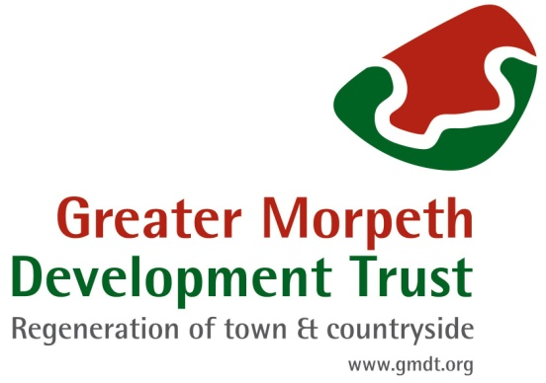

When completing this form, can you please PRINT your details.

|  |
| --- |
| **What activities are you interested in volunteering for? (Leave blank if this a general enquiry).**  **Tick the boxes for the Interest Group / Activities you are interested in.**  Arts and Culture Environment  Heritage General / Admin  **Comments:** |

**Volunteer Details**

|  |  |
| --- | --- |
| First Name: | Surname: |
| Email address: | Mobile no.: |
| We accept volunteers of any age, but those aged under 16 must be accompanied by an adult who is known to them.  Any volunteer aged under 18 must have the consent of their parent or guardian” | If appropriate please indicate your age below:  Under-16   16-18  Please circle your response |
| **To be completed by parent or guardian for applicants under the age of 18:**  I understand the young person’s details will be stored on Greater Morpeth Development Trust’s volunteer database and that they may be emailed directly in connection with their volunteer role  **Please select one of the following two options**  I give consent for the applicant to take part in the specified volunteering role only  I give consent for the applicant to take part in any volunteering opportunities with Greater Morpeth Development Trust that are deemed suitable for their age  Name: ­­­­­­­­­­­­­­­­­­­­­­____________________________Relationship to applicant: ______________________  Signed:___________________________ Email:_____________________________________ | |
| **Do you have any links to another charity or body?** If yes – please provide brief details. | |
| **Please tell us about any other skills, interests or hobbies that** you have which may be relevant to your volunteering with GMDT. For example: DIY, Gardening, IT skills, Project Management, Arts and Crafts? etc. | |
| **Please outline any Business skills you may have**: e.g. Accountancy, Business Management? | |
| Information on our register is strictly confidential and we do not pass on any personal data about you to outside organisations and/or individuals without your express personal consent. In signing this form, you are agreeing to the Trust keeping the information provided on computer and using your email address/mobile number to contact you. You are also agreeing to receive emails from GMDT Admin or the Interest Group Lead.  All GMDT emails will be sent out BLIND copy, for your privacy. If you decide at any time that you no longer wish to volunteer with the Trust or to receive volunteer emails, we will remove your details from our register. | |
| **We ask that all our volunteers adhere to our volunteer Code of Conduct, a copy of which will be issued to you.** | |

Date of Completion: _____________ Signature: ___________________

Return completed form to: **email:** [info@gmdt.org](mailto:info@gmdt.org) **or post to**: Unit 5 Benjamin Green House, Morpeth, NE61 2SL