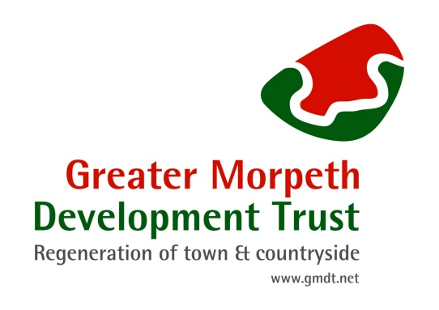

Greater Morpeth Development Trust

Volunteer’s Handbook

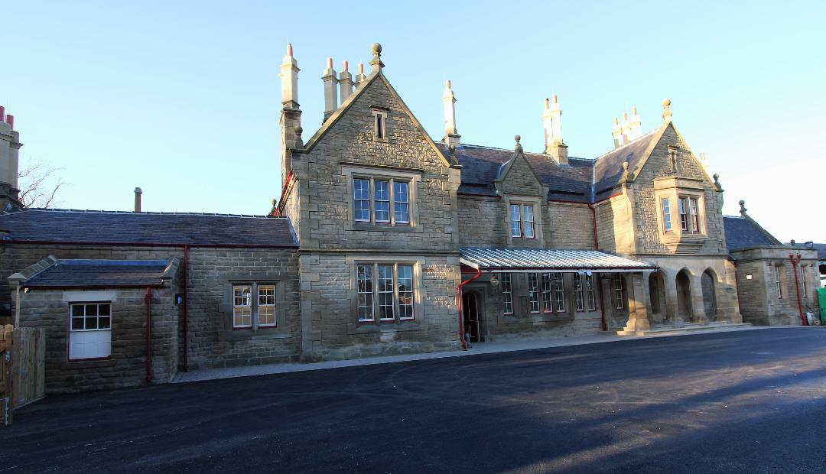

February 2023

Dear Volunteer

I would like to thank you for becoming a volunteer with Greater Morpeth Development Trust, your contribution to our work will be greatly appreciated.

A very warm welcome to you and I hope that your volunteering activities with us will be enjoyable and rewarding. Without the help given by volunteers we would not be able to achieve our goal of bringing partners together, through facilitation, to develop initiatives and through the skill base in the team, including volunteers, add value where ever possible to make Morpeth a quality place to live, visit and work.

The purpose of this handbook is to try to answer some of the questions asked by new volunteers and to provide further information about your voluntary work. Please always feel able to contact us either via our Community Director with responsibility for volunteers, one of the staff at our Railway Station office (Unit 1, Benjamin Green House), or any of the other Directors.

We hope you find volunteering with us worthwhile and satisfying and on behalf of GMDT a big thank you for giving your time.

Mike Willis
Chair
Greater Morpeth Development Trust (GMDT)

Mission Statement

Build a strong, confident and ambitious community, with increasing access to a wide range of opportunities, contributing to an improved quality of life. We will work with partners across the locality to contribute to the economic well being of the county through the delivery of the cultural, social, tourism and enterprise agenda.

Vision

Greater Morpeth Development Trust will help develop Morpeth to be a premier market town in North East England. Promoting and improving the town and countryside for public benefit, economic and social well-being of people living and working in Morpeth and surrounding areas of Northumberland through the promotion of urban and rural regeneration.

Context

Morpeth is an ancient market town and as such is steeped in history. The town and surrounding area contain many historical sites such as Morpeth Castle, Morpeth Town Hall, the 13th Century Chantry and Newminster Abbey. Morpeth is also linked to several famous historical figures including Lord Admiral Collingwood, William Turner, Emily Wilding Davison and the artist Joseph Crawhall Junior. Heritage is a key unique selling point to develop tourism, increase understanding and promote civic pride.

There is a wide range of businesses operating within Morpeth and the surrounding area. GMDT has strong links with the Chamber of Trade, Morpeth Town Council and Sanderson Arcade.

The arts and culture offer is an important part of Morpeth ranging from the promotion of Dance Festivals, live theatre and music, the Bagpipe Museum, the monthly community cinema, the annual picnic in the park and significant regional events such as the Northumbrian Gathering.

The projects that we work on are aimed at improving the living environment for residents and at increasing footfall through the area to improve and sustain the local economy. It is important that we work with the community to identify and develop such projects. Any and all profits that the Trust makes will be ploughed back into the projects it delivers.

What is Greater Morpeth Development Trust?

GMDT is one of a number of Development Trusts operating in Northumberland, and from October 2022 is located at Morpeth Railway Station at Unit 1, Benjamin Green House.

The structure of GMDT, through its Interest Groups, attempts to maximise the voluntary sector and statutory grant funding available for Morpeth mainly in the following areas:

- Heritage & Museum Development.
- Arts and Culture
- Environment development
- Social enterprise and business development support.
- Disability and accessibility issues.
- Large scale development projects that encourage economic growth and maximise market town initiatives.

How GMDT operates

GMDT provides a Community Service to the town of Morpeth. GMDT is an independent company limited by guarantee and a registered charitable trust. The Board of Directors are the Trustees of the company and work on a purely voluntary basis. GMDT is obligated to make sure the business is correctly run according to the law and the requirements of its charitable status.

The Operational team consists of:
- Employees – currently employ 2 part-time members of staff. We also engage casual staff as and when needed for specific skills.
- Volunteers – underpin GMDT through their activities from the Board of Trustees and within the 3 Interest Groups and carry out various other voluntary activities to assist with the smooth running of the organisation. (see separate booklet on volunteering opportunities)

The GMDT Board of Trustees currently consists of 6 volunteer members (Directors), 1 Associate Director, and 2 representatives from Morpeth Town Council and Northumberland County Council as participating observers. All board members take on certain responsibilities within the management of the organisation utilising any specialist skills they have.

The Directors on the Board consist of:

3 Community Directors
1 Environment Director
1 Heritage Director
1 Arts & Culture Director

Involvement of Volunteers

GMDT recognises the benefits and value of volunteering and believes opportunities should be open to all members of the community.

Volunteers bring a wide range of experience, talents, skills and qualities and enable GMDT to achieve much on behalf of the community of Morpeth and the surrounding area.

Volunteers increase community involvement and spread the word about the work of GMDT. As well as giving their time they are likely to support us in other ways and introduce us to new volunteers and new opportunities.

Volunteering enables you to:
meet new people / make new friends
learn new things / skills
share knowledge
contribute as part of a team
have a sense of responsibility and commitment
give something back to the community
possibly gain experience while studying / seeking employment
have fun

Everyone has a different reason or motivation for volunteering and we welcome the diversity this brings to our organisation.

Responsibility for the Management of volunteers
The individual project coordinators have the responsibility for the volunteers in their project together with the community director with responsibility for volunteers.

Security
GMDT is not able to take responsibility for volunteers’ personal belongings whilst helping so anything you bring with you is at your own risk.
As a volunteer you are required to make yourself familiar with any associated health and safety procedures, including emergency exits and assembly points. We encourage volunteers to take reasonable care for health and safety of themselves and other people who may be affected by their acts by reporting any incident which has led or could lead to damage or injury and by assisting in any investigation with regard to incidents.

As a Volunteer you have the right to:

- Receive accurate information about the organisation and its volunteering policies
- Agree a clear and comprehensive description of your role and have a reasonable understanding of the lines of accountability
- Be seen as part of the organisation through inclusion at meetings, social functions etc.
- Receive training as necessary
- Know who to turn to with problems or difficulties
- Have your work valued by the organisation and to receive regular and constructive feedback on your performance.
- Have choices and be able to exercise those choices (say no)
- Carry out your voluntary work without being exploited
- Be consulted on matters that directly or indirectly affect you and your work.

As a volunteer you have responsibility to:

- Be reliable, punctual, and committed
- Notify your GMDT contact if you are not able to make an appointment or are running late.
- Agree to the policy on volunteers
- Carry out the agreed volunteering role
- Give feedback, communicating relevant and important information
- Be accountable and accept evaluation where relevant
- Acknowledge decisions made by others
- Undertake relevant training
- Ask for support and advice when it is needed.

Volunteer Records

GMDT maintains records on a computer and paper for each volunteer from the point of initial contact with the organisation and for two years after they leave. These records include information recorded on the registration form and correspondence between yourself and our organisation.

Volunteer records are confidential within the organisation and are not shared with any third parties. You may request to see any records held on you by GMDT.

GMDT operates a policy of Equal Opportunities and wishes to recruit volunteers from all areas of the community.

Change to personal details

Please update GMDT with any changes to your personal details so that we can continue to keep you updated about the charity’s news, events and opportunities. It is also important that we are able to contact you or your designated person in case of emergency.

Changing or ending volunteering

If for any reason you become unable to carry out your role effectively please inform the project manager and the community director with responsibility for volunteers. We will try to look for an alternative volunteering role if appropriate.

If circumstances change within a scheme or project, we will endeavour to tell you, giving as much notice as possible. We may have to suggest alternative volunteering roles. We will work with you to make sure any changes are the right move for you and the decision is yours as to whether you would like to continue volunteering for us.

Please give us as much notice as possible if you intend to leave your volunteering role.

Can you help promote volunteering with GMDT?

If you are willing to do so there are several ways you can help raise awareness about volunteering with us:
- Tell friends, relatives, colleagues about volunteering with us.
- Do you have a local or company newsletter where we could promote volunteering with GMDT? If so please let us know.

Contact Us
Greater Morpeth Development Trust
Unit 1, Benjamin Green House
Morpeth Railway Station
Coopies Lane
Morpeth
Northumberland
NE61 2SL

Tel: 01670 503866 email: info@gmdt.org

www.gmdt.net/

Usual Office opening hours: Monday – Friday 9.00am - 2.00pm

