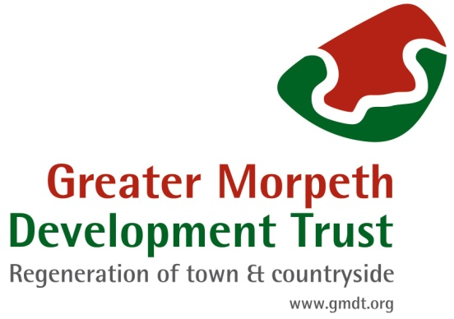

PP 11 VOLUNTEER POLICY

The purpose of this policy is to clearly state the arrangements in relation to volunteer recruitment and management at GMDT.

- About this policy

Volunteers are vital to the work of GMDT. We have a number of volunteering opportunities some time limited, others occurring annually and some regular events.

- GMDT firmly believes that volunteers provide a valuable contribution to the achievement of our mission.
- We recognise their importance by actively encouraging and supporting them and ensuring that they are treated with fairness and consistency.
- GMDT recognises that volunteers require satisfying work and personal
development opportunities and will seek to help volunteers meet these needs.
- GMDT recognises that volunteers often need flexible arrangements with regard to time and level of commitment and we will try to work within these constraints.

- Recruitment

- We will use appropriate means to advertise for volunteers taking into account the
principles of our Equal Opportunities and Diversity Policies. Volunteer applicants will have to complete an application form (help can be given with this if necessary).
- All voluntary roles will be clearly defined. If an applicant is not deemed suitable for the voluntary role for which they have applied, we may suggest an alternative role or hold the application until a suitable opportunity becomes available.
- We advertise volunteering opportunities through our website and via current projects and events. We may also use our partners to help us contact a wider range of people for specific opportunities.

- Induction and Training
- Volunteers will receive a copy of the Volunteer Handbook and will be introduced to the project coordinator of the project they will be working on.
- If necessary training will be arranged but it is the responsibility of the project coordinator to ensure that the volunteer fully understands their role.
- If a volunteer wishes to develop their skills further then other opportunities will be offered if available.

- Support and Supervision
- The project leader will support their volunteers and meet with them to discuss any problems or issues that may arise. If a volunteer feels they are not receiving the support needed they can contact the Community Director responsible for volunteering.

- Insurance
- The Charity has a valid insurance policy with a level of cover of up to £5 million.
- A copy of the policy is available on request.

GMDT POLICIES RELEVANT TO VOLUNTEERS

Equal Opportunities
Volunteers are covered by the GMDT equal opportunities policy, a copy of which is available on request.

Health and Safety
GMDT has a legal Duty of Care to volunteers. Volunteers are covered by the GMDT health and safety policy, a copy of which is available on request.

Confidentiality and Data Protection
It is important that volunteers maintain confidentiality throughout their time with GMDT. Confidentiality prevents disclosure of your personal details. At the same time it protects members, other volunteers and staff. This applies whether information is received directly or indirectly, deliberately or accidentally, is written or spoken. Volunteer records are confidential within the organisation and are not shared with any third parties. You may request to see any records held on you by GMDT. Please see our Privacy Policy for further information.

Photographic use consent
By signing our volunteer agreement you are giving permission for the Charity to use any image of you photographed during your voluntary activities or at GMDT events. These images may be used for display on our website, in documents or for any other
publicity purpose; for example in newspaper articles or other publications. If you do not wish to give your consent please let your project co-ordinator know as soon as possible.

Expenses
As we value our volunteers and want to ensure that there are no barriers to volunteer
involvement, we will endeavour to cover out-of-pocket expenses, if needed. A volunteer should discuss the need for expenses with the project coordinator prior to incurring any costs. To claim expenses, an expenses form must be completed and sent to the GMDT office.

Resolving Problems
We want our volunteers to enjoy their work with us and to feel a sense of achievement.

If a volunteer is dissatisfied with any aspect of their work they should:
- Initially explain their dissatisfaction to their project co-ordinator
- If that does not resolve the concern then the relevant interest group director should be consulted.
- If that does not resolve the concern then a meeting will be arranged with the
Community Director with responsibility for volunteering
- If after this we are unable to resolve the problem, then it would be
inappropriate for the volunteer to continue to be a volunteer
- At all times the volunteer will be freely able to state their case and can have a friend to accompany them to any meeting attended

If GMDT has concerns about a volunteer, it will be dealt with by:
- Holding an initial meeting with the relevant project co-ordinator who will explain the concerns.
- If this does not resolve the concern then a meeting with the Community Director with responsibility for volunteering will be convened with the chair or vice chair.
- If the concern persists then we shall have to stop using the volunteer’s services
- At all times the volunteer will be able to freely state their case and can have a friend to accompany them to any meeting attended.

