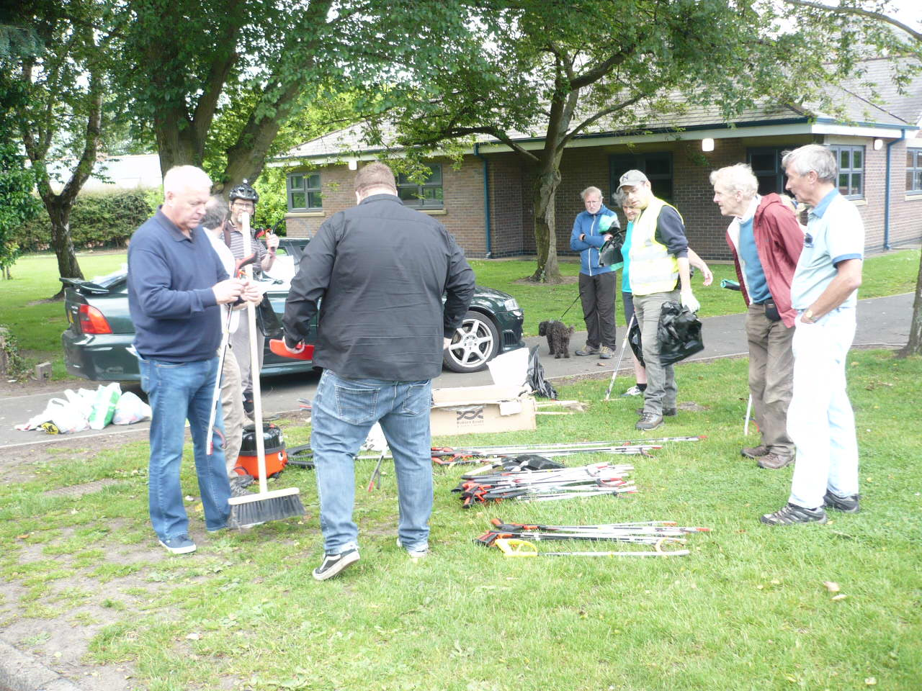
A REPORT SPONSORED BY GREATER MORPETH DEVELOPMENT TRUST
Supported by Local Businesses
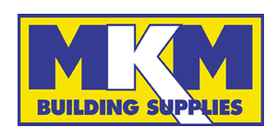

Contents
INTRODUCTION 4
History of Morpeth Litter Group 5
SECTION 1: PLANS FOR 2021 5
1.1 Morpeth businesses’ support 5
1.2 Morpeth Litter Group’s Adopt a Street / Location 7
1.3 Morpeth Litter Bin – new school posters 7
1.4 Joint Partnership with NCC to tackle verge clean-ups 7
1.5 Landscaping in partnership with others 7
1.6 Bin Management and options 8
1.7 Inside Morpeth article 8
1.8 John Beynon’s Adopt a Bench 8
SECTION 2: CONCLUSION AND 2021 MLG STRATEGY 8
SECTION 3: Key Latest updates 10
3.1 How to Report new issues in 2021 10
3.2 Quick reference Summary of Improvements made in Spring 2021 and existing open issues 11

ACKNOWLEDGEMENTS

A GENUINE COMMUNITY PARTNERSHIP
GMDT/KBT: David (Dai) Richards - 2018 Keep Britain Tidy Ambassador
KBT: Tracy Kenny - 2019 Keep Britain Tidy Ambassador
GMDT
- Hugh Edmundson (Environment Director)
- Simon Cox
MORPETH LIONS AND FRIENDS
- Chris Offord
- Richard Nash (Key role as MLG Street Blitz Marshall)
- Les Sage – Including his role as Chamber of Trade
MORPETH JUSTICE AND PEACE GROUP
- Janet Hedley
- Mary Ord
KEVI School
- Andy Clark – Deputy Head
NCC Officers + Councillors
- Nicola Wardle, supported by Carrol Plessey - Business Support and Customer Liaison team
- Paul Lowe – NCC NEAT team and Refuse/Street Bin Collection teams
- Frances Povey (Area Countryside Officer) supported by her Carlisle Park maintenance team
- Councillor Richard Wearmouth (also NCC)
- Councillor John Beynon
MORPETH TOWN COUNCIL (MTC)
- Councillor and Mayor David Bawn, Deputy Mayor Rachael Hogg
- Councillor and 2019 Mayor Alison Byard
- Councillor and 2018 Mayor Jack Gebhard
- Town Clerk Tracey Bell
- Assistant Town Clerk Joanne Wilson
MORPETH SCOUTS –at least 4 separate groups
MORPETH CHAMBER OF TRADE
- The late Ken Brown
- Les Sage
MORPETH ROTARY
- Colin Dyson
- Paul Crooks
- Barry Swan (see section 4.6 for areas covered)
PEOPLE OF MORPETH – names below will not be a definitive list!
- Matias Liddle Colin Coates
- Alan and Linda Kenny Josh Burton
- Jill and Mike Pinkney Janice Ryan
- The late Adrian Barnes Tracey Sharp
- Joyce Carey Sheila McRoberts
- Diane Davies Diane Wright
- Pauline Tulloch Emma Thorne
- Margaret Lovering Pat Fuller
- Shirley Richards Lynda Heslop
- Graham and Val Langston who clear the Morpeth Dam regularly
- Jean Gregson Alex Gilmour
- Pam Thirlwell Russell and Fiona Emmerson
- Peter Maylia Janet & Barry Mason
- Pauline Williams Elle Richardson
- Plus so many other unsung heroes that give up their time every week in the fight against litter (too many to list here!)
Morpeth Ramblers – at least 3 separate groups now picking up litter in the far reaches of Northumberland
Wansbeck MP Ian Lavery for Raising issues in Parliament and relevant departments
ADOPT A STREET Volunteers – 100+ people now involved, with full 72 people actively Adopting a Street

INTRODUCTION
The 3rd “End of Year” Annual report from the Morpeth Litter Group (MLG) outlines the results of our litter picking activities held during this difficult Covid-19 pandemic impacted year. To have achieved anything at all has been a major accomplishment by everyone, since the virus restrictions have been serious blockers to any group activities. It has been so pleasing to see enthusiastic individuals going the extra mile to complete the clean-ups, and to see the success of the new Adopt a Street initiative, despite the lockdown constraints placed upon us.
Over the year, Northumberland County Council NEAT team have been extremely busy. This report aims to reflect some of their efforts that have been observed when walking around the town in the preparation of this report. Special mention must be made of the major clean-up of the large mounds of detritus/fly-tipping in Morpeth Town AFC’s Craik Park. Our sincere thanks to NCC NEAT team for their efforts. Over the year we appreciate that with stretched resources, NCC NEAT team have had a huge impact on the battle against litter.
This year, Tracy Kenny has put in a phenomenal effort with her many new Morpeth initiatives. These include the weekly Wombling Wednesday event plus the growth of Adopt a Street. Both support our commitment to voluntary community activities.
Working in partnership with Northumberland Council Environment team (leader Paul Lowes) and Nicola Wardle (Business Support and Customer Liaison team), we have been able to keep Morpeth Town area relatively clear of detritus. Provision of new equipment has continued, especially for the Adopt a Street initiative.
Morpeth Town Council (MTC) has again supported us by the movement/provision of bins and the fitting of new butt ashtrays on a number of bins. We again thank MTC for their support.
It is pleasing to see the people of Morpeth recognise our efforts and we ourselves can see that our efforts are keeping our wonderful town much clearer of litter. However, we are under no illusion that the battle against litter is anything other than a never-ending task. This year our report continues with the old and adds new suggestions which we consider are important in the battle against litter. For the first time, we are highlighting issues which NCC might consider raising at Government Environment Department level, especially the Environment Agency and Department for Environment, Food and Rural Affairs (DEFRA).
The MAIN REPORT records the fuller results of:
- the few 2020 litter Blitz events
- the Wombling Wednesday events that took place in September 2020
- the new Adopt a Street initiative
It’s impossible to cover the extensive work of all the MLG’s individual activity but the report does include some recommendations raised by MLG volunteers who are looking for County / Town / National level support to address the problems they are encountering. This community partnership is essential to win the war against litter.
We are fully aware that our suggestions may have resource or financial implications. We ask that the owner of the issue raised here, considers the request by bearing in mind the resolution of the issue will address something that an MLG volunteer feels is important. It champions the Working Together ethos that is an essential part of this Community Initiative.
As an example, installation of additional bins could be addressed by:
- replacing single-use doggy bins with multi-use blue bins
- replacing bins in locations which have 2x120 litre bins with a single 240 litre bin, thereby avoiding any increase in the number of bins to empty
- moving low-used bins to new locations and possibly looking at new technology with street cigarette receptables.
New technology is available where using new ENEVO sensors - bins can report back their FULL status – could this be something NCC NEAT team could consider to support, thereby increasing the number of bins around the town?
This year we again ask MTC to consider the approach of allowing bins to be ADOPTED by local businesses. Evidence has shown that this approach has been successful with many other local authorities around the country. It increases the number of bins but has no increase in the number of bins to be emptied by NCC NEAT team. This we feel is a win-win situation. Having businesses step forward to keep Morpeth litter-free, shows that everyone is working together.
Covid-19 pandemic is an ongoing challenge for everyone. Littering does not go away but we are confident that with a positive approach towards continued improvements in 2021, we will further reduce littering on our streets and the town’s green areas.
It is important that the authorities don’t view the MLG work as a permanent supplementary activity/resource, but more as a partnership where we are working together to address the problems of littering.
This CONCISE + FULL MAIN REPORT report will be published on the GMDT website, and will be disseminated to Northumberland County Council, Morpeth Town Council and King Edward VI School Morpeth, Keep Britain Tidy and other local groups involved.

History of Morpeth Litter Group
The arrival of a Cavalier King Charles Spaniel (Alfie) and subsequent retirement, started a daily walking routine for Dai Richards. This brought into focus the scale of litter everywhere. It became a constant annoyance to him, so much so that with NCC’s help in providing a litter picker, he began picking up the detritus along Castle Walk and the Cenotaph regularly as he walked Alfie. A new bin was placed at the Cenotaph, a doggy bin in entrance to Allery Banks moved to Mafeking Roundabout and a doggy bin replaced with a blue bin at the Sun Inn Newcastle-bound bus stop: all by MTC and we could immediately see a general improvement in the area becoming much less cluttered with litter. Other dog walkers joined Dai, and the Deuchar Park Litter group was spawned. In December 2017, an area at the top of the Carlisle Park Burn was identified as an issue by a member of the group – the scale of litter was just enormous and was too large for the small litter group. The Litter Blitz idea was spawned, and with the support of members from Greater Morpeth Development Trust (GMDT), Morpeth Lions, Deuchar Park Litter group and people of Morpeth we arranged the first ever Litter Blitz on 11th February 2018 – it was a freezing cold afternoon but the whole area was cleaned up in just 90 minutes. We became aware that a number of community organisations and individuals around Morpeth were involved in voluntary random litter picking but there was no organised regular activity. With NCC support, equipment was purchased and arrangements for disposal of all bags made with NCC NEAT team. Monthly litter blitzes were set up – the response was phenomenal! It was timely since the outrage against litter was becoming a national concern with people wanting to make a difference.
The group’s primary objective is to supplement the County and Town Councils’ activities in as many areas of the town as possible, and to tie this into the Northumberland or Britain In-Bloom inspections and national Keep Britain Tidy (KBT) events such as the Great British Spring/Autumn Clean-ups. Working in partnership is our key mantra, understanding the limited resources available from the NCC and MTC teams in trying to keep Morpeth Town free of litter.

SECTION 1: PLANS FOR 2021

1.1 Morpeth businesses’ support
This was originally planned for 2020 but Covid-19 blocked this activity. It is hoped in 2021 that we can look again at this set of proposals. Post Covid-19 will be an opportunity to regenerate our country and Morpeth Town centre needs everyone to see what they can do. We are hoping Morpeth’s Business Community can help the MLG volunteer activity, by working together to keep Morpeth Town centre free of litter.
Keeping Morpeth free of litter attracts visitors, increases footfall to shops and contributes to the Britain in Bloom and Northumbria in Bloom competitions.
The following programmes could be key contributions to Morpeth’s COVID19 recovery plan:
- ADOPT a BIN: Increasing the number of bins is always curtailed by the limited NCC NEAT team resources. The Co-op store and Cooplands bakery at Loansdean have set a standard which it is hoped other shops in Morpeth could match. Target businesses could be:
- Takeaways / Coffee shops e.g. Boulevards, Pizza Express, Morpeth Fish and Chips, Greggs, Costa, Harrys Bar and others
- Shops / Newsagents e.g., Iceland, Newgate News
The MACE shop at St Mary’s Field has had, since opening, a small litter bin to the left of their entrance
door. It is greatly used by their customers and emptied more than once a day. If that bin wasn’t there, the
scale of litter would be much worse outside this popular shop. The shop owners, at their own cost
dispose of the rubbish collected.
See small bin to left of main door
The 2 new stores at Loansdean – Co-op and Coopland bakery shop have adopted their own bins outside their shops. Speaking to Co-op management, they ask their cleaner to empty the bins each day as part of their duties. Both companies have support from their HQ where the rubbish collected is taken away by the company’s delivery staff. They find this arrangement works very well and keeps the scale of litter around the area low.

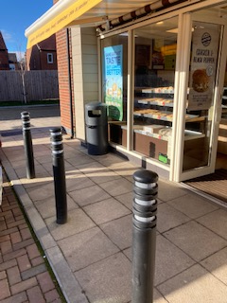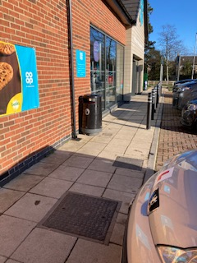
Coopland bakery bin Co-op bin

In June 2021 – Penfold Convenience store have started to support the fight against litter by putting out and emptying a bin outside their store – our sincere thanks to the Penfold team.

- MULTI-USE COMMERCIAL BINS: It has been suggested previously that the commercial bins could be used by the general public. Could we work with businesses and place signs at the location where a commercial bin can be used by the general public? Best example of this, are the bins at the back of Lollo Rosso restaurant and its potential to be supporting the end of Whalebone Yard car park.
.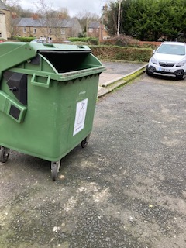
Bin at the back of Lollo Rosso restaurant
- BUTT RECEPTABLES: The Joiners Arms led the way in 2019 with their commitment to the clean-up of their patrons’ cigarette butts which accumulated outside their business, especially at their side entrance. They put up an elegant chrome cigarette butt receptable and once a week hoovered up the butts that still collected in the cobbles. The difference was amazing. Could we encourage other businesses to do the same for their premises? For example:
- Black Bull – numerous butts and a substantial amount of detritus constantly sits outside the main entrance, at the front to the left of their Bridge Street entrance. Outside lockdown, the scale of butts flows onto the kerbside of Bridge St. and blows over to the south side.

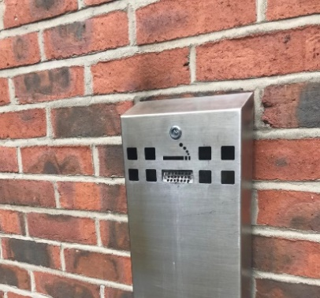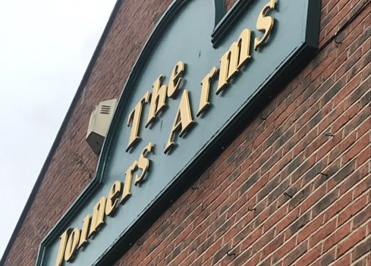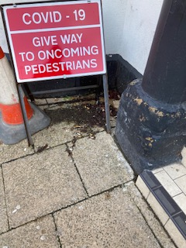
Silver cigarette receptable fitted on side of Joiners Arms. Area to left of Black Bull main entrance
- Restaurants.
- Staff butt receptables for main street stores
Two businesses are being mentioned due to the high scale of butt detritus behind their premises:
- Costa
- Boots Optician Hearing care
See R29 for photos of rear of the shops and heavily hit by cigarette butts.
Can NCC / MTC put in place a local by-law that enforces pubs and restaurants to provide cigarette receptables in suitable places where their patrons / employees go for a smoke? This may be required in more than one place if for example patrons smoke both in front and at the rear of the premises.
Grade 2 listed buildings regulations may stop us putting a receptable on an external wall – this issue has been raised by Dai with KBT to discuss with HM Environment minister, we need some flexibility here.
- Keep Britain Tidy’s 2019 #BINTHEBUTT campaign has made available posters and beer mats which we can use. It would be great if these could be used in 2021.
- SWEEPING THEIR FORECOURT: Design a new poster where businesses can display their commitment to the cleanliness of our town. The business commitment is to daily brush the front of their shop.
The following businesses already show their commitment – our sincere thanks for their support:
- Chisholms Betting shop
- Waterford Lodge
- Pet HQ
These three businesses show their commitment to keeping Morpeth litter-free and having pride in the area in front of their premises, especially the removal of cigarette butts on the pavements and market place.
Businesses used to sweep the front of their stores – how can we encourage shops to recommence this 5-minute activity at the start of their business day? A new poster – showing we clean our forecourts /pavements would show the people of Morpeth they care about their community and could be a way of improving footfall. (See appendix action R8 of Full Report).
- SILVER FOIL: It has been observed that there is an increase in silver foil being littered around the town centre, especially after a weekend. We need to ask all businesses to avoid using silver foil in food takeaways. Morpeth Litter Group KBT Ambassadors will make contact with the shops creating this problem.

1.2 Morpeth Litter Group’s Adopt a Street / Location
In an attempt to move away from monthly litter blitzes in Morpeth, articles will be posted on all media asking for people to come forward and adopt their street / location. Targeting dog walkers especially – we hope to expand to other areas of Morpeth, not currently covered, so more streets and parks are cleaned on a regular basis. The 2020 success has been astounding, and could result in the regular Morpeth litter blitz events being not required allowing us to help NCC in other towns in Northumberland to encourage new litter groups.
For this to grow further we will need help from Nicola Wardle / Carrol Plassey and NCC NEAT team as follows:
- NCC to provide another large number of litter pickers – it is recommended NCC purchase of 20 x 3ft Helping Hands litter pickers, lessons learned is that other manufacturers are just not robust enough for intensive use.
- NCC NEAT team to provided support to either pick up bins from individuals homes or bin locations around the town. Improving the ‘Report a problem’ website to allow ‘Report a full bin’ plus NCC NEAT team number the bins to ease reporting. We also need to look at building a record of the most used street blue bins by MLG Adopt a Street litter pickers so NCC NEAT team can schedule more frequent bin-emptying.

1.3 Morpeth Litter Bin – new school posters
The existing school posters on the side of our street bins are brilliant (designed by 1st school students) but are all looking a little tired and, in many places, are peeling off. Dai has been advised, by someone who was involved with the original posters, that they are over 20 year old. It is suggested that we have a new school project or competition, asking for the local Junior schools to organise new posters to be placed onto the bins. This would be a great message to our youngsters to take their litter home or put it in a bin. It would also align with Post Covid-19 regeneration.
Similarly, to existing arrangements, Morpeth First schools to have their own winners and posters selected. See R9 of MAIN REPORT for recommendation raised.

1.4 Joint Partnership with NCC to tackle verge clean-ups
MLG volunteers would like to help NCC NEAT team to tackle the large scale of litter along roadside verges.
It is important that is done in a safe manner, working partnership, NCC provide the traffic light / men at work
roadside signs, allowing the MLG volunteers to tackle the roadside litter, in safety. Is there any merit to this
proposal? This has already been undertaken in some parts of the town’s highway network.

1.5 Landscaping in partnership with others
It has been proven that beautifying an area with landscaping and planting flowers making it aesthetically pleasing on the eye, substantially reduces the scale of litter.
In 2021, MLG volunteers would like to work with NCC / MTC to look at poorly maintained areas to consider landscaping. See also 3.8 below for family adopting a bench.

1.6 Bin Management and options
The number of bins around Morpeth is always limited by the impact on NCC NEAT team resources to empty the bin. Have NCC/MTC considered the options available from ENEVO and GLASDON to provide cost effective bin management solutions? For example:
- ENOVO WIFI Bin management tool WWW.ENEVO.COM
Solutions – Enevo
Newcastle City Council have a blog about their experience using the service provided by Enevo
What Newcastle’s waste data told us about COVID-19 – Enevo
Has NCC looked at this product and is it something that could be cost effective for management of Morpeth Town bins?
- Glasdon 240 litre bins.
Morpeth Town Council purchase the 120Litre Futuro bins.
FUTURO 120L £409 JUBILEE 240L £650
Could the purchase of the larger JUBILEE 240L bin: Glasdon Jubilee™ 240 Wheelie Bin Housing
be more cost effective as a solution especially in the town locations where 2 Futuro 110L bins are placed?
Note: Glasdon advise bulk purchase is required to obtain the same blue colour as Futuro bins.

1.7 Inside Morpeth article
We were fortunate to have a lovely full page article in the September GMDT Inside Morpeth magazine. This generated a lot of interest, encouraging new volunteers to come forward and get involved. 15 people got involved with the Adopt a Street venture as a result of this article. In 2021 we continue to work in partnership with GMDT, our thanks to GMST for a £200 donation which has enables us to provide Litterpickers for St Roberts school who are adopting Carlisle Park , clean-ups in progress each Friday.

1.8 John Beynon’s Adopt a Bench
At the request of a local family, Town Councillor John Beynon has worked with NCC to have a new
Bench installed at the entrance to Deuchar Park. The bracken behind the bench has been cut back, creating a
lovely spot to rest and chat with friends. The cutting back of the bushes has enabled MLG Adopt a Street
volunteer to get access to any litter that is deep into the woods. All costs for the bench including fitting has
been covered by the local family and has been adopted by them. Could this idea be considered in many areas
around Morpeth to beautify the given location and give people pleasure sitting watching the world go by?
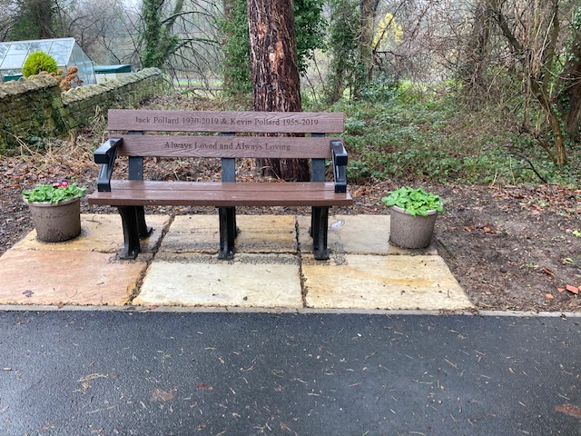

SECTION 2: CONCLUSION AND 2021 MLG STRATEGY
2.1 The first litter blitz planned in February 2020 was thwarted by severe high winds, stopping the planned
clearance of the layby opposite Dobbies’ Heighley Gate. The March litter blitz was also stopped by bad weather and then the Covid-19 pandemic hit the country, with the national lockdown decimating any attempts to have an MLG litter blitz.
The various tier restrictions have also limited what the group could undertake, but when you look back over the year, the Community team (MTC/NCC/MLG) should be very pleased to see what has still be achieved.
2.2 MTC have modified a number of bins with the new cigarette butt trays, it is hoped that over the coming years, further improvements will be made to bins. New bins have been installed across the town. Any new bin is being purchased with the new cigarette trays and some doggy bins have been replaced with dual use bins. These achievements have helped us in this continual battle against litter.

2.3 NCC NEAT team have addressed a number of issues raised in the 2019 End of Year report. Some have been substantial achievements e.g. the huge piles of rubbish that were along one side of the Craik Park car park. They have quietly removed this, asked for no thanks, but what a difference the team has made to the car park that has become much more heavily used because of Morpeth Town FC’s success, and is visited by people from all over the country. Again this has improved the image of our town.
Town centre hedges have been cut back making the whole town much easier to keep clear of litter. Special mention for their efforts at St James’ car park which is now much lighter and safer for volunteers to clear any litter along the church wall.

2.4 After being furloughed during COVID-19, Tracy Kenny was able to commit more time during 2020 to MLG and tackle areas such as:
- Heighley Gate layby
Setting a target to clear 75 large black bags of rubbish, taking 24 hours over 10 days to clear the woods in this area.
- Coopies Lane Industrial Estate
Tracy hit the whole industrial estate and over 3 days cleared 25 large black bags of rubbish. This area has never been blitzed over the 3 years of MLG blitzes.
- Facebook Page
Tracy has developed the new Morpeth Litter Group Facebook page. The articles have been funny and interesting and sometimes sad, especially when we read about wildlife being killed by some item discarded by a human. We now have over 300 followers. A fantastic achievement which has encouraged over 80 new people to take on an Adopt a Street role.
- Hedgehog Post
Tracy won 2nd prize in KBT’s National scene for the most interesting article. Her subject was the young hedgehog she found amongst a pile of litter during an event, which was taken to an animal sanctuary for medical assistance.
- Wombling Wednesday
When we were in a lower tier category, Tracy organised weekly Wombling Wednesday 6 person events where for 2 hours the team blitzed areas of Morpeth. This was well supported but was again thwarted by Covid-19 restrictions. We hope these can start again in 2021 when restrictions are lifted.

2.5 It was planned that MLG’s KBT Ambassadors would support a new KEVI litter blitz event, where, on a given Friday in July at 3:45pm the whole school would be asked to clean up the school grounds of any litter. This was to be widely supported by teachers and students – again thwarted by Covid-19.
We will endeavour to look again at this in 2021 – pandemic pending of course. Feedback from Mark Simpson, Former Deputy Head, was that with school and caretakers’ support, many of the improvements raised in last year’s report have been actioned. The school grounds are definitely tidier this year. With MTC fitting a new blue bin at the gate of the KEVI rugby fields, the scale of litter in this area has been greatly reduced.

2.6 Morpeth Rotary Club members have stepped forward to hit a number of areas in Morpeth. The A192 Rotary Glade has been fully adopted and is being kept clear of litter. Barry Swan and team now cover 4 town centre car parks, 1) Lidl 2) Dacre Street 3) St James and 4) Morrison’s underground plus Dacre St, Dark Lane opposite Morrisons (2 bus stops) and Howard Terrace. Our sincere thanks to Morpeth Rotary Club in supporting us.
2.7 Morpeth Lions members have adopted Curley Kews banking and the section from the Co-op roundabout to Clifton. Our sincere thanks to Lions members Chris and Richard for their support.

2.8 Adopt a Street has taken off in the last half of 2020. Despite the Tier 3 and national lockdown restrictions in place, we have still been able to get over 43 individuals taking on a section of Morpeth, keeping the area clear of litter. Our sincere thanks to Nicola Wardle and Carrol Plessey for the provision of new litter pickers for the venture. We hope this can grow further in 2021 – there are still a number of hotspots that need to be covered e.g., Church Walk behind the shops. But the more Adopt a Street grows, the less work there will be for NCC NEAT team and MLG.

2.9 This report makes a number of recommendations and bin requests. We understand this constant raising of issues can pressurise MTC and NCC teams, with their limited and often shrinking resources, but the battle against litter is a continual fight. As part of Continuous Improvement with MTC and NCC Council support, we can further enhance our defence in the battle against litter. It is fully respected and recognised that financial and manpower resources will be constraints when addressing any issues. We identify these issues hoping they can be addressed without impacting the constraints currently on councils and businesses.

2.10 It was our hope that we could engage with Morpeth’s Chamber of Trade to build upon our initiative, by asking its members to take responsibility for helping to keep the town clean where they promise to brush the area front their store. This would have included new design and printing of new BUSINESS HELPING MORPETH FIGHT AGAINST LITTER posters they could display proudly at the front of their premises.

2.11 Our new Business Adopt a Bin initiative will be emotive – but if it increases the number of bins in our town
centre, and remove the need for street placards/billboards, it can only help the town in this fight against litter.
When Dai is picking up litter along Bridge Street during the week, it is amazing to have so many visitors to Morpeth expressing their thanks and saying what a lovely and tidy town Morpeth is. People say they come to Morpeth since it is so tidy. These are future customers for our shops. How can shops help to keep Morpeth Town free of litter?

2.12 We do not expect all suggestions to be taken up, either for resource/financial constraints or practical reasons, but hope that our actions and report have given you some food for thought. The least we emphasise is that more attention should be given to the major hotspots identified: Stanley Terrace, Morrisons underground car park, Morrisons hedges along Tommy’s Field for example. The need to do more to reduce cigarette butt pollution is also very obvious to us.

2.13 Covid-19 has thwarted the MLG Litter cleaning activity, but Adopt a Street has definitely partly filled the gap. Morpeth continues to look much clearer of detritus but we mustn’t think we are winning. There are a number of areas where the scale of litter is very bad. Efforts in 2020 have helped in enhancing the reputation of Morpeth as an increasingly clean, litter-free place in which to live, work and visit. .

2.14 Funding will be required for our 2021 activities to enable us to produce posters, car stickers etc. We can expect Adopt a Street to grow further. Having a budget to purchase the more expensive litter pickers is essential because the cheaper versions are really a false economy solution since, they are not built to last for very regular use. As stated last year, we hope MTC and NCC can continue to help with equipment donations, but it is recognised that MTC may struggle due to the fact that the MLG is not a registered charity, but it is a non-profit making organisation, run by volunteers, and is therefore a cheap, effective means of supplementing Council resources.
.
2.15. Working with Nicola Wardle, MLG and GMDT will arrange a 2020 End of Year review meeting where the issues identified here will be discussed. Invitees from the following teams would be appreciated:
a. NCC NEAT team representatives f. GMDT Environment director
b. NCC Business Support/Customer Liaison team g. Co-op / Coopland bakery store managers
c. MLG KBT Ambassadors h. Morpeth Chamber of Trade
d. MTC Mayor and Deputy Mayor i. Morpeth Rotary Group
e. MTC Officers j. Hebron + Hepscott Parish Council

SECTION 3: Key Latest updates

3.1 How to Report new issues in 2021
The Full Version of the Report includes the responses from NCC and MTC owners of issues raised at the meeting on 28th February and/or feedback post the completion of the meeting. Where an issue has been addressed notes from the meeting shown in GREEN. Some issues may show different ownership to the version discussed; this reflects the new “ownership” post the meeting. Ownership change can be seen by strikethroughs xxxx. If you would like to see full details of each issue please read the FULL REPORT version.
For any issues raised which you as a volunteer or originator of the request feel the issue still needs addressing, we recommend that the issue is raised as a new issue – see below process to follow:
. You the reader may disagree with final decisions, sometimes strongly or you may encounter a new issue that you would like to have addressed by Morpeth Town Council. In those cases can we ask that you raise the issue yourself with your local Town Councillor, cc to Morpeth Town Mayor, in some cases cc your County Councillor to request investigation. It is expected that the Councillor will make representation for you to the Town Clerks.
REPORTING an ISSUE / Request a Change or Improvement: Refer any improvements you would like to see being made, firstly by contacting Northumberland County Council, who are responsible for litter etc on the highway. You can report any issues by phone on 0345 600 6400 Option 4 (other), option 6 (other) or by completing an online report form Northumberland County Council - Report. Select the option REQUEST LITTER REMOVAL.

So for example we have identified an issue where we think replacement of a stubber plate on a bin new Kirkhill Chemist will reduce the high scale of cigarette butts around the bin. We are being asked to follow the above process to request an improvement.

It is expected that budget constraints may stop any improvement being made in the existing financial year. If you consider the matter urgent the other option you have is to report any issue to your local Town Councillor (we recommend also cc the Town Council Mayor), and/or County Councillor who will in turn forward it to the relevant officers in the relevant council for consideration.
At all times Tracy Kenny and Dai Richards , as your KBT Ambassadors and Morpeth Litter administrators will be available in preparing your argument to justify further improvement required.

3.2 Quick reference Summary of Improvements made in Spring 2021 and existing open issues
a. Morpeth Town Council
1. 3 bins in Newgate St. have been fitted with new cigarette trays.
3. A bin near Chantry seat has been moved to other side of wall to facilitate more usage.
4. The stolen bin located opposite Jackson barber , Chantry bridge, has been replaced.
5. On 14th May – Morpeth Town Council Clerk has confirmed a new bin will be installed on Stanley terrace /
path entrance to Lidl store. At this time no details provided re installation date.
6. We awaiting a possible doggy bin conversion to dual use blue bin, bin located behind Bookers.
b. NCC
1. The Heighley Gate car park has had substantial improvements with additional Sulo bins fitted.
2. New NCC email reporting process in place, helps MLG Adopt a Street volunteers report bags to collect.
3. It is uncertain that there is regular hoovering of the Morrisons underground car park, scale of litter here is
still high. Do we need a bin placed in the far corner?
4. Regular hoovering of the Town Square has improved greatly the general appearance of a main focal point.
5. Bonfire remains, behind Church Walk, have been cleared of detritus.
6. We need the bracken cutback behind Castle Close garages – with MLG team clearing litter afterwards.
7. A new Sulo bin placed has been fitted next to the bus stop on Fairway road / Northgate roundabout, this
needs monitoring since the new Springhill estate is quite far from this bin – the dog walkers in that estate
have nowhere to deposit their full doggy bags.
8. The bushes at the back of the Railway station need trimming to enable MLG volunteers to clear detritus.
c. Network Rail / Northern Rail
1. Network Rail team have cut back the bushes at the rear entrance to station – they have also cleared the
litter there.
2. A new bin has been placed by Northern Rail Morpeth Railway staff to collect people’s cans etc before they
leave/enter the station via the rear entrance.
3. Agreement has been reached with Network rail to put up a new Cigarette Bin Receptable at the semi-circle
of the railway station drop-off area, this bin will be adopted and emptied by members of Morpeth Litter
Group.

d. Karbon Homes
1. Ownership of areas around Karbon homes has been resolved with most with NCC and MTC.
2. Karbon Homes looking at options for hotspot behind the garages at rear of Church Walk.
d. NHS
1. MLG are working with NHS to have a new bin fitted at Northgate hospital which will hopefully resolve new
HOTSPOT #5 – see MAIN REPORT
e. Hepscott Parish Council and Hebron Parish Council
1. Hepscott Parish Council met on 20th May, they have agreed to convert 2 doggy bins to full dual bins – this
will greatly help the capture of litter around Stobhill farm roundabout.
2. David Towns Hebron Councillor and David Bawn Morpeth Town Mayor have agreed with NCC NEAT team
that a trial of a bin placed along the Morpeth Bypass – location to be identified that provide safe a
and easy access to the NCC NEAT team to empty the bin.

f. Morpeth Litter Group
1. New MLG Street Blitzes have taken off with great support, High House Lane fully cleared – 15 bags filled.
2. More and more volunteers offering their help in Adopt a Street, post Covid-19 lockdown they want to get
out and get litter from our streets.
3. Jewsons have provided us with superb Men at Work Orange bibs they are being worn when volunteers are
picking up litter along street / roadside verges – they are very clear and stand out warning drivers to slow
down.
4. Crowdfunding has raised enough funds to get more MEN at WORK Litter picking in progress signs,
ensuring volunteers are safe when working on roadside verges.
5. We have facilitated 1st time contacts with Karbon Homes, Network Rail, Northern Rail – all of whom have
been supportive in our fight against litter.
6. GMDT have been donated £200 to Morpeth Litter Group, this has been used to the purchase of 60cm Litter pickers for
St Roberts School, who are committed to each school week spend an hour Adopting Carlisle Park.
7. New Hotspot around Morpeth Castle cleared by NCC NEAT team, followed up with a deep cleanse by a team of 5
members of the Litter Group. We have reached agreement with Landmark trust to fit a new bin around the trees, adopted by Morpeth Litter Group where MLG volunteers will empty the bin. Funds will be provided by Landmark Trust to purchase the bin; we have received permission from Historic England to fit the bin.
8. Adopt a Bin action in progress, agreement reached with Northern Rail management to put up a new Cigarette
Receptable at the front entrance to the railway station.

