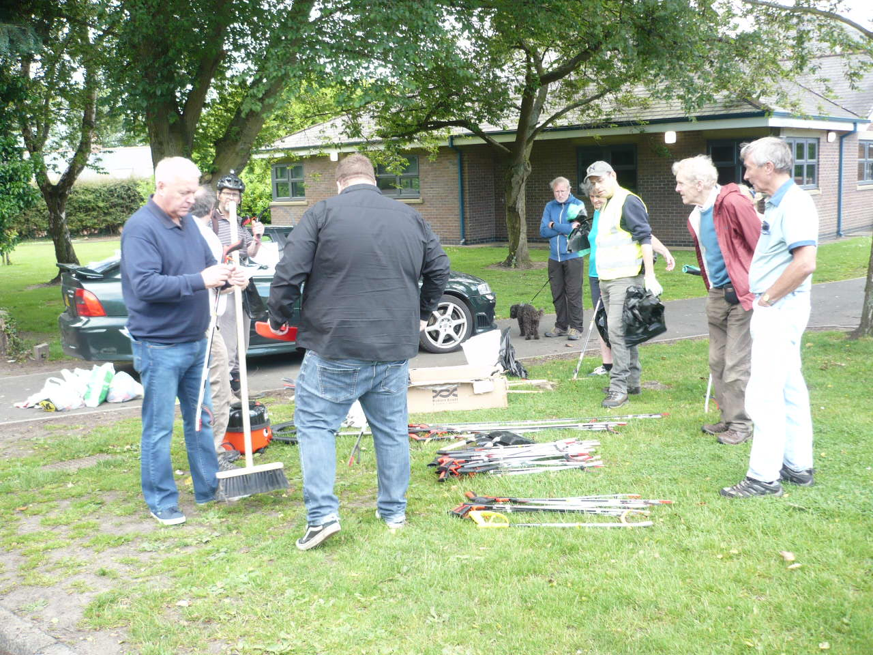
A REPORT SPONSORED BY GREATER MORPETH DEVELOPMENT TRUST
Supported by Local Businesses

Table of Contents
ACKNOWLEDGEMENTS 3
INTRODUCTION 4
History of Morpeth Litter Group 5
SECTION 1: The 2020 “blitzes” and other activities 5
1.1 GMDT/MLG Local business meetings – 13th January 5
1.2 Friends of Kirkley Hall presentation - 12th February 5
1.3 Prince’s Trust team – 27th / 28th February 6
1.4 Morpeth Litter Group’s KBT Ambassador Burn Clean-up 6
1.5 2020 LITTER BLITZ 1: 26th July – Town Centre 6
1.6. New Hotspot Clean-up St George’s Hospital – 2nd August 2020 7
1.7 2020 LITTER BLITZ (am: Town centre), (pm: Stobhill) - 30th August 7
SECTION 2: OTHER ACTIVITIES IN 2020 8
2.1 Morpeth Rotary Club 8
2.2 KEVI school 2019 Litter Improvement plan – planned 19th June 2020 8
2.3 Sale of cigarette butt pouches: 8
2.4 Wombling Wednesday events 9
2.5 Adopt a Street 9
2.6 Corporation Yard clean-up 9
2.7 100 bag challenge 10
2.8 Morpeth Litter Group Facebook page 10
SECTION 3: PLANS FOR 2021 11
3.1 Morpeth businesses’ support 11
3.2 Morpeth Litter Group’s Adopt a Street / Location 12
3.3 Morpeth Litter Bin – new school posters 13
3.4 Joint Partnership with NCC to tackle verge clean-ups 13
3.5 Landscaping in partnership with others 13
3.6 Bin Management and options 13
3.7 Inside Morpeth article 14
3.8 John Beynon’s Adopt a Bench 14
SECTION 4: CONCLUSION AND 2021 MLG STRATEGY 14
SECTION 5: Key Latest updates 16
5.1 How to Report new issues in 2021 16
5.2 Quick reference Summary of Improvements made in Spring 2021 and existing open issues 17
APPENDICES 18
APPENDIX A1: SYNOPSIS OF RECOMMENDATIONS and BIN REQUESTS 18
A1.1 Recommendations and Bin Requests completed in 2020/21 19
A1.2 Recommendations for 2020/21 22
A1.3 Bin Recommendations for 2020 35
A1.4 Reasons we should not give up! 43
A1.4.1 Why you should always wash your hands when back home!! 43
A1.4.2 This is what an area is like before a MLG Volunteer has been there! 43
APPENDIX A2: 2021 MAJOR LITTER HOTSPOTS IDENTIFIED 44
APPENDIX A3: 2021 NEW BIN RECOMMENDATIONS MAP 45
APPENDIX A4: 2021 MORPETH LITTER GROUP – ADOPT A STREET/STREET BLITZ 46
APPENDIX A5: HM Environment minister response – Rebecca Pow 47

ACKNOWLEDGEMENTS

A GENUINE COMMUNITY PARTNERSHIP
GMDT/KBT: David (Dai) Richards - 2018 Keep Britain Tidy Ambassador
KBT: Tracy Kenny - 2019 Keep Britain Tidy Ambassador
GMDT
- Hugh Edmundson (Environment Director)
- Simon Cox
MORPETH LIONS AND FRIENDS
- Chris Offord
- Richard Nash (Key role as MLG Street Blitz Marshall)
- Les Sage – Including his role as Chamber of Trade
MORPETH JUSTICE AND PEACE GROUP
- Janet Hedley
- Mary Ord
KEVI School
- Andy Clark – Deputy Head
NCC Officers + Councillors
- Nicola Wardle, supported by Carrol Plessey - Business Support and Customer Liaison team
- Paul Lowe – NCC NEAT team and Refuse/Street Bin Collection teams
- Frances Povey (Area Countryside Officer) supported by her Carlisle Park maintenance team
- Councillor Richard Wearmouth (also NCC)
- Councillor John Beynon
MORPETH TOWN COUNCIL (MTC)
- Councillor and Mayor David Bawn, Deputy Mayor Rachael Hogg
- Councillor and 2019 Mayor Alison Byard
- Councillor and 2018 Mayor Jack Gebhard
- Town Clerk Tracey Bell
- Assistant Town Clerk Joanne Wilson
MORPETH SCOUTS –at least 4 separate groups
MORPETH CHAMBER OF TRADE
- The late Ken Brown
- Les Sage
MORPETH ROTARY
- Colin Dyson
- Paul Crooks
- Barry Swan (see section 4.6 for areas covered)
PEOPLE OF MORPETH – names below will not be a definitive list!
- Matias Liddle Colin Coates
- Alan and Linda Kenny Josh Burton
- Jill and Mike Pinkney Janice Ryan
- The late Adrian Barnes Tracey Sharp
- Joyce Carey Sheila McRoberts
- Diane Davies Diane Wright
- Pauline Tulloch Emma Thorne
- Margaret Lovering Pat Fuller
- Shirley Richards Lynda Heslop
- Graham and Val Langston who clear the Morpeth Dam regularly
- Jean Gregson Alex Gilmour
- Pam Thirlwell Russell and Fiona Emmerson
- Peter Maylia Janet & Barry Mason
- Pauline Williams Elle Richardson
- Plus so many other unsung heroes that give up their time every week in the fight against litter (too many to list here!)
Morpeth Ramblers – at least 3 separate groups now picking up litter in the far reaches of Northumberland
Wansbeck MP Ian Lavery for Raising issues in Parliament and relevant departments
ADOPT A STREET Volunteers – 100+ people now involved, with full 72 people actively Adopting a Street

INTRODUCTION
The 3rd “End of Year” Annual report from the Morpeth Litter Group (MLG) outlines the results of our litter picking activities held during this difficult Covid-19 pandemic impacted year. To have achieved anything at all has been a major accomplishment by everyone, since the virus restrictions have been serious blockers to any group activities. It has been so pleasing to see enthusiastic individuals going the extra mile to complete the clean-ups, and to see the success of the new Adopt a Street initiative, despite the lockdown constraints placed upon us.
Over the year, Northumberland County Council NEAT team have been extremely busy. This report aims to reflect some of their efforts that have been observed when walking around the town in the preparation of this report. Special mention must be made of the major clean-up of the large mounds of detritus/fly-tipping in Morpeth Town AFC’s Craik Park. Our sincere thanks to NCC NEAT team for their efforts. Over the year we appreciate that with stretched resources, NCC NEAT team have had a huge impact on the battle against litter.
This year, Tracy Kenny has put in a phenomenal effort with her many new Morpeth initiatives. These include the weekly Wombling Wednesday event plus the growth of Adopt a Street. Both support our commitment to voluntary community activities.
Working in partnership with Northumberland Council Environment team (leader Paul Lowes) and Nicola Wardle (Business Support and Customer Liaison team), we have been able to keep Morpeth Town area relatively clear of detritus. Provision of new equipment has continued, especially for the Adopt a Street initiative.
Morpeth Town Council (MTC) has again supported us by the movement/provision of bins and the fitting of new butt ashtrays on a number of bins. We again thank MTC for their support.
It is pleasing to see the people of Morpeth recognise our efforts and we ourselves can see that our efforts are keeping our wonderful town much clearer of litter. However, we are under no illusion that the battle against litter is anything other than a never-ending task. This year our report continues with the old and adds new suggestions which we consider are important in the battle against litter. For the first time, we are highlighting issues which NCC might consider raising at Government Environment Department level, especially the Environment Agency and Department for Environment, Food and Rural Affairs (DEFRA).
This report records the results of:
- the few 2020 litter Blitz events
- the Wombling Wednesday events that took place in September 2020
- the new Adopt a Street initiative
It’s impossible to cover the extensive work of all the MLG’s individual activity but the report does include some recommendations raised by MLG volunteers who are looking for County / Town / National level support to address the problems they are encountering. This community partnership is essential to win the war against litter.
We are fully aware that our suggestions may have resource or financial implications. We ask that the owner of the issue raised here, considers the request by bearing in mind the resolution of the issue will address something that an MLG volunteer feels is important. It champions the Working Together ethos that is an essential part of this Community Initiative.
As an example, installation of additional bins could be addressed by:
- replacing single-use doggy bins with multi-use blue bins
- replacing bins in locations which have 2x120 litre bins with a single 240 litre bin, thereby avoiding any increase in the number of bins to empty
- moving low-used bins to new locations and possibly looking at new technology with street cigarette receptables.
New technology is available where using new ENEVO sensors - bins can report back their FULL status – could this be something NCC NEAT team could consider to support, thereby increasing the number of bins around the town?
This year we again ask MTC to consider the approach of allowing bins to be ADOPTED by local businesses. Evidence has shown that this approach has been successful with many other local authorities around the country. It increases the number of bins but has no increase in the number of bins to be emptied by NCC NEAT team. This we feel is a win-win situation. Having businesses step forward to keep Morpeth litter-free, shows that everyone is working together.
Covid-19 pandemic is an ongoing challenge for everyone. Littering does not go away but we are confident that with a positive approach towards continued improvements in 2021, we will further reduce littering on our streets and the town’s green areas.
It is important that the authorities don’t view the MLG work as a permanent supplementary activity/resource, but more as a partnership where we are working together to address the problems of littering.
This report will be published on the GMDT website, and will be disseminated to Northumberland County Council, Morpeth Town Council and King Edward VI School Morpeth, Keep Britain Tidy and other local groups involved.

History of Morpeth Litter Group
The arrival of a Cavalier King Charles Spaniel (Alfie) and subsequent retirement, started a daily walking routine for Dai Richards. This brought into focus the scale of litter everywhere. It became a constant annoyance to him, so much so that with NCC’s help in providing a litter picker, he began picking up the detritus along Castle Walk and the Cenotaph regularly as he walked Alfie. A new bin was placed at the Cenotaph, a doggy bin in entrance to Allery Banks moved to Mafeking Roundabout and a doggy bin replaced with a blue bin at the Sun Inn Newcastle-bound bus stop: all by MTC and we could immediately see a general improvement in the area becoming much less cluttered with litter. Other dog walkers joined Dai, and the Deuchar Park Litter group was spawned. In December 2017, an area at the top of the Carlisle Park Burn was identified as an issue by a member of the group – the scale of litter was just enormous and was too large for the small litter group. The Litter Blitz idea was spawned, and with the support of members from Greater Morpeth Development Trust (GMDT), Morpeth Lions, Deuchar Park Litter group and people of Morpeth we arranged the first ever Litter Blitz on 11th February 2018 – it was a freezing cold afternoon but the whole area was cleaned up in just 90 minutes. We became aware that a number of community organisations and individuals around Morpeth were involved in voluntary random litter picking but there was no organised regular activity. With NCC support, equipment was purchased and arrangements for disposal of all bags made with NCC NEAT team. Monthly litter blitzes were set up – the response was phenomenal! It was timely since the outrage against litter was becoming a national concern with people wanting to make a difference.
The group’s primary objective is to supplement the County and Town Councils’ activities in as many areas of the town as possible, and to tie this into the Northumberland or Britain In-Bloom inspections and national Keep Britain Tidy (KBT) events such as the Great British Spring/Autumn Clean-ups. Working in partnership is our key mantra, understanding the limited resources available from the NCC and MTC teams in trying to keep Morpeth Town free of litter.

SECTION 1: The 2020 “blitzes” and other activities

1.1 GMDT/MLG Local business meetings – 13th January

GMDT Environment director Hugh Edmundson and Dai had separate meetings with the following businesses:
- Sanderson Arcade: Discussed the opportunity with their employee’s suggestion to Adopt a Bin in Lumsden Lane by Morpeth Comrades’ Social Club.
They also provided a sample of spray they use to remove chewing gum from their slabs in Sanderson Arcade.
They advised separately that senior managers don’t support cigarette butt trays on their buildings’ walls. Sample provided which has been trialled on Corporation Yard clean-up.
- Lidl Management: The management team confirmed that they do endeavour to keep the car park free of litter. They stated they would like to see the provision of a full-size bin on Stanley Terrace to help reduce the scale of litter.
- Morrisons Store: They promised to look at the provision of the fine mesh for their Delivery area (confirmed in January 2021 that it has been erected).
They will also look into maintaining the bushes along Tommy’s Field.
They confirmed they are committed to keeping the fountain area clear of detritus.

1.2 Friends of Kirkley Hall presentation - 12th February

In Autumn 2019, GMDT Environment director Hugh Edmundson received a request from Margaret Lees, Friend of Kirkley Hall, asking if the MLG could present some slides documenting its success. Over a 2-week period, our KBT Ambassadors pulled together a set of slides titled ‘Litter and flytipping – the scourge of our times’ outlining the success of the group over the past 2 years. Dai and Tracy Kenny delivered a 45-minute presentation with a further 30-minute Q&A session. Feedback from the audience of about 50 people was very positive.
We hoped it was a thought-provoking session and made people go away with a goal to make a difference by getting involved in tackling their local litter problem and at the same time protect our wildlife etc.
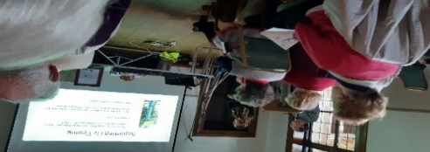

1.3 Prince’s Trust team – 27th / 28th February

For two days, a team of three Prince’s Trust teenagers, supported by two adults, tackled litter around Stanley Terrace, Dark Lane and the upper and lower levels of Morrisons’ car parks.
With Dai’s support, the bushes along Tommy’s Field fence were cut back to gain access to the heavy scale of litter present there. Over two days, 16 large black bags were filled. It was very kind of Morrisons’ management to provide a full English breakfast to the team as a thank you for their efforts. This was much appreciated on a very cold day.

1.4 Morpeth Litter Group’s KBT Ambassador Burn Clean-up

On 22nd March, Tracy and Dai blitzed the heavily hit area at the rear of the field that backs onto Carlisle Park / Burn area and next to Castle Close. Over a 90-minute period, 7 full black bags were collected and a request raised with NCC for NCC NEAT team to pick up the large items left from the November 2019 bonfire night. Full Covid-19 national lockdown started the next day on 23rd March 2020!
See RB10 and Hotspot 2 identification, for requests to look at how we can get on top of this area.

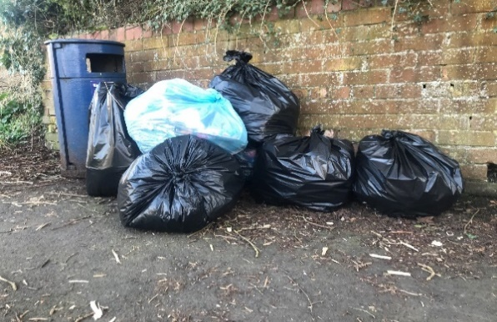
Collection of bags post clean-up

1.5 2020 LITTER BLITZ 1: 26th July – Town Centre

The fact this was our first litter blitz of 2020 shows how the year’s plans were decimated by Covid-19. It was carefully organised with arrangements put in place for people to meet as follows:
- Equipment (litter pickers, gloves and bibs) cleaned in preparation for the event (washed after each event).
- Registration of all volunteers to adhere to Track and Trace requirements, data held per Track and Trace rules.
- Hand sanitiser provided for volunteers to clean their hands pre- and post-event.
- Disposable gloves provided for all volunteers
- Max size of groups 2 for each route – wherever possible, grouping with a friend.
A fantastic turnout, 19 people came along and 27 large black bags were filled.
A number of new volunteers came via our Morpeth Litter Group Facebook page, with a request to help from a volunteer re the new Hotspot at St George’s Hospital – it was agreed that a small team would meet the following Sunday 2nd August. See below.
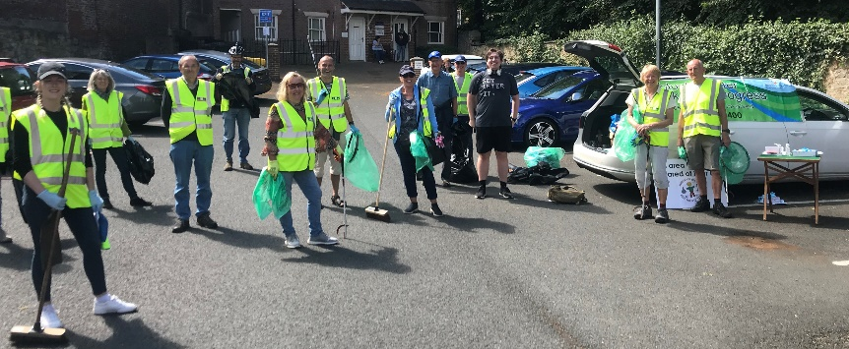
See table on RHS which was used for registration and hand sanitisers.

1.6. New Hotspot Clean-up St George’s Hospital – 2nd August 2020
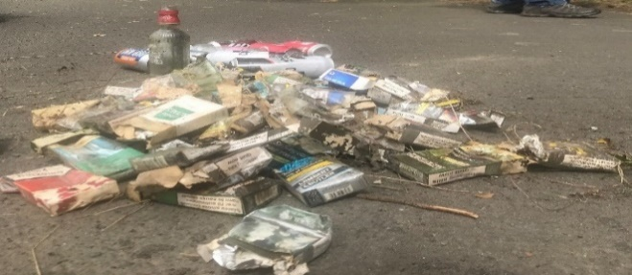
Pile of empty cigarette packs
A team of 5 people turned up plus an additional supporter (a hospital patient) who was a great help. The scale of litter was just astounding:
- 100’s of empty cigarette packets
- 1000’s of cigarette butts
- Numerous cans, plastic bottles, glass bottles
In total, 5 large black bins were filled up here. See photo above showing the pile of cigarette packets.
See RB14 for request for a trial bin (minimum) to be put in this area see also the latest photo 27th January 2021 (the huge scale of litter has reappeared). Without a bin here this new hotspot will just get more and more heavily polluted with detritus. It’s clearly a popular area where litter will be dropped. It is also a popular dog walkers’ route – a blue bin would help here.

1.7 2020 LITTER BLITZ (am: Town centre), (pm: Stobhill) - 30th August

We didn’t know at the time that this day would be the last time we could organise a large-scale litter blitz. Working within the constraints laid down by KBT and the UK’s Covid-19 guidelines, we organised 2 separate events am – coordinated by Dai, pm – coordinated by Tracy, ensuring social distancing at all times.
Another excellent effort with 23 large bags (photo below) filled by 17 people at the Stobhill event and 8 large
bags by 6 people at the Town Centre event.
Numerous residents of the Stobhill estate and others gave their thanks to the volunteers, recognising their tremendous efforts in picking up the litter – lovely to hear their appreciation.

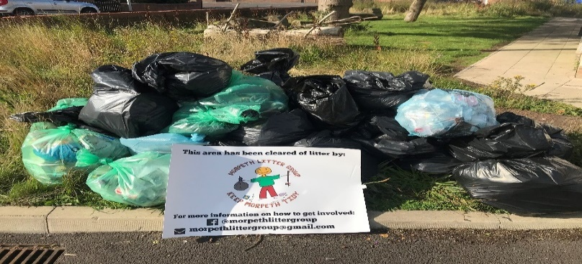

SECTION 2: OTHER ACTIVITIES IN 2020

2.1 Morpeth Rotary Club
At the start of the year, Morpeth Rotary Club promised to investigate how their members could help with the Keep Morpeth Tidy endeavour. Their commitment was excellent with the following ownerships taken on:
- Dacre St., St. James car park, Morrisons underground car park adopted with a weekly/bi-weekly clean-up.
- A192 Shields road – Rotary Glade – Rotary members worked in 2 pairs of 2 people with a commitment this is done monthly.
Our sincere thanks for their support – it is great to see other groups helping to keep Morpeth tidy.

2.2 KEVI school 2019 Litter Improvement plan – planned 19th June 2020

It was agreed in late 2019 that in June 2020, a new approach would be taken with the KEVI litter blitz. It would be a “whole school litter pick” involving all students. Arrangements were made in June 2020 to provide a comprehensive set of equipment for KEVI school to organise their new KEVI litter blitz event. With the support of NCC NEAT team, additional litter pickers, bags, gloves were booked and cleaned in readiness – COVID-19 put a damper on this with the event having to be cancelled.
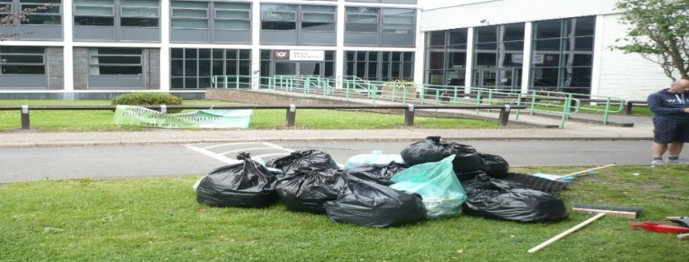
Some of the litter collected at KEVI in 2019

It is hoped this event can be rearranged for a June 2021 date.

Walking around KEVI school ground recently showed that the school area has substantially less litter around. Andy Clark, Deputy Head, advises that the key message of looking after the environment/litter is discussed at assemblies and tutor time. Duty staff also tackle litter at breaks and lunchtimes. This team effort is making a difference.
Summarising:
- Communication with students via assemblies and tutor activities.
- Communication with duty staff to be proactive with littering.
- More bins better placed around the site.
- There is a noticeably improved attitude towards litter at break and lunch.
- School Council whole school consultation on the environment.
- Groundsmen are actively emptying the bins regularly, ensuring they are available for use

2.3 Sale of cigarette butt pouches:
A trial was started to see how popular the sale of new cigarette butt pouches would be. With the support of Newgate News, they allowed our product to be sold in a prominent place at their counter. Generously, 100% profits from the sales are given to MLG.

Our sincere thanks to Newgate News. In addition, they use the MLG collection box to accept small change from their customers – this has resulted in a collection of over £20 in the past 6 months.

Sales of the pouches are not very high - we estimate it will take some years to sell our 50 pouches - but having them on sale is an opportunity for smokers to buy a safe pouch in which to collect their butts and it is often a topic of discussion in the shop.
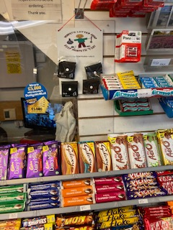
Pouches for sale in prominent place near the sweet counter

2.4 Wombling Wednesday events
Tracy K wanted to start a weekly litter-picking activity for a small team, so created the Wombling Wednesday event. This started in September and for 90 minutes each Wednesday, six people joined Tracy to complete a clean-up. A number of areas were tackled - Newgate St., Morrisons upper car park, Stanley Terrace, car parks around the leisure centre. Dai also supported the events after completing his one-hour Corporation Yard deep-clean that started at 12 noon each time.
7 large black bags collected on 2nd Sept,7 bags on 9th Sept, 6 bags on 16th Sept. Changes to government COVID guidelines blocked all events from 23rd September

2.5 Adopt a Street
Tracy K has been championing this new initiative which allows an individual to support the Keep Morpeth Tidy campaign on a solo basis, but at the same time stay within the rules set down by any National Covid-19 tier restrictions or Tier lockdown.
Using the new Morpeth Litter Group FACEBOOK page, 80 new volunteers have stepped forward to Adopt a Street / Location on or near their doorstep. The scale of cover across Morpeth has grown substantially – see Appendix A4 for current maps showing areas of Morpeth “adopted”.
Our thanks to NCC teams Nicola Wardle/Carrol Plessey for the new litter pickers and NCC NEAT team for the new bags and agreement to collect the full bags that are being deposited around Morpeth on a daily basis.
Look out for black bags with the MLG Logo on them – these have been filled by an Adopt a Street volunteer. The location of any such bags are always reported to NCC NEAT team who promptly arrange collection – THANK YOU.
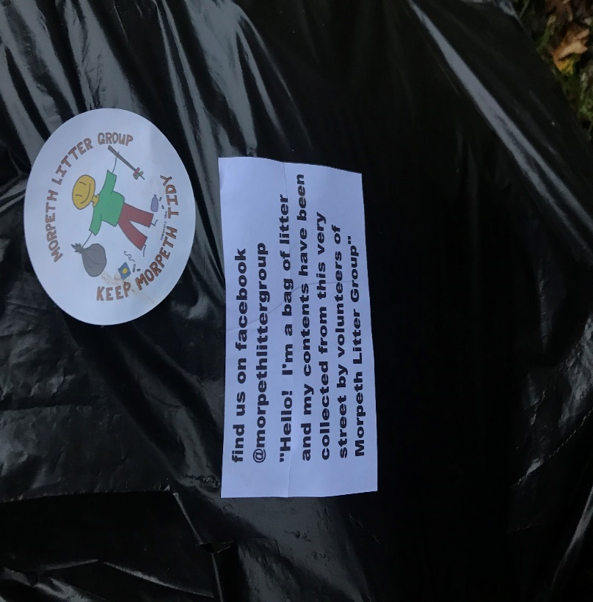
Example of stickers put on full black bags by Adopt a Street volunteers

2.6 Corporation Yard clean-up
Dai had the idea to complete a deep cleanse of the yard. With Tracy K’s support, starting at 12noon on the first Wombling Wednesday, the following cleanse took place:
- Full hard brushing of the yard
- Removal of the chewing gum splattered all over the ground
The difference was amazing – weeks later it is starting to return to an untidy state with high number of cigarette butts and other pieces of detritus in this area. As a main entrance to Bridge Street. See RB7 recommendation for a new bin plus photo of heavy littering here. Heavily hit also by cigarette butts. Area is being often cleaned up by a MLG Adopt a Street volunteer.

2.7 100 bag challenge
In November, Tracy Kenny set herself a challenge to collect 100 large black bags of rubbish in a total of 24
hours, tackling two areas not previously blitzed by MLG:
- Coopies Lane Industrial Estate
- Layby opposite Dobbies/Heighley Gate
The layby opposite Dobbies was one of the worse litter hot spots the group has collectively come across, with 75 bags of litter collected from this small area. This essentially broke the back of the enormous amount of the long-term litter left within the wooden area next to the layby, but it was observed that much more work would be needed to really get on top of the problem. The wheelie bins in situ need replacing/repairing and mounting properly on a solid surface. Some have missing lids on bins. In December Russell and Fiona Emmerson who live nearby bravely offered to adopt the layby and will be chipping away at it over the next few months but they also share the view that the state of the bins provided need addressing to encourage layby visitors to at least use them. See R7 for Recommendation for bin improvement at the layby.
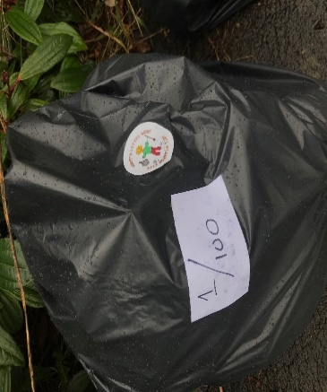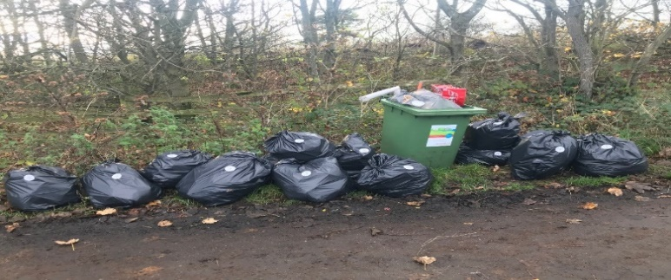
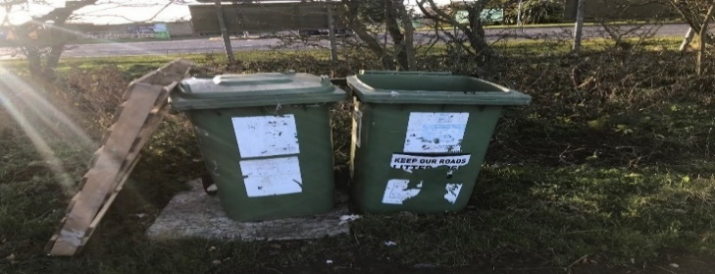
Photos from Heighley Gate Layby clean-up
As part of the 100 bag challenge, Coopies Lane, Coopies Field and Coopies Way were all tackled with 25 bags collected. Much more work needed to really make an impact on the scale of litter in certain areas within the estate.
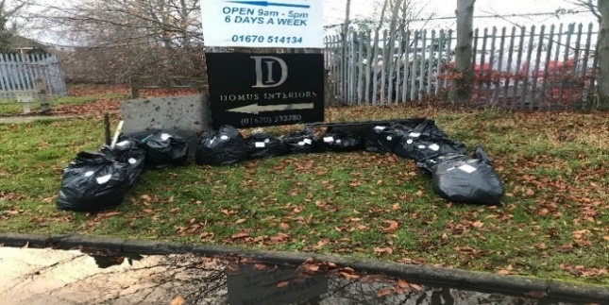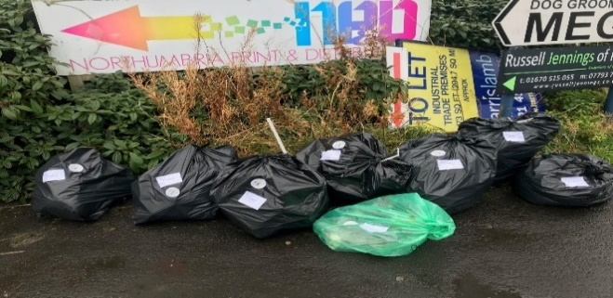
Photos from Coopies Lane clean-up

2.8 Morpeth Litter Group Facebook page
See Morpeth Litter Group Facebook page: https://www.facebook.com/morpethlittergroup/
In 2020, Tracy K developed the new Facebook page. Regular weekly posts featuring a mix of fun and
interesting stories have helped to boost engagement with shares, comments and likes which have organically grown month-on-month. One of Tracy’s posts about a group of volunteers rescuing a baby hedgehog from a pile of litter in Oldgate, won 2nd prize in a Keep Britain Tidy national competition.

The page now has 340 followers, from which 80 new people stepped forward to become Adopt a Street volunteers. Plans are underway to set up a separate closed Facebook group specifically targeting Adopt a Street volunteers to help with tracking progress, litter bins being used and areas being adopted. Additionally a new Adopt a Street website will be built in 2021.

SECTION 3: PLANS FOR 2021

3.1 Morpeth businesses’ support
This was originally planned for 2020 but Covid-19 blocked this activity. It is hoped in 2021 that we can look again at this set of proposals. Post Covid-19 will be an opportunity to regenerate our country and Morpeth Town centre needs everyone to see what they can do. We are hoping Morpeth’s Business Community can help the MLG volunteer activity, by working together to keep Morpeth Town centre free of litter.
Keeping Morpeth free of litter attracts visitors, increases footfall to shops and contributes to the Britain in Bloom and Northumbria in Bloom competitions.
The following programmes could be key contributions to Morpeth’s COVID19 recovery plan:
- ADOPT a BIN: Increasing the number of bins is always curtailed by the limited NCC NEAT team resources. The Co-op store and Cooplands bakery at Loansdean have set a standard which it is hoped other shops in Morpeth could match. Target businesses could be:
- Takeaways / Coffee shops e.g. Boulevards, Pizza Express, Morpeth Fish and Chips, Greggs, Costa, Harrys Bar and others
- Shops / Newsagents e.g., Iceland, Newgate News
The MACE shop at St Mary’s Field has had, since opening, a small litter bin to the left of their entrance
door. It is greatly used by their customers and emptied more than once a day. If that bin wasn’t there, the
scale of litter would be much worse outside this popular shop. The shop owners, at their own cost
dispose of the rubbish collected.
See small bin to left of main door
The 2 new stores at Loansdean – Co-op and Coopland bakery shop have adopted their own bins outside their shops. Speaking to Co-op management, they ask their cleaner to empty the bins each day as part of their duties. Both companies have support from their HQ where the rubbish collected is taken away by the company’s delivery staff. They find this arrangement works very well and keeps the scale of litter around the area low.

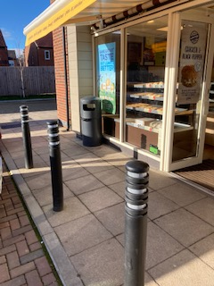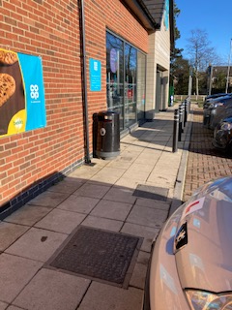
Coopland bakery bin Co-op bin
In June 2021 – Penfold Convenience store have started to support the fight against litter by putting out and emptying a bin outside their store – our sincere thanks to the Penfold team.

- MULTI-USE COMMERCIAL BINS: It has been suggested previously that the commercial bins could be used by the general public. Could we work with businesses and place signs at the location where a commercial bin can be used by the general public? Best example of this, are the bins at the back of Lollo Rosso restaurant and its potential to be supporting the end of Whalebone Yard car park.
.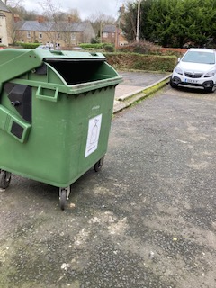
Bin at the back of Lollo Rosso restaurant
- BUTT RECEPTABLES: The Joiners Arms led the way in 2019 with their commitment to the clean-up of their patrons’ cigarette butts which accumulated outside their business, especially at their side entrance. They put up an elegant chrome cigarette butt receptable and once a week hoovered up the butts that still collected in the cobbles. The difference was amazing. Could we encourage other businesses to do the same for their premises? For example:
- Black Bull – numerous butts and a substantial amount of detritus constantly sits outside the main entrance, at the front to the left of their Bridge Street entrance. Outside lockdown, the scale of butts flows onto the kerbside of Bridge St. and blows over to the south side.

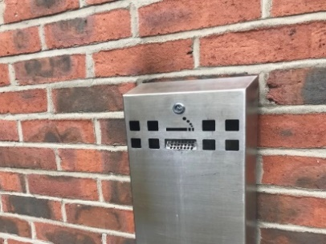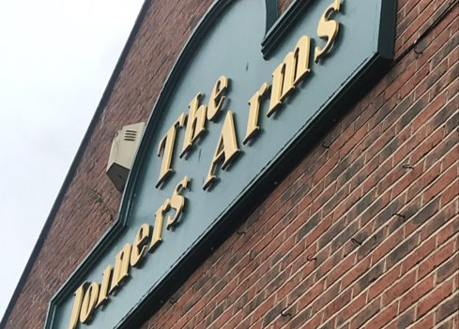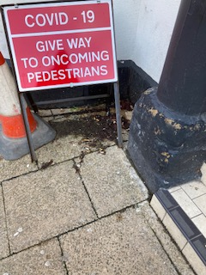
Silver cigarette receptable fitted on side of Joiners Arms. Area to left of Black Bull main entrance
- Restaurants.
- Staff butt receptables for main street stores
Two businesses are being mentioned due to the high scale of butt detritus behind their premises:
- Costa
- Boots Optician Hearing care
See R29 for photos of rear of the shops and heavily hit by cigarette butts.
Can NCC / MTC put in place a local by-law that enforces pubs and restaurants to provide cigarette receptables in suitable places where their patrons / employees go for a smoke? This may be required in more than one place if for example patrons smoke both in front and at the rear of the premises.
Grade 2 listed buildings regulations may stop us putting a receptable on an external wall – this issue has been raised by Dai with KBT to discuss with HM Environment minister, we need some flexibility here.
- Keep Britain Tidy’s 2019 #BINTHEBUTT campaign has made available posters and beer mats which we can use. It would be great if these could be used in 2021.
- SWEEPING THEIR FORECOURT: Design a new poster where businesses can display their commitment to the cleanliness of our town. The business commitment is to daily brush the front of their shop.
The following businesses already show their commitment – our sincere thanks for their support:
- Chisholms Betting shop
- Waterford Lodge
- Pet HQ
These three businesses show their commitment to keeping Morpeth litter-free and having pride in the area in front of their premises, especially the removal of cigarette butts on the pavements and market place.
Businesses used to sweep the front of their stores – how can we encourage shops to recommence this 5-minute activity at the start of their business day? A new poster – showing we clean our forecourts /pavements would show the people of Morpeth they care about their community and could be a way of improving footfall. (See appendix action R8).
- SILVER FOIL: It has been observed that there is an increase in silver foil being littered around the town centre, especially after a weekend. We need to ask all businesses to avoid using silver foil in food takeaways. Morpeth Litter Group KBT Ambassadors will make contact with the shops creating this problem.

3.2 Morpeth Litter Group’s Adopt a Street / Location
In an attempt to move away from monthly litter blitzes in Morpeth, articles will be posted on all media asking for people to come forward and adopt their street / location. Targeting dog walkers especially – we hope to expand to other areas of Morpeth, not currently covered, so more streets and parks are cleaned on a regular basis. The 2020 success has been astounding, and could result in the regular Morpeth litter blitz events being not required allowing us to help NCC in other towns in Northumberland to encourage new litter groups.
For this to grow further we will need help from Nicola Wardle / Carrol Plassey and NCC NEAT team as follows:
- NCC to provide another large number of litter pickers – it is recommended NCC purchase of 20 x 3ft Helping Hands litter pickers, lessons learned is that other manufacturers are just not robust enough for intensive use.
- NCC NEAT team to provided support to either pick up bins from individuals homes or bin locations around the town. Improving the ‘Report a problem’ website to allow ‘Report a full bin’ plus NCC NEAT team number the bins to ease reporting. We also need to look at building a record of the most used street blue bins by MLG Adopt a Street litter pickers so NCC NEAT team can schedule more frequent bin-emptying.

3.3 Morpeth Litter Bin – new school posters
The existing school posters on the side of our street bins are brilliant (designed by 1st school students) but are all looking a little tired and, in many places, are peeling off. Dai has been advised, by someone who was involved with the original posters, that they are over 20 year old. It is suggested that we have a new school project or competition, asking for the local Junior schools to organise new posters to be placed onto the bins. This would be a great message to our youngsters to take their litter home or put it in a bin. It would also align with Post Covid-19 regeneration.
Similarly, to existing arrangements, Morpeth First schools to have their own winners and posters selected. See R9 of MAIN REPORT for recommendation raised.

3.4 Joint Partnership with NCC to tackle verge clean-ups
MLG volunteers would like to help NCC NEAT team to tackle the large scale of litter along roadside verges.
It is important that is done in a safe manner, working partnership, NCC provide the traffic light / men at work
roadside signs, allowing the MLG volunteers to tackle the roadside litter, in safety. Is there any merit to this
proposal? This has already been undertaken in some parts of the town’s highway network.

3.5 Landscaping in partnership with others
It has been proven that beautifying an area with landscaping and planting flowers making it aesthetically pleasing on the eye, substantially reduces the scale of litter.
In 2021, MLG volunteers would like to work with NCC / MTC to look at poorly maintained areas to consider landscaping. See also 3.8 below for family adopting a bench.

3.6 Bin Management and options
The number of bins around Morpeth is always limited by the impact on NCC NEAT team resources to empty the bin. Have NCC/MTC considered the options available from ENEVO and GLASDON to provide cost effective bin management solutions? For example:
- ENOVO WIFI Bin management tool WWW.ENEVO.COM
Solutions – Enevo
Newcastle City Council have a blog about their experience using the service provided by Enevo
What Newcastle’s waste data told us about COVID-19 – Enevo
Has NCC looked at this product and is it something that could be cost effective for management of Morpeth Town bins?
- Glasdon 240 litre bins.
Morpeth Town Council purchase the 120Litre Futuro bins.
FUTURO 120L £409 JUBILEE 240L £650
Could the purchase of the larger JUBILEE 240L bin: Glasdon Jubilee™ 240 Wheelie Bin Housing
be more cost effective as a solution especially in the town locations where 2 Futuro 110L bins are placed?
Note: Glasdon advise bulk purchase is required to obtain the same blue colour as Futuro bins.

3.7 Inside Morpeth article
We were fortunate to have a lovely full page article in the September GMDT Inside Morpeth magazine. This generated a lot of interest, encouraging new volunteers to come forward and get involved. 15 people to get inv15 people got involved with the Adopt a Street venture as a result of this article. In 2021 we continue to work in partnership with GMDT, our thanks to GMST for a £200 donation which has enables us to provide Litterpickers for St Roberts school who are adopting Carlisle Park , clean-ups in progress each Friday.

3.8 John Beynon’s Adopt a Bench
At the request of a local family, Town Councillor John Beynon has worked with NCC to have a new
Bench installed at the entrance to Deuchar Park. The bracken behind the bench has been cut back, creating a
lovely spot to rest and chat with friends. The cutting back of the bushes has enabled MLG Adopt a Street
volunteer to get access to any litter that is deep into the woods. All costs for the bench including fitting has
been covered by the local family and has been adopted by them. Could this idea be considered in many areas
around Morpeth to beautify the given location and give people pleasure sitting watching the world go by?
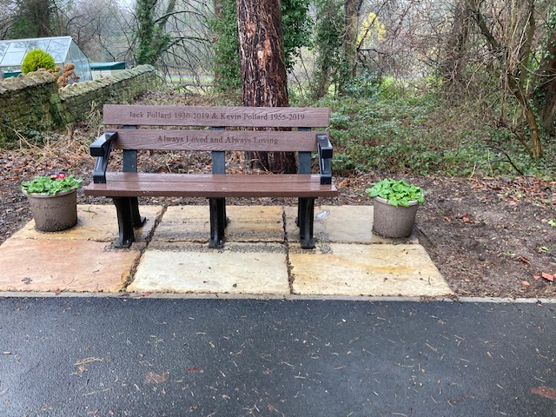

SECTION 4: CONCLUSION AND 2021 MLG STRATEGY
4.1 The first litter blitz planned in February 2020 was thwarted by severe high winds, stopping the planned
clearance of the layby opposite Dobbies’ Heighley Gate. The March litter blitz was also stopped by bad weather and then the Covid-19 pandemic hit the country, with the national lockdown decimating any attempts to have an MLG litter blitz.
The various tier restrictions have also limited what the group could undertake, but when you look back over the year, the Community team (MTC/NCC/MLG) should be very pleased to see what has still be achieved.
4.2 MTC have modified a number of bins with the new cigarette butt trays, it is hoped that over the coming years, further improvements will be made to bins. New bins have been installed across the town. Any new bin is being purchased with the new cigarette trays and some doggy bins have been replaced with dual use bins. These achievements have helped us in this continual battle against litter.

4.3 NCC NEAT team have addressed a number of issues raised in the 2019 End of Year report. Some have been substantial achievements e.g. the huge piles of rubbish that were along one side of the Craik Park car park. They have quietly removed this, asked for no thanks, but what a difference the team has made to the car park that has become much more heavily used because of Morpeth Town FC’s success, and is visited by people from all over the country. Again this has improved the image of our town.
Town centre hedges have been cut back making the whole town much easier to keep clear of litter. Special mention for their efforts at St James’ car park which is now much lighter and safer for volunteers to clear any litter along the church wall.

4.4 After being furloughed during COVID-19, Tracy Kenny was able to commit more time during 2020 to MLG and tackle areas such as:
- Heighley Gate layby
Setting a target to clear 75 large black bags of rubbish, taking 24 hours over 10 days to clear the woods in this area.
- Coopies Lane Industrial Estate
Tracy hit the whole industrial estate and over 3 days cleared 25 large black bags of rubbish. This area has never been blitzed over the 3 years of MLG blitzes.
- Facebook Page
Tracy has developed the new Morpeth Litter Group Facebook page. The articles have been funny and interesting and sometimes sad, especially when we read about wildlife being killed by some item discarded by a human. We now have over 300 followers. A fantastic achievement which has encouraged over 80 new people to take on an Adopt a Street role.
- Hedgehog Post
Tracy won 2nd prize in KBT’s National scene for the most interesting article. Her subject was the young hedgehog she found amongst a pile of litter during an event, which was taken to an animal sanctuary for medical assistance.
- Wombling Wednesday
When we were in a lower tier category, Tracy organised weekly Wombling Wednesday 6 person events where for 2 hours the team blitzed areas of Morpeth. This was well supported but was again thwarted by Covid-19 restrictions. We hope these can start again in 2021 when restrictions are lifted.

4.5 It was planned that MLG’s KBT Ambassadors would support a new KEVI litter blitz event, where, on a given Friday in July at 3:45pm the whole school would be asked to clean up the school grounds of any litter. This was to be widely supported by teachers and students – again thwarted by Covid-19.
We will endeavour to look again at this in 2021 – pandemic pending of course. Feedback from Mark Simpson, Former Deputy Head, was that with school and caretakers’ support, many of the improvements raised in last year’s report have been actioned. The school grounds are definitely tidier this year. With MTC fitting a new blue bin at the gate of the KEVI rugby fields, the scale of litter in this area has been greatly reduced.

4.6 Morpeth Rotary Club members have stepped forward to hit a number of areas in Morpeth. The A192 Rotary Glade has been fully adopted and is being kept clear of litter. Barry Swan and team now cover 4 town centre car parks, 1) Lidl 2) Dacre Street 3) St James and 4) Morrison’s underground plus Dacre St, Dark Lane opposite Morrisons (2 bus stops) and Howard Terrace. Our sincere thanks to Morpeth Rotary Club in supporting us.
4.7 Morpeth Lions members have adopted Curley Kews banking and the section from the Co-op roundabout to Clifton. Our sincere thanks to Lions members Chris and Richard for their support.

4.8 Adopt a Street has taken off in the last half of 2020. Despite the Tier 3 and national lockdown restrictions in place, we have still been able to get over 43 individuals taking on a section of Morpeth, keeping the area clear of litter. Our sincere thanks to Nicola Wardle and Carrol Plessey for the provision of new litter pickers for the venture. We hope this can grow further in 2021 – there are still a number of hotspots that need to be covered e.g., Church Walk behind the shops. But the more Adopt a Street grows, the less work there will be for NCC NEAT team and MLG.

4.9 This report makes a number of recommendations and bin requests. We understand this constant raising of issues can pressurise MTC and NCC teams, with their limited and often shrinking resources, but the battle against litter is a continual fight. As part of Continuous Improvement with MTC and NCC Council support, we can further enhance our defence in the battle against litter. It is fully respected and recognised that financial and manpower resources will be constraints when addressing any issues. We identify these issues hoping they can be addressed without impacting the constraints currently on councils and businesses.

4.10 It was our hope that we could engage with Morpeth’s Chamber of Trade to build upon our initiative, by asking its members to take responsibility for helping to keep the town clean where they promise to brush the area front their store. This would have included new design and printing of new BUSINESS HELPING MORPETH FIGHT AGAINST LITTER posters they could display proudly at the front of their premises.

4.11 Our new Business Adopt a Bin initiative will be emotive – but if it increases the number of bins in our town
centre, and remove the need for street placards/billboards, it can only help the town in this fight against litter.
When Dai is picking up litter along Bridge Street during the week, it is amazing to have so many visitors to Morpeth expressing their thanks and saying what a lovely and tidy town Morpeth is. People say they come to Morpeth since it is so tidy. These are future customers for our shops. How can shops help to keep Morpeth Town free of litter?

4.12 We do not expect all suggestions to be taken up, either for resource/financial constraints or practical reasons, but hope that our actions and report have given you some food for thought. The least we emphasise is that more attention should be given to the major hotspots identified: Stanley Terrace, Morrisons underground car park, Morrisons hedges along Tommy’s Field for example. The need to do more to reduce cigarette butt pollution is also very obvious to us.

4.13 Covid-19 has thwarted the MLG Litter cleaning activity, but Adopt a Street has definitely partly filled the gap. Morpeth continues to look much clearer of detritus but we mustn’t think we are winning. There are a number of areas where the scale of litter is very bad. Efforts in 2020 have helped in enhancing the reputation of Morpeth as an increasingly clean, litter-free place in which to live, work and visit. .

4.14 Funding will be required for our 2021 activities to enable us to produce posters, car stickers etc. We can expect Adopt a Street to grow further. Having a budget to purchase the more expensive litter pickers is essential because the cheaper versions are really a false economy solution since, they are not built to last for very regular use. As stated last year, we hope MTC and NCC can continue to help with equipment donations, but it is recognised that MTC may struggle due to the fact that the MLG is not a registered charity, but it is a non-profit making organisation, run by volunteers, and is therefore a cheap, effective means of supplementing Council resources.
.
4.15. Working with Nicola Wardle, MLG and GMDT will arrange a 2020 End of Year review meeting where the issues identified here will be discussed. Invitees from the following teams would be appreciated:
a. NCC NEAT team representatives f. GMDT Environment director
b. NCC Business Support/Customer Liaison team g. Co-op / Coopland bakery store managers
c. MLG KBT Ambassadors h. Morpeth Chamber of Trade
d. MTC Mayor and Deputy Mayor i. Morpeth Rotary Group
e. MTC Officers j. Hebron + Hepscott Parish Council

SECTION 5: Key Latest updates

5.1 How to Report new issues in 2021
This version of the End of Year Report includes the responses from NCC and MTC owners of issues raised at the meeting on 28th February and/or feedback post the completion of the meeting. Where an issue has been addressed notes from the meeting shown in GREEN. Some issues may show different ownership to the version discussed; this reflects the new “ownership” post the meeting. Ownership change can be seen by strikethroughs xxxx.
For any issues raised which you as a volunteer or originator of the request feel the issue still needs addressing, we recommend that the issue is raised as a new issue – see below process to follow:
You the reader may disagree with final decisions, sometimes strongly or you may encounter a new issue that you would like to have addressed by Morpeth Town Council. In those cases can we ask that you raise the issue yourself with your local Town Councillor, cc to Morpeth Town Mayor, in some cases cc your County Councillor to request investigation. It is expected that the Councillor will make representation for you to the Town Clerks.
REPORTING an ISSUE / Request a Change or Improvement: Refer any improvements you would like to see being made, firstly by contacting Northumberland County Council, who are responsible for litter etc on the highway. You can report any issues by phone on 0345 600 6400 Option 4 (other), option 6 (other) or by completing an online report form Northumberland County Council - Report. Select the option REQUEST LITTER REMOVAL.

So for example we have identified an issue where we think replacement of a stubber plate on a bin new Kirkhill Chemist will reduce the high scale of cigarette butts around the bin. We are being asked to follow the above process to request an improvement.

It is expected that budget constraints may stop any improvement being made in the existing financial year. If you consider the matter urgent the other option you have is to report any issue to your local Town Councillor (we recommend also cc the Town Council Mayor), and/or County Councillor who will in turn forward it to the relevant officers in the relevant council for consideration.
At all times Tracy Kenny and Dai Richards , as your KBT Ambassadors and Morpeth Litter administrators will be available in preparing your argument to justify further improvement required.

5.2 Quick reference Summary of Improvements made in Spring 2021 and existing open issues
a. Morpeth Town Council
1. 3 bins in Newgate St. have been fitted with new cigarette trays.
3. A bin near Chantry seat has been moved to other side of wall to facilitate more usage.
4. The stolen bin located opposite Jackson barber , Chantry bridge, has been replaced.
5. On 14th May – Morpeth Town Council Clerk has confirmed a new bin will be installed on Stanley terrace /
path entrance to Lidl store. At this time no details provided re installation date.
6. We awaiting a possible doggy bin conversion to dual use blue bin, bin located behind Bookers.
b. NCC
1. The Heighley Gate car park has had substantial improvements with additional Sulo bins fitted.
2. New NCC email reporting process in place, helps MLG Adopt a Street volunteers report bags to collect.
3. It is uncertain that there is regular hoovering of the Morrisons underground car park, scale of litter here is
still high. Do we need a bin placed in the far corner?
4. Regular hoovering of the Town Square has improved greatly the general appearance of a main focal point.
5. Bonfire remains, behind Church Walk, have been cleared of detritus.
6. We need the bracken cutback behind Castle Close garages – with MLG team clearing litter afterwards.
7. A new Sulo bin placed has been fitted next to the bus stop on Fairway road / Northgate roundabout, this
needs monitoring since the new Springhill estate is quite far from this bin – the dog walkers in that estate
have nowhere to deposit their full doggy bags.
8. The bushes at the back of the Railway station need trimming to enable MLG volunteers to clear detritus.
c. Network Rail / Northern Rail
1. Network Rail team have cut back the bushes at the rear entrance to station – they have also cleared the
litter there.
2. A new bin has been placed by Northern Rail Morpeth Railway staff to collect people’s cans etc before they
leave/enter the station via the rear entrance.
3. Agreement has been reached with Network rail to put up a new Cigarette Bin Receptable at the semi-circle
of the railway station drop-off area, this bin will be adopted and emptied by members of Morpeth Litter
Group.

d. Karbon Homes
1. Ownership of areas around Karbon homes has been resolved with most with NCC and MTC.
2. Karbon Homes looking at options for hotspot behind the garages at rear of Church Walk.
d. NHS
1. MLG are working with NHS to have a new bin fitted at Northgate hospital which will hopefully resolve new
HOTSPOT #5
e. Hepscott Parish Council and Hebron Parish Council
1. Hepscott Parish Council met on 20th May, they have agreed to convert 2 doggy bins to full dual bins – this
will greatly help the capture of litter around Stobhill farm roundabout.
2. David Towns Hebron Councillor and David Bawn Morpeth Town Mayor have agreed with NCC NEAT team
that a trial of a bin placed along the Morpeth Bypass – location to be identified that provide safe a
and easy access to the NCC NEAT team to empty the bin.

f. Morpeth Litter Group
1. New MLG Street Blitzes have taken off with great support, High House Lane fully cleared – 15 bags filled.
2. More and more volunteers offering their help in Adopt a Street, post Covid-19 lockdown they want to get
out and get litter from our streets.
3. Jewsons have provided us with superb Men at Work Orange bibs they are being worn when volunteers are
picking up litter along street / roadside verges – they are very clear and stand out warning drivers to slow
down.
4. Crowdfunding has raised enough funds to get more MEN at WORK Litter picking in progress signs,
ensuring volunteers are safe when working on roadside verges.
5. We have facilitated 1st time contacts with Karbon Homes, Network Rail, Northern Rail – all of whom have
been supportive in our fight against litter.
6. GMDT have been donated £200 to Morpeth Litter Group, this has been used to the purchase of 60cm Litter pickers for
St Roberts School, who are committed to each school week spend an hour Adopting Carlisle Park.
7. New Hotspot around Morpeth Castle cleared by NCC NEAT team, followed up with a deep cleanse by a team of 5
members of the Litter Group.
8. Adopt a Bin action in progress, agreement reached with Northern Rail management to put up a new Cigarette
Receptable at the front entrance to the railway station.

g. LANDMARKTRUST – Morpeth Castle Grounds
1. Support of Landmark Trust in the provision of a new bin in the grounds – bin to be adopted by members of Morpeth Litter Group. Permission obtained in June from Historic England for installation of post in a Conservation area.

APPENDICES

APPENDIX A1: SYNOPSIS OF RECOMMENDATIONS and BIN REQUESTS
(against each issue we have made a suggestion of who should be the owner.
COVID-19 impacts: In preparing the report Morpeth Litter Group reviews the 2019 issues by walking/driving around the town. Covid-19’s Stay at Home instructions has limited the amount we could achieve to confirm an issue is closed. If any issues are resolved but not shown in the report our sincere apologies. To avoid this can we ask that in 2021, all owners email the MLG KBT Ambassadors of an update when an issue has been addressed or status update. This will ensure we have more accurate representations of the efforts made by everyone.
TRAFFIC LIGHT COLOURS USED:
- GREEN: ADDRESSED – Closed
- GREY: Issued discussed and rejected by owning party
- AMBER: Morpeth Litter Group would appreciate this being addressed by 2022
- RED: Morpeth Litter Group HIGH priority – can this be addressed in 2021
Abbreviations used:
Greater Morpeth Development Trust GMDT
HM Government Environment Agency HM GOV ENV
Department for Environment Food & Rural affairs DEFRA
Keep Britain Tidy KBT
King Edward VI School KEVI
Morpeth Litter Group MLG
Morpeth Town Council MTC
Northumberland NEAT team NCC

GMDT / Keep Britain Tidy Morpeth Litter Group 2020 End of Year Summary of Issues by KEY OWNER
REQUIREMENTS ISSUES | Updated 27th April 2021
NCC | 1,5,7,16,17,18,19,21,22,23,25,29 | MTC | 10,14,28
MTC/NCC | 2,13,30 | MLG/Housing Trust | 11
MLG/Chamber of Trade | 6,8,31 | MLG/GMDT/Network Rail | 4
MTC/NCC/MLG/Chamber of Trade | 12 | MLG/Keep Britain Tidy/Government departments | 24
MLG/KBT – Couriers or Utilities | 3,15,20,26,27 | MLG/Schools | 9
BIN REQUESTS | Updated 27th April 2021
MTC/NCC | 3,9,12,16 | NCC | 11,13
MLG/Chamber of Trade | 7 | MLG | 2,8
MLG/Northern Rail | 4,5 | NCC/MLG | 10
MLG/NHS | 14 | MLG/Morrisons | 15
NCC/Hepscott Parish Council | 6 | NCC/Hebron Parish Council | 1

A1.1 Recommendations and Bin Requests completed in 2020/21
R1-2019 [R7-2018]: That representation is made to Morrisons management to ask that they put up fine mesh
webbing to stop the detritus blowing from its loading bay onto the river frontage and into the river, and that bins are placed in its car park which results in litter blowing around and often ending up in the Burn.
REASON:
- To control litter in the riverside area in the interests of amenity, and reducing river and sea pollution.
UPDATE: Our sincere thanks to the Morrisons Management team – new mesh is now in place and no detritus accumulating on the other side of the fence.

R5-2019 That the responsible body monitors and clears the Allery Banks open space and Church Burn gully
on a regular basis (Perhaps quarterly?).
REASON:
- To control litter pollution which is harmful to wildlife and domestic pets (dogs being exercised) and may cause drainage blockages in the burn.
UPDATE: Our sincere thanks to the NCC NEAT team – Churchburn now clear of rubbish.
MLG volunteer has also gone into the bushes and cut through paths for any future clear up. 2 large black bags collected to clear this area.

R10-2019 That a review is made of the types of bushes planted around Morpeth, many are jagged and quite
ugly in appearance and in many cases difficult to keep clear of litter. Consideration should be made to look at a plan over the next few years to work with Carlisle Park Horticulturist to look at replacing plants in the following areas: placing plants in the following areas:
- Stanley Terrace.
- Rear car parks of Bridge Street – south – behind Rutherfords etc.
- Hedges along the front of St Georges car park.
- Hedges around the leisure centre.
REASONS:
- To assist in controlling litter at source.
- Making Morpeth more attractive to visitors which will also change the mentality of throwing litter to the ground.
OTHER CONSIDERATION:
- Impact upon birds and wildlife to be factored in – we would not want to remove bushes that are used as their habitat.
UPDATE: The bushes have been substantially cut back by NCC team. Many areas of Morpeth has been tackled, Dacre St. car park, rear car parks behind Bridge Street, St George’s car park and St James car park. This is helping to reduce the scale of litter and any dropped there can be easily accessed by MLG Adopt a Street volunteer.
Our thanks to NNC NEAT team for initiating this action. SEE RB13 for summary of move of a bin.

R12-2019: That the responsible authority monitors and clears the layby adjacent to the golf course on the
Whalton road on a regular basis (perhaps monthly).
REASON:
- To control litter pollution which is harmful to wildlife and detracts from public amenity.
UPDATE: In January 2021 the SULO is still present and being used. The scale of detritus has reduced substantially – on 7th Jan 2020 Dai cleared large bag of litter from this area. COVID-19 has stopped any litter blitz clearing the layby – 1 of the MLG Adopt a Street volunteers will agree to look at this quarterly.

R13-2019: The car park at Craik Park is severely hit by heavy industrial scale fly tipping, facing the westerly
woods. This gives an awful first impression of our lovely town of Morpeth to away football fans.
REASON:
- The lack of any locked gates and visible cameras to detect illegal activity needs to be considered.
UPDATE: NCC NEAT team have done a fantastic job and cleared up this area. The difference is
enormous, new spaces are now available to Morpeth Town AFC supporters.
We cannot thank the NCC team enough for clearing this huge amount of dumped material,

R14-2019: With the extended Lidl car park, the scale of litter that is blown around the car park is high at
times. Can representation be made to Lidl store to ask that their employees take responsibility to keep the car park clear of rubbish.
REASONS:
- To control litter pollution which is harmful to wildlife and detracts from public amenity.
- To make the car park attractive to visitors and improve footfall into the store.
UPDATE: LIDL management team have advised MLG 2018 KBT Ambassador that they endeavour to keep on top of the litter on a regular basis.

R17-2019: {R11-2018]: That the party responsible for maintaining the school playing field is tasked with
picking up potentially dangerous litter such as bottles and cans.
REASON:
- To minimise the possibility of injury to students when items remain in situ, mowed, creating sharp, jagged edges.
UPDATE: KEVI management have advised that attempts are made to keep the grounds clear of
cans and plastic bottles. They have also put-up Private Property/No Admittance/ Trespassers will
be prosecuted signs on their field entrances.

RB4-2019: That a request is made to Stanners (Coopies Lane) business to provide and maintain a bin near their car hoover facility. The scale of detritus is alarming where car owners hoover their car and just discard their takeaway cartons etc. onto the grass.
REASONS:
- To reduce litter pollution which is harmful to wildlife and domestic pets.
- To try and encourage car owners to be responsible and put their rubbish in the near placed bin.
UPDATE: A large new bin has been installed next to the hoover. It is not known when this was installed- result is there is now no litter on the grass area behind the hoover. Our thanks to the person / company who have addressed this.

RB18-2019: It is proposed that the following improvement project is started in 2020 on St James car park:
- Label the commercial bins to show they can be used by the public.
- Cut back the hedges between St James’ car park and St James’ Church to make it easier to clear litter from the area.
- Weed kill dandelions growing in the hedge.
- General deep clean using sweepers/hoovers to clean-up the car park.
REASONS:
- To improve litter control in this busy car park.
- To improve the appearance of the car park to discourage littering.
- To make it safer for Morpeth Litter Group volunteers top extract litter from the hedge.
UPDATE: NCC NEAT team have substantially cut back the bushes along St. James’ Church wall. This has helped MLG volunteers to pick up litter safely. The car park continues to be hit by high scale of litter, no bins exist at the top end of the car park, people just throw their drink cups out of their car. Only by catching people littering and penalising them will this attitude change.

RB25-2019: The existing doggy bin at the rear of Hillside Convenience store and behind the burn replaced
with a dual use blue bin.
REASON:
- The high volume of cans / bottles gives us a chance they could be captured by a blue bin.
UPDATE: MTC have replaced the old-style bin at the corner of Oldgate / Newgate St. moving this bin to this location. It has helped to reduce the scale of litter in this area. Our thanks to everyone for making this change happen.

RB28-2019: 2019 request to relocate the existing bin at the junction of Cottingwood Vale / Cottingwood Lane
to a higher position near the entrance to KEVI rugby grounds.
REASONS:
- To control litter pollution which is harmful to wildlife and domestic pets.
- To ensure that litter from the school is effectively controlled.
- To provide bin where dog walkers can place their full doggy bags – a very popular location for dog walkers.
UPDATE: MTC have removed the bin at Cottingwood Vale / Cottingwood Lane. New blue bin installed at the entrance to KEVI’s rugby ground. There is a distinct improvement in this area with little litter in this general area.
Our thanks to everyone for making this change happen.

RB29-2019: That an additional bin is placed in the woods behind the 6th Form centre.
REASONS:
- To control litter pollution which is harmful to wildlife and domestic pets.
- To ensure that litter from the school is effectively controlled.
- Heavily used area by KEVI students for eating their lunch / snacks.
UPDATE: Rejected by MTC and NCC.

RB30-2019: Staff from Sanderson Arcade have offered to support a bin in Lumsden Lane – area blighted by
cigarette ends and other detritus.
REASONS:
- The staff recognise a tidy Morpeth increases footfall and visitors to our market town. This maintains jobs in the town and makes the experience of shopping in the town much more enjoyable with vibrant shops abound.
- The fact the team will adopt the bin means no increase in no. of bins to be emptied by NCC NEAT team.
- Addresses a Town Centre hotspot that at the moment is only kept clean by our KBT Ambassador hitting this every week day. On 20th Nov 142 butts picked here!
- Scale of litter here is very heavy – Sanderson Arcade team have offered to adopt this bin.
UPDATE: It was accepted by MTC and NCC, but Sanderson Arcade management were not supportive to their staff’s proposal

RB31-2019: That an additional bin is placed at the lower west side of Newgate Street, or could the
“Old Style” bin at the corner of Oldgate / Newgate Street. be moved?
REASON:
- Scale of litter here can be very heavy – especially when winds are strong.
UPDATE: New bin fitted by MTC in January 2020.

RB32-2019: The existing bin located in front of Carlisle Park, opposite the Court House, is only catching
Some of the pedestrians walking along the roadside path, not any litter thrown along the park hedges and bench. By moving the bin to just to the right of the steps and to the left of the bench it will enable both routes to be covered.
REASON:
- Each weekend many cartons, drink cans etc are thrown in the Castle Woods further up the path towards Mafeking Roundabout. Placement of the bin could reduce the amount of litter being thrown to the ground and put into the bushes aligning the castle grounds.
UPDATE: Rejected by all MTC, disappointing since it is clear the bin next to the seat facing the beautiful clock would encourage higher use.

RB33-2019: Consideration should be made to relocate the blue bin placed on the A197 opposite the new Co-
op store.
REASON:
- The 2 stores located here place a bin out in front of their store. Is there a need for a 3rd bin in this location?
UPDATE: Rejected by all MTC, disappointing since Co-op continue to provide a number of bins outside their store – does this bin have a low use?

RB35-2019: Consideration should be made to relocate the blue immediately opposite the entrance to the
leisure centre – opposite side of the road.
REASON:
- There are 3 bins on that side of the road – does this bin get used excessively?
UPDATE: Rejected by MTC.

RB36-2019: The existing doggy bin at the Bridge Street, immediately behind Rutherfords store is replaced
with a dual use blue bin.
REASON:
- The high volume of cans / bottles in the car parks at the rear will have a better chance of being placed into a blue bin in this area.
UPDATE: New blue bin installed and sat there with another new bin immediately across the road. In December 2020 both bins removed, the scale of litter in the car park is high, was the new bin placed in the wrong place?
The new bar and restaurant Please to Meet You will open in 2021. It can be expected this will create problems with litter. Has this been factored into the business plan? Will this necessitate reinstallation of bins at the rear of Bridge St.?
Post 2020 Meeting Action Point-2019: It was agreed in the January 2020 meeting that NCC NEAT team work
with Dai Richards to cut a path through the bushes behind the wall on Castle Bank to facilitate accessing the detritus thrown over the wall. This was completed in January 2020 by Dai Richards.
REASON:
- Cutting back the branches will enable Dai to adopt this area and keep the area clear of detritus thrown over the Castle Bank wall as you approach Mafeking roundabout from the Town centre.
Post 2020 Meeting Action Point: Covid-19 has put pressure on council’s budgets. It was suggested by Dai
that we look at Crowdfunding to raise funds for bins e.g., new bins cigarette trays, new street standing cigarette butt receptables. MLG thought there was merit in this suggestion in that any funds raised would accelerate the improvements needed to our bins in the battle against cigarette butts.
UPDATE: In Autumn 2020 MTC turned down this suggestion.

Post 2020 Meeting Action Point: Tommy’s Field footpath urgently requires gravel to be laid down on the
footpath along the burn parallel to Morrisons underground car park. It is practically impossible to walk along this public footpath after heavy rain due to the deep mud that is there. Can NCC team please arrange a spreading of gravel in this area to make it safe for walkers from Tommy’s Field to Morrisons. This has been identified as a safety issue with risk that someone could lose their footing and fall into, at times of bad weather, a fast flowing burn.
UPDATE: NCC team have been contacted and it is hoped this will be resolved soon. On Wednesday 27th Jan 2021 the path was just a skating rink where a person could literally slide into the burn!

A1.2 Recommendations for 2020/21

R1-2020: [R1-2019]: B1337 Layby Suggested Owner: NCC
Can NCC NEAT team monitor and clean the B1337 layby opposite Pegswood Moor Country Park.
REASONS:
- To reduce pollution which will be causing harm to wildlife
- To reduce visual intrusion in a well-used highly attractive public (including tourists) route into and from the town centre and nearby villages, and as the gateway to Pegswood Moor Country Park.
- To discourage the public from viewing the area as an acceptable place to leave rubbish.
UPDATE:
The layby has a number of items in its edges. Due to Covid-19 MLG have not been able to go up to this location.
The SULO bin is making a major improvement but it does require NCC NEAT team to tidy up the area occasionally.
The new bin has facilitated the removal of the doggy bin across the road, an additional positive to the new bin.
Minutes from NCC/MTC meeting and current position:
NCC meeting response: no response received from NCC.
MLG response: This has not been cleaned up in 2020, we will endeavour to complete a clean-up in Spring 2021. This will be included in our next STREET blitz planned (along the B1337).

R2-2020: [R2-2019]: Hedges along Tommy’s Field Suggested Owner: Morrisons/MLG/MTC/NCC
The hedges aligning Tommy’s Field and Morrisons store is a severe hotspot for collecting litter. We need support from the persons who have the authority to cut back the bushes so they are accessible to volunteers in clearing the detritus that collects there.
In January 2020, Dai was able to cut back branches so the deep section in the far corner has been cleared. It is hoped we can obtain approval this year to cut back the bushes to ease litter picking.
REASONS:
- Morrisons have improved the appearance of the edgings along the wall aligning the Cottingburn – looking much tidier. It would be great if the hedges could be made easier to access to clear the litter.
- The scale of litter is so bad in the far corner that it can’t be reached by our longest litter pickers – 8’ length.
- Numerous requests to Morrisons management have been made in 2019 asking that the hedges be trimmed to give easy access to Morpeth Litter Group volunteers, could this be addressed in 2021?
- See RB-16 for request for a trial bin in this area. Would this help to reduce the scale of litter in this area?
- Additional bins in Morrison’s car park would also help – see bin recommendation RB15.

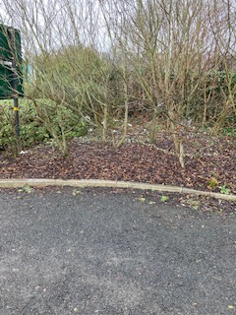
Bushes aligning Tommy’s field in Morrisons – sharp branches – needs cutting back
Minutes from NCC/MTC meeting and current position:
MTC/NCC meeting response: “the planting acts as a barrier and the type of planting selected on the basis of sustainability. It is part of the Inbloom submission of the town.”.
MLG Response: MLG have asked for help in cutting back the bushes since any attempts to extract detritus from the bushes is very dangerous to any litter picker injuring their hands or their eyes! It was hoped the bushes could be cut back so that MLG volunteers could extract the detritus without endangering themselves on the very sharp thorns. In spring 2020 this was cleared by a MLG volunteer, 8 large black bags were collected, especially from the far corner (accessed by pruning at low level a route through to the corner). This is a constant HOTSPOT for detritus since the winds blow the litter into the bushes. MLG Coordinators must have a duty of care to its volunteers, so with bushes not being trimmed to give volunteers a safe access, we must make the decision that no volunteers will not be asked to tackle this area. It is hoped everyone understands this position but our MLG Volunteers’ Health and Safety must be uppermost in all our approach.

R3: [R3-2019]: Coopies Lane Mineral Path Suggested Owner: MTC/NCC/MLG
2019: That the responsible public authority continues to monitor Coopies Lane former mineral railway public footpath and clears litter and fly tipped material on a regular basis, which is suggested as 3-6 monthly. Additionally, litter prosecution warning notices could also be displayed.
2020: The lane is definitely tidier, is it tidier because someone is keeping the area tidy e.g. NCC NEAT team? Reviewing this area in December, a number of dog walkers asked for a DOGGY bin to be put somewhere along the path, pleading there is “no bin” anywhere to dispose of full doggy bags. See RB2.
REASONS:
- To reduce litter pollution which is harmful to wildlife and domestic pets (dogs being exercised).
- To properly control litter in the interests of public enjoyment and safety on a designated public footpath.
- New doggy bin will help substantially – it is recommended it is placed at the exit to Coopies Lane Field road.
Minutes from NCC/MTC meeting and current position:
MTC/NCC meeting response: “It is felt that, as this path is not busy with walkers, the litter is not generated by public dropping litter but from litter blowing onto the path from adjoining businesses or elsewhere. A bin along the path would be problematic for operations and a litter bin that is easily accessible would likely be abused by businesses or their customers.”
MLG response: The lane is a popular location for dog walkers and for the whole length of the lane there is no dog bin nearby. We had recommended a bin being placed on the edge of Coopies Field road where the lane crosses – this would give easy access to NCC NEAT team to empty the bin being right next to Coopies Field road.
This issue remains open – there is a clear need for a doggy bin in this location. MLG will look at other options.

R4-2020: [R4-2019]: Railway Station – Front Foliage Suggested Owner: NCC/GMDT/MLG//Network Rail
GMDT have successfully completed the refurbishment of the Railway Station. It continues to be blighted by scale of litter around the building. Despite station staff putting 2 rubbish bags on the Southbound line, the high scale of litter that accumulates in the large bushes around the front of the building detracts from the general appearance of the station. Many of the bushes are jagged and it’s dangerous to extract detritus from them. Is this area maintained / owned by NCC – if yes can NCC cut back these bushes? Otherwise if Network Rail or Northern Rail own this, can GMDT Environment obtain their commitment to look at replacing the hedges with soft landscaping?
REASONS:
- To control litter pollution in an important gateway into and out of Morpeth.
- To increase the aesthetic appearance of the area with better landscaping
Minutes from NCC/MTC meeting and current position:
MLG response: MLG are working closely with GMDT Environment director Hugh Edmundson to look at our options working with Network Rail. This may be a longer term project, which take some years to achieve.

R5-2020:[R4+RB9-2019]: Railway Station- Rear Entrance Suggested Owner: NCC/GMDT/MLG//Network Rail
GMDT have successfully completed the refurbishment of the Railway Station. It continues to be blighted by litter. This area has been identified as an issue in the past 2 years re the scale of litter left here, making it very unwelcoming to visitors to Morpeth coming from the Railway Station. The problem has been exacerbated this year by the removal of the bin, early 2020, halfway up the slope that approaches the railway station rear entrance. The amount of litter thrown over the fence and other banks continues.
Work has started on the hedges over the fence (RHS as you go up the hill) by Network Rail.
Could the following improvement plan be started in 2021:
- Continue cutting back the bushes over the green fencing, bringing any litter in that area closer to the fencing to be extracted using a litter picker from the path or rubbish collected by the team cutting back the hedges?
Could NCC NEAT team cut back the hedges on LHS and the hedges that align both sides of the unofficial path?
REASONS: See RB4 below
- First impression to new visitors to Morpeth is a very ugly sight of 100’s of cigarette butts at the area.
- The Northern Rail team have placed rubbish bags on the platforms which are being used, but scale of litter continues to grow in this area.
- The original blue bin, half way down the rear slope, was ripped from its base on 14th Jan 2020, on 21st Jan 2020 the bin was taken away and has never returned, could a bin be replaced.
- Cutting back the bushes will give MLG Adopt a Street volunteer to periodically clear the area of any litter.
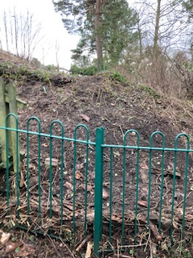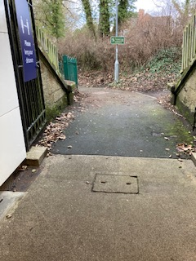
Banking to left as your leave the rear entrance Could a bin be placed on the lamppost at rear entrance?

Minutes from NCC/MTC meeting and current position:
MTC/NCC meeting response: Re Bin: “A bin can't be located here due to access for emptying, and it would not stop fly tipping.”
Re Hedges on Left side: “This is not an official path and NCC have no right to maintain.”
MLG response: Thanks to Northern Rail staff at Morpeth Railway station, they have put up a bin at the entrance to the rear tunnel. Network Rail have also supported us by cutting back the bushes on the right side over the metal fence plus the bushes on the unofficial path that goes up the bank to the North Bound railway line. They have also cleared any litter that has accumulated there.
We are advised by Network rail that all the bushes on the opposite sides are the responsibility of NCC, it is hoped NCC NEAT team will relook at this and cut back the bushes there so MLG volunteers can access the litter that accumulates here.
We await NCC NEAT team’s response re the remaining activity with the bushes to the left of the path, as you walk up the path.

R6-2020: [R6-2019]: Town Centre yards Suggested Owner: MTC/MLG/Chamber of Trade
That the responsible authority monitors and clears yards in the town centre and adjacent streets on a regular basis, and that this includes cigarette butts.
REASON:
- To control litter pollution in all public areas of the town centre in the interests of residents, businesses and tourism.
Dec 2020 Update: We are unable to ascertain any ownership or improvement in this area. The yards continue to collect with detritus including glass fragments especially behind the White Swan. This is a safety hazard to any animal walking in these areas.
Minutes from NCC/MTC meeting and current position:
MTC meeting response: “Town centre yards are not adopted highway, and in some cases are marked as private.
MLG response: MLG are working with Morpeth Chamber of Trade to see if any options available to us to engage with shop and
property owners.

R7-2020:Heighley Gate Layby improvements Suggested Owner: NCC
The wheelie bins in situ at the Heighley Gate layby need replacing/repairing and mounting properly on a solid surface, some have missing lids on bins. In December a couple of MLG volunteers who live
nearby bravely offered to adopt the layby and will be chipping away at it over the next few months but
they also share the view that the state of the bins provided need addressing to encourage people
visiting the layby to use them.
REASONS: see para 2.7
- MLG volunteers have put in a lot of effort clearing the woods of detritus.
- What encouragement could be put in place to get people to use the bins that are placed there?
- Some of the existing Sulo bins are precarious and easily fall over. There is a safety issue here that a full bin could fall on someone.
UPDATE: After seeing the 100 bags of litter challenge on social media, two volunteers living close to the layby stepped forward, offering to adopt the layby and are slowly making further inroads. The scale of the litter is such that it requires the use of a wheelbarrow to speed up the process. At the time of writing, they have spent over 16 hours over several visits clearing the area. They have commented that the wheelie bins provided are completely inadequate with broken lids and generally extremely dirty - essentially not sending out the message of 'use me'. Several wheelie bins are situated on uneven grass and are very unsteady and prone to tipping over which poses its own risks to passing traffic.
Minutes from NCC/MTC meeting and current position:
NCC meeting response: “NCC will place two additional bins on the Dobbies side of the road.”
MLG Response: The NCC team have made substantial improvements to the actual layby which is helping to keep the layby less cluttered with litter. Our sincere thanks to the NCC NEAT team. MLG volunteers have adopted this layby endeavouring to keep on top of the detritus that collects here. The scale of litter continues – some volunteers would like to see NCC use covert cameras being placed here to catch people flytipping. It is observed that people are coming to the layby using the Sulo bins to dump their home rubbish, quickly filling up the bins to the general public using the layby – is this a problem county wide?

R8-2020: [R9-2019]: Brush the Front of your Shop Suggested Owner: MLG/Chamber of Trade
This requirement was thwarted by Covid-19, it is hoped that in 2021 we can look at working with Morpeth Chamber of Trade where shops can get engaged with a Keep Morpeth Tidy initiative where a simple commitment is requested: BRUSH the FRONT of your Premises.
As part of this will be the requirement to design and print MY SHOP HELPING TO KEEP MORPETH LITTER FREE.
It is recommended we involve KEVI design students in the design of the poster.
REASONS:
- Everyone helping to keep Morpeth Free of Litter will encourage others to change their habits.
- Funding will be required to facilitate the production of the shop posters.
Minutes from NCC/MTC meeting and current position:
MLG Response: We are working with Morpeth Chamber of Trade to look at a Business sponsorship scheme. Look out for new Keeping Morpeth Tidy stickers on shop windows.
Speaking to Penfold Convenience Co-Owner Chloe Penfold, she has confirmed that they have endeavoured to keep the front of their store clear of detritus, they have a commitment to brush their store 2 times a day, morning and afternoon. It is hoped other stores in Morpeth will have the same commitment – it really makes a difference.

R9-2020: [R16-2019]: School Posters refresh Suggested Owner: MTC/MLG/Schools
Street bins are looking tired with the school logos peeling off in many places. Could a new competition be arranged to ask for new school logos which we can place on the side of our bins.
REASONS: see para 3.3
- Engages with local schools and engage with our youngsters to Keep Morpeth Tidy
- New posters will encourage people to keep their lovely town of Morpeth free of litter.
Minutes from NCC/MTC meeting and current position:
MTC/NCC meeting response: “This would be for the schools to organise internally, but who would cover the costs, the posters/labels on the bins are quite expensive.”
MLG response: We are looking at options available to take this forward, it is hoped to organise a project working with all Morpeth’s Junior/1st Schools with sponsorship from a local Morpeth business. We consider this is very appropriate for a post Covid-19 refresh activity, Keeping Morpeth Tidy message and engaging our young people is a very important initiative to encourage future generations to get rid of their litter properly plus the fun in seeing the new posters / ideas may encourage old generations to stop throwing litter on the ground.
MLG are in talks with a local business and the potential to obtain funding from a local business to take this forward in 2021.

R10-2020: [R11-2019]: Street Furniture annual budget Suggested Owner: MTC
The installation of cigarette butt trays has been very successful in the town, it would be helpful to have each year a small budget of approximately £5000 to facilitate the following:
- Replacement of a doggy bin with a dual use blue bin
- Conversion of existing bin with new cigarette trays – with a target to convert 10-20 bins each year. Existing priorities are:
- All bins on Newgate Street - 3 in total
- Any bin located next to a bus stop
- Purchase of new larger bins
- Purchase of floor mounted cigarette butts receptables
REASONS:
- Having a specific budget each year for bin management will facilitate a definite improvement each year.
- Targeting hotspots for Butt Trays especially in town centre locations and bins next to bus stops will reduce the scale of cigarette butt detritus into the environment and our river and sea.
- The scale of cigarette butts detritus in Morpeth Town centre had reduced greatly with the improvements made to our bins.
Minutes from NCC/MTC meeting and current position:
Pre Meeting-MTC response to MLG’s policy request for a budget for Bin Infrastructure improvements: “No specific budget will be assigned; Town Council Clerk manages any bin improvements under existing budgets.”
MTC/NCC meeting responses:
a.“There is not the budget to change each dog bin to a blue bin”.
MLG Response: Just to clarify: We have not asked for all dog bins to be converted this year; we are asking that yearly a budget is made available to convert a small number of bins each year.
Any MLG volunteer who has raised a request for a Doggy Bin conversion, who disagree with MTC’s response, please make your own representation with your local Town Councillor, we suggest with a business justification for the upgrade.
b1. “MTC will convert the three bins on Newgate Street which have not yet been done.”
MLG response: The 3 bins have been converted in March 2021, they already making a big improvement to the reduction in cigarette butts on the ground. Our thanks to the MTC team.
b2. “MTC will review how many bins are next to bus shelters.”
MLG response: Our thanks for making this review, we are confident that converting these bins over the next 5 years will help in the fight against Cigarette butts. Can consideration be made by MTC Budget planning be made to assigning a small capital for the next 5 years to convert a number of bins each year. In parallel MLG are asking KBT and HM Government for some budget to be released to cover such improvements plans as they did in March 2019.
c. “Larger bins are not in keeping in a market town, town centre bins are emptied on a daily basis and there is no reports of any problems with bin capacity.”
MLG response: Reflecting NCC NEAT team resources are stretched, the need for more bins to be emptied further extends the NCC NEAT’s team to empty the bins, there are 3 known locations in Morpeth where 2 blue bins are located next to each other, could these be better addressed by 1 larger bin, this will also facilitate generating a stock of 6 blue bins for future use.
The bins on the square are very often full to the brim, this has been seen during the lockdown period, evidence shows that the bins in the square are not big enough to capture all discarded items. Recent photos taken showing bins full on all the square at 6pm on a Saturday evening.
d. “NCC do not have the capacity to empty any further bins, ashtrays will be incorporated where necessary.”

R11-2020: [R15-2019]: Hillside landscape project Suggested Owner: MTC/NCC/MLG/Housing Trust
A new improvement project is required for around Hillside Convenience Stores. Last year MTC swapped
out the doggy bin at the rear with an old-style dual blue bin, this has helped but this year we are hoping
that landscaping of the rough area behind the garages, possibly to lawn, will ease maintenance and help
to stop littering/flytipping in this area. May need to contact Karbon homes.
REASONS:
- This is a severe Hotspot where litter is being thrown everywhere. The lack of a bin behind here could be alleviated easily by replacing a doggy bin with a blue bin.
- This is a popular fly tipping area which could be improved by making the area more pleasant.
- In January 2021 this continues to be a problem area, on 8th Jan 2021 there was even an old microwave dumped here. MLG’s KBT ambassadors did a substantial clean-up of this area in March 2020 immediately prior to the Covid-19 lockdown. The scale of litter here reflects 10 months rubbish collected.
Minutes from NCC/MTC meeting and current position:
MTC/NCC meeting response: ““To be addressed by Karbon Home”
MLG response: We have made contact with Karbon Homes, it is hoped this could be part of MLG’s 2021 new Environment project. Funding to be considered from various channels to facilitate purchase of plants, soil, hire of equipment to deliver this.

R12-2020: [R18-2019]:Business Adopt a Bin Suggested Owner: MTC/NCC/MLG/KBT/Chamber of Trade
It would help enormously if we could increase the number of bins in Morpeth Town Centre. However, the disabler here is the ability to empty the bins as well as funding the purchase of new bins.
This requirement is asking for MTC/NCC support to Businesses adopting a bin. The Co-op and Cooplands bakery shops have shown us what is achievable with the 2 shops supporting 3 bins outside their store, they have superb support from their HQ where arrangements have been made that the companies’ delivery person takes away the rubbish collected. Could the larger businesses such as MORRISONS, LIDL, GREGGS, SUBWAY and ICELAND support the bins located at the front of their store with similar arrangements at HQ level to take away the rubbish?
Some smaller businesses could also adopt a bin themselves if arrangements can be made re emptying the bin, what can NCC offer.
Locations / Businesses recommended to be considered are:
- Iceland store – Bridge St. requires contact with their headquarters
- Greggs store – Bridge St. requires contact with their headquarters
- Subway Store – Newgate St. requires contact with their headquarters
- Lidl Store - Stanley Terrace requires contact with their headquarters
- Morrisons store requires contact with their headquarters
- Newgate News – Newgate St.
- Morpeth Fish and Chip shop – Newgate St.
- Lollo Rosso restaurant – Bridge St.
- Craik Park – post NCC NEAT’s team fantastic clearance of hotspot in the car park – could Morpeth Town AFC adopt litter bins in this area to keep the area clear of litter?
- Sun Inn – could the current lamppost bin be replaced? See photo below:

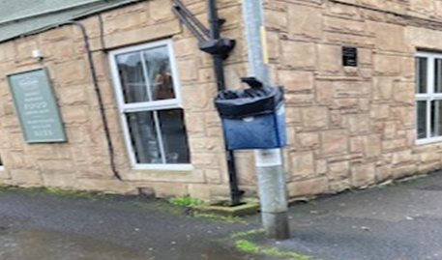
REASONS:
- Increasing the number of bins around Morpeth Town Centre will enable us to give people more places to put their discarded waste.
- Increasing the number of bins is blocked by inability to increase the number of bins due to lack of NCC manpower to empty the bins.
- Bins adopted by a nearby local business could result in the bin being emptied more often than existing bins emptied by NCC NEAT team.
- Initial contacts with some businesses has been very positive. Could this be an opportunity to increase the number of bins in the main shopping areas of Morpeth without impacting NCC NEAT team resources to empty them?

Minutes from NCC/MTC meeting and current position:
MTC/NCC meeting response: “There are 72 bins within the town centre. There is no need for any additional bins. The bins in the town centre are emptied every day so we don't see the take up of this being very high for a service that is paid for through business rates and commercial waste contracts. Why would businesses want to pay staff to bring rubbish through their shops to put it into their own commercial waste which they paid separately for?
In the case of Co-op and Cooplands, they are on a new housing estate which is serviced by a private management company which residents pay them directly for. NCC does not service in terms of public bins, grass cutting etc. The arrangement for bins in front of the stores might have been part of their lease/rent agreement.”
MLG response: MLG volunteers are identifying locations for new bins where they feel it would help in the battle against litter. The fact these volunteers has called out these changes reflect the scale of litter they are finding in this area.
Working with KBT we have identified many national businesses are wanting to make a difference by providing bins. It is pleasing to see our government is in dialogue with businesses, see Environment minister’s Rebecca Pow response in Appendix 5.
There is also great merit in asking local businesses to adopt a bin since making the town litter free attracts footfall into their shops.
Re Co-op and Cooplands , management have confirmed that their senior managers made the decision to coordinate emptying and taking away of any rubbish – their initiative is to be commended and we should ask if other businesses in the town could do something similar.
From the meeting it was agreed that local businesses could adopt a bin, but any placement of a bin does not create any obstruction on the pavement. MLG will work with Morpeth Chamber of Trade/ Local Businesses/KBT to see if more bins can be adopted. It is great to see local businesses like COOPLANDS and MACE (St Marys Field) making a difference. Our thanks also to Co-op, Sainsburys, Morrisons in providing bins outside their premises.

R13-2020: Market Place Cleaning Suggested Owner: MTC/NCC
Morpeth’s Market Place is an important area for presenting to visitors how lovely our town is. Disappointingly, too often it is a poor state of presentation with litter and branches on the ground, especially after the day after a market stall event, where you will find food picks, clothes hangers, remains of vegetables for example.
It would be appreciated if MTC could put in place, a commitment to hoover the area the next day after an event in the Market Place. Could there be a monthly commitment to hoover the Market Place?
REASONS:
- The lack of regular cleaning results in the square looking very untidy giving a poor first impression to any visitor to the town.
- At times glass, twigs, discarded vegetables cover the ground leaving the area dangerous when conditions are wet underfoot. Note green glass has been spread on the floor in front of the Hay’s Travel shop, it has been there for all of January 2021.
Note: is there a need for a set of Sulo bins for traders to use on a market day, currently the blue bins are used and quickly fill up on the given day?
Minutes from NCC/MTC meeting and current position:
MTC/NCC meeting response: “The large sweeper can't be used on the Market Place due to weight restrictions. Regular sweeping by the small vehicle has been blighted recently due to staffing issues. MTC will arrange for their dedicated NCC NEAT team to check the Market Place first thing on a Thursday morning for rubbish left by the market traders. We will also contact the market manager to ask him to reiterate that traders remove all rubbish.”
MLG Response: Over the past weeks it is apparent the square is now being hoovered; it has made a big difference in the town’s appearance. The square looks very tidy and well-kept and makes it attractive to visitors. Our thanks to the NCC NEAT team for making this improvement.
Could MTC/NCC make representation to Sandersons Arcade who manage the stall rentals to provide Sulo bins for rubbish collected on Market days but also to brush up around their stall at end of day?

R14-2020: Market Place seats around tree Suggested Owner: MTC
The seats around the central trees have been removed in Morpeth’s Market Place. This has allowed MLG volunteers to pick up the cigarette butts embedded in the grills around the trees.
Could this be a permanent position with new benches placed strategically around the square instead?
REASONS:
- The tree seats are very popular with people but unfortunately are liable to be hit by large amounts of detritus under the seats and around the base of the trees at the back of the benches.
- Access to the detritus is very limited resulting in detritus remains there despite efforts from MLG volunteers.
Minutes from NCC/MTC meeting and current position:
MTC meeting response: “Seats cannot be placed anywhere else for access purposes. The seat around the tree was a dedicated seat so may well be replaced at some point. MTC’s Neat team will use their hoover to address butts in the grills.”

R15-2020: Rear of Street Furniture cabinets trial Suggested Owner: MTC/NCC/MLG/Utilities
It has been observed that detritus accumulates behind street furniture. Could MTC/NCC support a trial to fit plates around the back of the street furniture at the following sites:
- Town Hall – see to left of the hall between front and right side of Santander Bank.
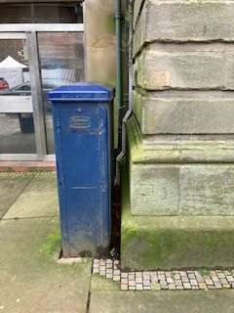
- Lumsdens Lane by George Chisholm betting shop and the wall of Peacocks shop
- On Corporation Yard – wall of Superdrug store.
REASON:
- The facility to put detritus behind street furniture appears to be popular to people who litter. You will often find cans, cigarette packages behind the furniture.
Minutes from NCC/MTC meeting and current position:
MTC/NCC meeting response: “Nothing can be attached to the street cabinets as they are not the property of either NCC or MTC. Rubbish is more likely to be blown in to these areas rather than thrown there”.
MLG response: This idea has been raised by national KBT Ambassadors, where they have found much merit in putting shields between the devices and the wall, stopping detritus accumulating behind them. MLG Volunteer’s experience has shown that it is a combination of items being blown by the wind but also miscreants pushing their litter behind the gaps.
MLG have identified that the cabinets are Electrical – MLG have made contact with Northern PowerGrid to see if any improvement can be made. For scale of problem – see the detritus collecting behind the cabinet immediate to the left of the town hall. Disappointing Northern PowerGrid have stated they will not make any changes with no commitment to clear any detritus that collects behind the cabinets.

R16-2020: Collection of redundant sandbags Suggested Owner: NCC
It has been noticed that there is a tendency by workmen to leave sandbags around the town. We are looking for NCC support to put in place a reporting process where these sandbags are picked up. Ability to trace the offender and encourage better practices would be appreciated.
Bags found at the following sites:
- Bottom of Stanley Terrace – near the roundabout behind NEXT – bag has been there for over 5 months now
- On the slope from Deuchar Park down to A192 main road, very old bag!
- Yellow bag on the fence side of the slope that goes up from Mafeking Roundabout to rear of Railway Station
- Another yellow bag on the wall on A192 as you approach the railway bridge coming from Mafeking Roundabout and just after the entrance to Deuchar Park.
REASONS:
- The bags are a hazard to pedestrians as well as being an eyesore.
- They are heavy to remove so just sit there for months.
- The number of them left behind is surprising when you start looking around the town centre.
Note: road resurfacing around Mafeking (January 2021) was superbly done but detritus left around the area was poor reflection on NCC – how can teams be asked to leave their work area clear of detritus?
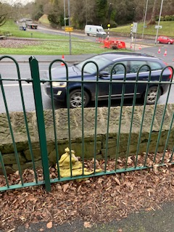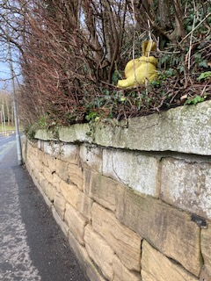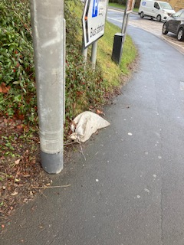
Path to station rear, A192 over wall A192 to left – just before Railway bridge at the mini roundabout at the end of Stanley Terrace

Minutes from NCC/MTC meeting and current position:
MTC/NCC meeting response: “Sandbags are the responsibility of either highways or the private contractors, however this can be reported to NCC as a fly tip.”.
MLG response: Post a review any bags remaining in location have been reported as a FLY TIPPING incident on the NCC Report a Problem website. MLG volunteers have been advised of the new approach, 1 individual has stated they intend to just slit the bag open, remove the sand and get rid of the bag – the person felt this was the most expedient solution. Some bags have been removed, 1 removed by emptying the sand and disposing of the bag.

R17:2020: ENEVO.COM SENSOR option? Suggested Owner: NCC
Glasdon Bins have set up a partnership with ENEVO.com to look at adding the ENEVO SENSOR reporting product which would enable NCC NEAT team to have a real-time update on bin usage.
See Enevo blog on trials around the country, Newcastle City council is one of the triallists and appears to be very positive.
REASONS:
- Having the ability to direct NCC NEAT team resources to bins that are full or almost full should facilitate an increase in the number of bins around the town centre without impacting NCC NEAT team resources to manage them.
- Morpeth is an ideal sized town to look at trialling this product.
- Existing bins can be retrospectively fitted with this monitoring tool
- New bins can be ordered from Glasdon with brackets to add this tool
- Could this new technology give us the opportunity to increase the number of bins around the town without impacting upon NCC NEAT team resources to empty?
Minutes from NCC/MTC meeting and current position:
NCC meeting response: “This scheme was trialled by NCC in Berwick, and was not deemed a success. This was not only costly at £5 per bin per month, but gave false readings. daily emptying of the town centre bins and regular emptying of the outlying bins does not warrant such an additional expense.”

R18-2020:NCC reporting mechanisms + bin #s Suggested Owner: NCC
Adopt a Street has been very successful but its success has created new pressures where bins are filling up much quicker. The MLG’s Adopt a Street Welcome pack includes advice to use “carrier bag” size since these would not fill up street bins.
MLG would like to see on “NCC REPORT A PROBLEM” website to include a mechanism to REPORT A FULL STREET BIN, this could be used by MLG volunteers to advise NCC NEAT team of full bins that need emptying. It would also help if bins could be numbered so they are easily identified in any reporting of an issue. This would be similar to the street lampposts which are numbered.
REASONS:
- Making effective use of the small NCC NEAT team is essential to maximise best use of resources.
- Getting bins emptied when full key to stop litter falling onto the ground.
- Numbering of bins eases all communications, online, email or by phone. As per Street lights.
Minutes from NCC/MTC meeting and current position:
NCC meeting response: “Full bins can be reported without the need to give a number, a location in this case is more appropriate.”
MLG Response: Post the meeting and NCC response, a new email address has been provided to facilitate MLG Adopt a Street volunteers to report full bags awaiting collection. The same will be used to report a full bin.
It would be appreciated if the NCC NEAT team could consider numbering their bins – it would greatly help MLG volunteers in identifying the bin rather than trying to describe its location.
It would also help if a new Mobile App could be developed (many white label solutions already exist) which volunteers could use, that would make reporting bags to be collected much easier, if this is done when standing by the bin, the location could be autogenerated by the AP. There is merit in this AP also being used to report a full bin.

R19-2020: County Hall refurbishment detritus Suggested Owner: NCC
Comments have been received from 2 MLG volunteers, Tracy (Adopt a Street volunteer) and MTC Councillor Jack Gebhard, where the scale of litter around the County Hall is very severe. Could NCC management look at their surrounding car park and arrangements for collecting litter?
For example:
- Staff be advised to take their litter to the nearest bin
- Bin management survey to identify need for more bins around the car park area
- Firm involved in the refurbishment to be contacted to emphasize the importance that their employees take their detritus to a bin.
REASON:
- Scale of detritus around NCC’s offices has become severe with the work in progress.
Minutes from NCC/MTC meeting and current position:
MTC/NCC meeting response: “senior NCC management have asked NCC managers to speak to the builders about litter around the building from the building work with a view to introducing preventative measures.”
MLG response: It would be appreciated if NCC staff are also asked to take care with their rubbish, the scale of litter at the back of the NCC headquarters is high. This area is hit by high winds so any litter thrown onto the ground ends up imbedded in the bushes at the back of the car park – making it very difficult to extract and bag.
Feedback from MLG Volunteers on 26th April, informs us that the scale of litter around County Hall has decreased greatly.

R20-2020: Chewing Gum removal Suggested Owner: MLG/KBT
Dai has during this cold period been experimenting with the removal of chewing gum from pavements. What has been found is that the cold period facilitates the removal of some fresher chewing gum, items that have been there for years are stubborn to remove.
Could the small pavement cleaner be fitted with rollers with a metal edge, which could successfully remove a high percentage of the chewing gum on pavements?
REASONS:
- Morpeth’s 2 KBT Ambassadors intend to target chewing gum on Bridge St., Town Square when the Covid-19 restrictions are lifted.
- Could the street cleaner remove the high percentage of chewing gum reducing the amount to be scraped off by the KBT Ambassadors?
- Could the pavement cleaning activity be aligned with post Covid-19 regeneration and shops cleaning the front of their business?
Minutes from NCC/MTC meeting and current position:
NCC meeting response: “this has been done in the town previously, unfortunately the result can make the pavement area look worse as it gives the ground a mottled effect.”
MLG response: Post the meeting and NCC response, engagement being made with KBT and Dept of Environment to look at other options.
Post Covid-19 lockdown and restrictions lifted it is hoped that a MLG team could attack the chewing gum down Bridge Street and the Town Square. It is accepted that the issue needs to be a national strategy to discourage Chewing Gum sales and possibly taxation to facilitate purchase and recruitment of staff to remove chewing gum.

R21-2020: New Railway Station grass mowing Suggested Owner: NCC
The new car park was opened in 2020 but the grass surrounding the car park was left to grow substantially in 2020. Can we have NCC Environment team’s support to ensure the grassy area appearance is kept in good order which will improve the general appearance to visitors.
REASON:
- It is important to keep this area in a general high state of repair to enhance the appearance especially to visitors to Morpeth.
Minutes from NCC/MTC meeting and current position:
NCC meeting response: “It is understood that the maintenance of the grass has not yet been passed to NCC, NCC NEAT team investigating.”
MLG response: MLG team will monitor the situation over 2021 and raise the issue with the NCC Neat team if mowing is required.

R22-2020: MLG + NCC tackling verges Suggested Owner: MLG/NCC
A number of areas around Morpeth are blighted by litter. MLG volunteers cannot clear up the area due to their location being edges of main roads. It would be great if we could set up a working team where NCC NEAT team and MLG volunteers work together tackling the following roads.
NCC team traffic managing the road, MLG volunteers hitting the litter as quickly as possible to enable the road to be fully reopened. Suggested roads:
- Rear lane at the back of Kirkhill-High House Road
- Whalton Road from Hole 18 to Piramal factory
- Morpeth Bypass from A1 junction to Whorral Bank roundabout
Any other areas that NCC would like us to help?
REASONS:
- Throughout Northumberland the scale of litter along verges is depressing. NCC team do not have the resources to clean these areas.
- Could this new team help to slowly clear hotspots – initially in Morpeth, but over Northumberland?
- If successful could this be a set list of locations to be tackled each year?
Minutes from NCC/MTC meeting and current position:
NCC meeting response: “This is not only a costly request due to the traffic management implications. It is also something that cannot be done due to the health and safety of volunteers and there being no insurance in place for such an activity.”
MLG response: MLG team are arranging 6 person teams to tackle a number of B,C and Unclassed lanes / roads around Morpeth. Jewsons have been very generous in the provision of yellow bibs and excellent Litter Picking AMBER bibs with ROADWORK SIGNS on the back for our volunteers (our sincere thanks to them, their support is much appreciated). Crowdfunding initiative has been completed to raise funds for the purchase of new Men At work – LITTER PICKING IN PROGRESS – SLOW. Our trial on 3rd April showed drivers did slow down. Liability insurance will be arranged via KBT by MLG’s KBT Ambassadors or will be STREET BLITZ marshals.
It is appreciated that Highways England charges NCC for any closure of roads discourages activity to clear the litter, the opportunity to use very keen volunteers in helping NCC clear detritus around Northumberland is a missed opportunity.
Issue will be raised with KBT to ask for lobbying of Dept Environment and Dept of Transport for some relaxation of charges regards Litter Picking.
April 3rd 2021: our 1st STREET BLITZ took place with 6 volunteers – in 3 hours the whole section of HIGH HOUSE Lane – an unclassified road behind Kirkhill estate, was cleared. 15 bags and other detritus collected. With MEN AT WORK signs in place and designated Marshalls, everyone was kept safe in completing the litter picking. More STREET BLITZES planned in the next 4 months.
Further Street Blitzes have taken place along Hepscott Lane, Bothal Sawmill lanes and road and extensively up Whalton Road: the scale of detritus being collected is astounding.

R23-2020: Cottingwood Burn bordering Morrisons Suggested Owner: NCC/ MLG/KBT
Cottingwood Burn bordering Morrisons underground car park is being inundated with items thrown over the wall of the underground car park. See photo below showing the 50+ items aligning the far side banks. How can we stop this detritus flowing out to sea. The high volume of detritus – sitting on either of the burn is a major concern. The far side is unreachable by any MLG volunteer, even with an 8’ Litter picker which may necessitate contacting Environment Agency to deal with the detritus.
Would the following improvements improve the situation:
- Placing a fine mesh, similar to type put up by Morrisons at their delivery section, could stop youngsters throwing items over the underground car park wall.
- We recommend a bin is placed in the far-left corner of the underground car park. (27th June – request was made to NCC NEAT team for a trial Sulo bin (unclear where we are currently). See RB13.
- We recommend a bin is placed on the corner of the entrance into Morrisons upper car park. See RB15 for photo of location – this will capture litter being thrown on the path side of the path.
Other issues needing to be addressed include:
- Need a metal girder removed from the burn – causing a dam in the burn. Need someone to get over the burn and clear the detritus on the banking.
REASONS:
- The far-left corner of the underground car park is a meeting point for teenagers, the scale of litter in that area is substantial – see RB13 for request for SULO bin.
- Placement of mesh along the top of the underground car park wall will stop items falling onto the far side banking of the burn.
- Reducing the scale of litter falling on the far side of the burn is important to reduce the need for an individual to complete a difficult traverse of the burn.
- We need the underground car park to be swept periodically by a pavement size road sweeper.
Note: this has been identified out as a popular drug taking location.

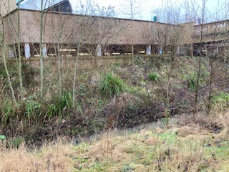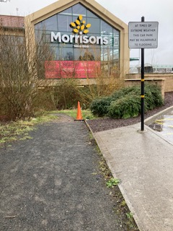
All white items is detritus – far side of bank Could we place a bin just in the gravel area by the cone?
Minutes from NCC/MTC meeting and current position:
NCC meeting response:
“1. This would need to be discussed with the Environment Agency;
2. This area is swept with the mini sweeper
3. This is for Morrisons to address”
MLG response:
- MLG team have made contact with the Dept of Environment who have responded that the issue must be owned by NCC – it is deemed outside the remit of the Environment Agency. .
- Visiting the car park evening, 8th April, the scale of litter in the far bottom of the car park is just awful, there is a clear need for a bin in this area. Hopefully the teenagers will use this rather than just throw cups, cans etc on the ground.
- MLG have Morrisons plc support in placement of a bin near the corner which will hopefully reduce the scale of litter in this area.

R24-2020: Biodegradable products Suggested Owner: NCC/MLG/KBT/DEFRA
Castle Walk is constantly being blighted by a habitual fly tipper, using Subway serviettes, Metro papers and their kitchen bin. A month ago, this person spread around gold-effect confetti – 12 weeks later the confetti is not decomposing at all. Clean-up almost complete, Dai has picked up over 3293 circles.
MLG Ambassadors will liaise with Keep Britain Tidy to see if issue can be raised with DEFRA to ascertain why a product is being sold which is not designed to be biodegradable. If NCC have a department which can also champion this issue, it would be appreciated if they could get involved. REASONS:
- Evidence has shown in the last 4 weeks the confetti does not degrade in any way.
- Impact on the environment is huge with the items just remaining for many years to come.
- Are there any other non-biodegradable products that need to be highlighted?
Minutes from NCC/MTC meeting and current position:
MLG response: The scale of confetti thrown is just staggering!! Over 3160 items picked up, and each day more are being found. They have been on the ground for 3 months now and are not degrading! MLG team have made contact with Ian Lavery Wansbeck MP who has raised this with Rebecca Pow DEFRA minister. There clearly needs to be improved national standards for biodegradable products – there needs to be controls in place to stop items such as NON BIO-DEGRADABLE confetti being sold. The scale of damage to UK’s environment and ultimate our world is immense!

R25-2020: Using Covert Cameras Suggested Owner: NCC and HM Gov
As per R28 above - Castle Walk is constantly being blighted by a habitual fly-tipper. We need to be able to use surveillance cameras to catch this person and fine them to discourage them from such activity. The use of cameras is emotive re an individual’s Human Rights, but can we put pressure on HM Government to raise the issue that County Councils need the powers to use cameras?
REASON:
- The scale of fly tipping is increasing – we need the tools to catch and fine individuals.
Minutes from NCC/MTC meeting and current position:
NCC meeting response: NCC are using Covert cameras for certain situations.
Further update from NCC Officer responsible for use of Covert Cameras:
Covert cameras will not be used for Littering or Dog Fouling as they do not meet the threshold for the seriousness of offence.
MLG response: Other councils around the UK are trialling use of COVERT cameras to capture Fly-tippers. Some councils are open with their policy statements on the web. We have asked the NCC officer for action after a section of 200ms of Morpeth’s Castle Walk hit by litter. There is a disconnect here between NCC’s approach to fighting against littering we would like to see NCC openly present their approach, getting the message out via Facebook etc. in the hope that this will discourage litterers. See ITV News item on Wednesday 24th February 2021 - Councils in England dealt with nearly 1m cases of fly-tipping in England - is your area the worst for illegal dumping? | ITV News
MLG Update 27th April: NCC response re use of Covert cameras for Littering is disappointing – we must endeavour to catch people who are littering, finding people must be used to encourage change in habits. If you deem this a priority, can you please make representation to your councillor to encourage a change of approach.
R26-2020: Courier Van Drivers littering Suggested Owner: NCC/ MLG/KBT/Courier businesses
Covid-19 has increased the use of purchasing via the internet, increasing the number of courier vans on our roads. It has been observed by a MLG Volunteer that road verges, especially High House Road all the way up to Tranwell Woods, are an almost a constant dump for litter. Suggestion is that we contact delivery drivers/builders vans, e.g. DHL/Hermes,UPS,Royal Mail asking them to emphasize the importance to drivers to return all litter to their depot.
REASON:
- Excellent suggestion from MLG volunteer – start with delivery firms and then widen scope in the months to come.
Minutes from NCC/MTC meeting and current position:
NCC meeting response: “Firms will have good practice guidance, however this can't be monitored or controlled by NCC.”
MLG response: Post the NCC/MTC meeting , ownership transferred to KBT / MLG. MLG team have made representation to KBT to see if they can lobby the UK couriers to put in place best practices for their couriers.

R27-2020: RECYCLE BINS update Suggested Owner: MTC/NCC/MLG/KBT
In 2020 a number of recycle collection points were placed around Morpeth. Has this been successful? Could MTC/NCC issue some stats regards their usage and do they suggest they should be rolled out to other locations, possibly in place of bins?
REASON:
- Could their success reduce the number of bins that are needed to be emptied?
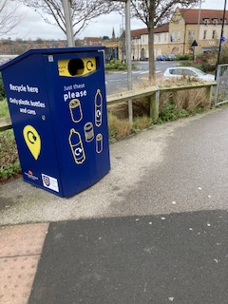
New Recycle Bin at the bus station
Minutes from NCC/MTC meeting and current position:
MTC/NCC meeting response: “There are no stats as such as the bins are not being used correctly, all collections are spoilt.”
MLG response: The Government has recently announced to delay its plans for deposit returns – MLG will work with KBT to lobby the government to bring forward this scheme. Without any deposit return the scale of litter associated with Bottles and cans will rise especially with the removal of Covid-19 lockdown restrictions.

R28-2020: Drain Covers Suggested Owner: MTC
In Turks Head Yard, a small improvement has been made where someone has fitted plastic drain covers. What a difference this is making – cigarette butts are no longer collecting in the drains.
Can MTC look around the town centre to see if this could be successful elsewhere?
REASON:
- The drains were previously capture points for cigarette butts, could this simple change reduce the butt detritus that ends up in the watercourse?
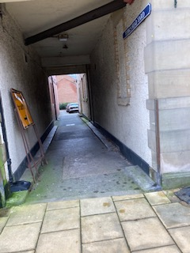
See black covers placed over the drains – stops cigarette butts accumulating

Minutes from NCC/MTC meeting and current position:
MTC meeting response: “These are private drains which MTC has no right to cover. There would also be issues regarding insurance should someone tip and fall on them.
MLG response: The placement of covers helps greatly with stopping cigarette butts going into the watercourse and the North Sea. It would be appreciated if these could be mentioned in any best practice recommendations.
MLG Update 3rd June: The over has been smashed in half by vandals, is there nothing that can be left!

R29-2020: Cigarette Butt Byelaws Suggested Owner: NCC/MTC
Can NCC/MTC put in place a local by-law that enforces pubs and restaurants to provide cigarette receptables in suitable places where their patrons/employees go for a smoke? This may be required in more than one place if for example patrons smoke in front of and at the rear of the premises.
Costa and Boots Optician Hearing Care businesses specifically mentioned due to the high scale of cigarette butt detritus at the rear of their business:
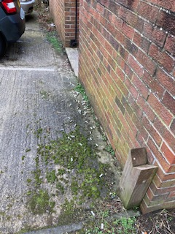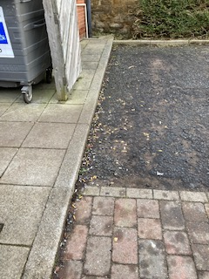
Rear of Boots Optician Hearing Care Rear of Costa store – 100’s of butts on the floor
REASONS: see para 3.1.c
- The town centre is being blighted outside most of its pubs and takeaways. Attempted by MLG to encourage businesses to put up cigarette receptables has only been successful with Joiners Arms and Chisholms.
- See scale of butt detritus outside Black Bull on Bridge St. and White Swan on Newgate St.
Minutes from NCC/MTC meeting and current position:
NCC meeting response: NCC officers are investigating options available to encourage engagement in addressing the issue.
MLG response: MLG will make contact with businesses to try and obtain their support to put up cigarette receptables.

R30-2020: Larger Bins Suggested Owner: MTC/NCC
To maximise NCC NEAT resources, utilisation of larger 240L bins would be more cost effective than using two 120L bins.
It is requested that MTC look at the following sites and replace two 120L Glasdon Future bin with their Jubilee 240L bin:
- 2 bins on the Wansbeck side of the Leisure Centre
- 2 bins at the edge of the Leisure Centre in front of Fortune Cookies Chinese takeaway
- Some of the bins on the square could be replaced with 240L capacity bin
REASONS:
- Replacing 2 smaller bins with 1 double size bin is more cost effective of NCC Neat team resources
- Replacing the 2 smaller bins recovers 4 bins that can be used somewhere else
- One 120L bin in Carlisle Park has been set alight causing the plastic to melt. This needs replacing since it is dangerous for anyone to use to put an item into the bin.
- Many of the bins on the main square are quickly filled by takeaway articles> Installation of the much larger bins will alleviate this problem.
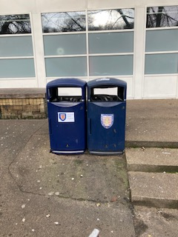
Bins by Leisure Centre Bins to the Wansbeck side of the Leisure Centre

Minutes from NCC/MTC meeting and current position:
MTC meeting response: “There is no need to replace four bins with two as they hold the same capacity of rubbish, large bins are not in keeping with a market town. There is no capacity to empty anymore bins so the four could not be placed elsewhere even if they were replaced with larger bins.”
MLG response: Reflecting NCC NEAT team resources are stretched, the need for more bins to be emptied further extends the NCC NEAT’s team ability to empty the bins, there are 3 known locations in Morpeth where 2 blue bins located next to each other could be better addressed with 1 larger bin, this will also facilitate generating a stock of 6 blue bins for future use.

R31-2020: Saying Thank You Suggested Owner: NCC/MTC/MLG/Chamber of Trade
This final issue is a question to everyone in ideas how we can thank people for their efforts. The successes in the very difficult 2020 Covid-19 year is down to individuals refusing to let the virus win. That includes Council workers, Adopt a Street volunteers and businesses. Having a post Covid-19 recovery plan which includes thanking people for their efforts / support would be an important recognition of people. Any thoughts / ideas?
REASON:
- Saying Thank You, is very important for people’s moral and enthusiasm – can we pull together a set of ideas / suggestions as to how we can thank everyone involved.
Minutes from NCC/MTC meeting and current position:
NCC/MTC meeting response: No response from MTC or NCC.
MLG Response: MLG Coordinators will consider what support we can obtain from local businesses. Wouldn’t it be great that each month we can have some vouchers for free coffee/sandwich for a volunteer who has gone the extra mile.
Update 27th April – at our 1st STREET BLITZ on Sunday 4th April a lucky dip was completed for 1 volunteer to have a free coffee and cake, compliments of Café Des Amis - excellent support from a local business and much appreciated.
CARIBE COFFEE manageress, ELLE CARCAMO: Generously offer the use of her mobile Coffee capability to come along to the Saturday Street Blitzes with free tea and coffees at the end of the events. What kindness and will be greatly appreciated by all volunteers.

A1.3 Bin Recommendations for 2020

RB1-2020: [RB2-2019]: Northgate Roundabout Suggested Owner: NCC/Hebron Parish Council
There is a need for at least 1 new bin on Northgate roundabout to help dog walkers etc in that area. Other areas in this estate and the bypass (regular dog walker route) should be considered.
REASON:
- The nearest bin for dog walkers is at the entrance to Lancaster Park – almost ½ a mile away.
Dec 2020 update:
- Covid-19 has delayed the discussions that were planned to take place between MTC and the Parish Councils. The owner of this issue has been delayed by this.
- There is clear need for a bin on this roundabout – the by-pass is a popular area for walkers and dog owners.
Minutes from NCC/MTC meeting and current position:
MTC/NCC meeting response: “A bin has now been placed next to the bus stop on the Northgate / Fairmoor road.”
MLG response: NCC NEAT team response relates to a new SULO bin located next to the bus stop off the old A1 slip road. It has been confirmed by NCC that the SULO bin here relates to a request from the St Andrews Estate. David Towns Hebron Parish Councillor advises that Morpeth Town Mayor David Bawn and Hebron parish council have agreed to jointly fund a trial bin along the bypass. Bin now in place at the start of June 2021 near Fulbeck bridge that goes over the bypass.

RB2-2020: [RB3-2019]: Doggy Bin Mineral Path Suggested Owner: MLG
There is a distinct lack of bins in the whole section of the Coopies Lane Mineral path. This path is very popular with dog walkers but there’s nowhere to deposit their full doggy bags. People instead throw them in the bushes. Walkers have asked Dai if we could put a doggy bin at the start of the second section, just where the path comes out onto Coopies Field. See R3 for Mineral Path improvements
REASONS:
- To reduce litter pollution which is harmful to wildlife and domestic pets.
- In the interests of amenity of the area (including the nearby public footpath).
- This is a popular dog walker’s route and no bins are available along the whole of the Mineral path.
Minutes from NCC/MTC meeting and current position:
MTC/NCC meeting response: : “A bin can't be located here due to access for emptying’.
MLG response: The lane is a very popular walk for dog walkers and for the whole length of the lane there is no dog bin anywhere! We had recommended a bin being placed on the edge of Coopies Field road where the lane crosses – this would give easy access to NCC NEAT team to empty the bin, especially with its location being just a few 100s yards from their premises.
This issue remains open – there is a clear need for a doggy bin in this location. MLG will look at other options.

RB3-2020: [RB7-2019, RB5-2018]: A192/Coopies Lane corner Suggested Owner: MTC/NCC
The area up the banking behind the new taxi office at the Railway Station is a magnet for cans and bottles being thrown from the pavement. MLG asked in 2018 and 2019 for consideration to be made to move one of the blue bins (either one by the bench or other next to the hidden to left of the bus stop) on the hill up the A192 to the corner of Coopies Lane Junction/A192.
REASONS:
- We raise this again in this 2020 Report due to the volume of litter deposited into the bracken on the banking.
- To reduce litter pollution particularly in the soft landscaping in the vicinity of the station and to improve visual amenity in the vicinity of this gateway into Morpeth, to complement imminent major regeneration of the station.
- To try to reduce the litter generated not only by people walking to and from Stobhill, but also from those exiting the station and Coopies Lane and proceeding to the town centre.
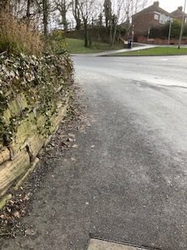
Corner of A192 and entrance to Coopies Lane Estate by the Railway station
Minutes from NCC/MTC meeting and current position:
MTC/NCC meeting response: “There are two bins which are located in the area, which are well used so there is not the justification to move either.’
MLG response: At the meeting MLG suggested that the bin next to the bus stop is moved down to this corner, thereby not increasing the number of bins in that area. MTC view was that the bin by the bus stop is needed for the people disembarking from a bus, but that there are more people disembarking from the trains than buses stopping here. This was rejected last year, could the MLG Adopt a Street volunteer gather statistical evidence over the next 6 months and put a business case via their Town Councillor for the bin to be moved.

RB4-2020:[RB9-2019,RB6-2018]:Northbound Railway entrance Suggested Owner: MTC/NCC/MLG/North rail
In January 2020 a bin was removed from the path, there is a clear need for a bin in this area – maybe a bin on a lamp post opposite the rear entrance to the railway station (northbound platform), will suffice?
REASONS: See R5.
- To reduce litter pollution particularly in the soft landscaping and to improve visual amenity in the vicinity of this important gateway into Morpeth, to complement the major regeneration of to the station.
- The scale of cigarette butts is high – relocated bin will help with this problem.
- The relocated bin will also capture litter thrown in the hedge where people take short cut option to Bankside.
Minutes from NCC/MTC meeting and current position:
MTC/NCC meeting response: “Bins can't be located on lamp posts due to access requirements for the street lighting team (bins would have to be placed too high).Additional bins at the railway station need to be raised with Network Rail.’
MLG response: Northern Rail’s Morpeth Railway station staff, have put a bin at the rear of the railway station, fitted 6th April. Our thanks to the team for such a quick resolution, great support. We expect this to make a big difference.

RB5-2020: [RB10-2019, RB7-2018]: Floor standing butt receptable Suggested Owner: MLG/Northern Rail
Consideration should be given to look at trialling floor standing cigarette receptables around the town where we have hotspots for cigarette butts. The improvements made to the town centre blue bins with butt receptables has shown that given the public the opportunity to use a receptable results in the butts being binned rather than thrown on the floor.
Areas we would like to consider:
- Receptable placed at the bus stop by the Railway Station on the path as you approach the railway semi-circle drop-off point. The scale of cigarette butts on the ramp up to the south bound platform at the station continues to be high.
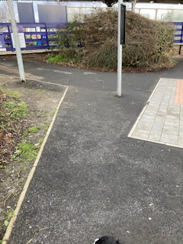
Drop off point at the semi-circle in front of South Bound platform

- Corner of Morrisons store roundabout, south side. A MLG volunteer spent over 30 mins in September 2020 picking up 100’s of butts in this spot. Further 45 minutes spent mid-January 2020 clearing 300+ butts from this area.
REASONS:
- To reduce the level of cigarette butt pollution in highly visible areas.
- To support the GMDT station upgrade and with further soft landscaping such as this, the overall appearance is a positive one to Morpeth visitors.
- The design of this should not have a major impact upon NCC NEAT team resources.

Example of Glasdon bin: Ashguard SG™ Cigarette Bin with Free Delivery - Glasdon UK
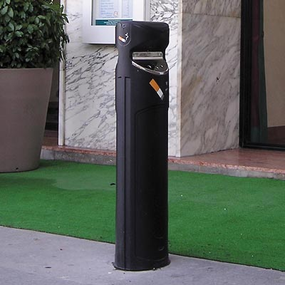
ASHGUARD SG Floor Standing This costs £240.40 inclusive VAT

Minutes from NCC/MTC meeting and current position:
MTC/NCC meeting response: “There is not the capacity to empty additional bins. These are not necessary as there are current 72 bins in the town centre.’
MLG response: MLG volunteers have identified the need for these type of bins in some places. It is disappointing that no trial can be considered by MTC/NCC. MLG will work with Northern Rail and its volunteers to look at getting a new cigarette butt receptable installed at the semi-circle Railway station drop off point.

RB6-2020: Doggy Bin conversions Suggested Owner: MTC/NCC/Hepscott Parish
Could we have MTC’s support to convert the following doggy bin to a dual use blue bin:
- Stobhill Farm roundabout – with the new housing estate now built a dual use bin will help to capture litter being dropped along the main road. See RB13-2019
- Bookers Trade wholesalers – doggy off the side of A196 to Guidepost See RB37-2019
- Whorral Bank: Heavily hit area where walkers going up the hill away from the town throw takeaway litter – seeing over the banking towards the kennels.
- Castle Meadows – doggy bin immediately behind the Renwick House sign
REASONS:
- The dual bins would enhance their use where general rubbish can be deposited.
- Improves the situation for the NEAT team with easier access to the detritus.
- Stobhill Farm location identified has a key bin which is too small for the volume of bags captured.
- New estates on the Hepscott boundary will increase the number of people, especially schoolchildren walking along this route. The doggy bin is no longer a suitable receptable to capture the various types of litter.
- Scale of litter behind Bookers was very high in 2019 – it is expected to be high again in 2020.
Minutes from NCC/MTC meeting and current position:
MTC/NCC meeting response: “1. This would be for Hepscott Parish Council to address as the new estate falls within their boundary.
2. Need to conduct a site visit to see which bin this is. 3. There is a bin on the bank. Litter found is more likely to be from rubbish thrown from vehicles. This was discussed at the last meeting. 4. This is private land, need to contact Karbon Homes.’
MLG response:
- At Hepscott Parish council’s May 2021 their response to our request was immediate, they have promised to convert 2 doggy bins to full blue bin dual use bins.
- We await MTC response to their survey.
- As stated last year the rubbish is being dropped by walkers going up the path. We have MLG Adopt a Street volunteers clearing litter that is being thrown out of car windows. Last year this doggy bin was fitted here, having a dual use blue bin will capture both doggy bags and other detritus.
- MLG made contact with Karbon Homes who confirmed bin owned by MTC. MTC have replied to our request with a rejection to any conversion to a blue bin. The scale of litter is high, see the litter that collects in the bushes in front of Renwick house. Can the Adopt a Street volunteers owning this area put together a business case and make representation to their town councillor for this bin to be converted.

RB7-2020: [RB19-2019, RB14-2018]: Corporation Yard Suggested Owner: MTC/NCC/MLG/Chamber of Trade
Scale of litter in Corporation Yard continues, despite monthly clean-ups. The scale of detritus spoils the main entrance onto Morpeth’s Bridge St. Last year it was proposed that we look at a general clean-up of this area – despite Covid-19 MLG KBT Ambassadors having partially cleaned up the area but further work required in 2021. Initially it was requested that a bin is placed in Corporation Yard.
The improvement plan proposes:
- Placement of new blue bin in this location.
- Deep clean of cigarette butts and chewing gum from the ground.
This has been half completed by MLG KBT Ambassadors, completion blocked by Covid-19 lockdowns. It is hoped to complete this in 2021.
- Whitewash of walls of the small alley. Need support from owners of Superdrug and the owner of the new shop (old Northern Rock) – D Nicholson.
- Mural or prints placed on the wall to improve appearance. This could be an exciting school project where art students could make an enormous difference to a very unsightly area.
REASONS: see para 2.6
- To improve litter control on this busy thoroughfare.
- To aesthetically improve this area to new visitors to Morpeth coming from the main car parks. An attractive town will encourage more footfall to the town.
- Corner of the yard is being used as a smokers’ area and scale of butts, chewing gum and other detritus is very severe in this area.
- The existing ground furniture is constantly being used to deposit cans, wrappings etc on the top of the cabinet.
Minutes from NCC/MTC meeting and current position:
MTC/NCC meeting response: “a. This is not adopted highway and is a private car park, and throughfare we could not place a bin here.
b. Again, this is not adopted highway. c. You would need to contact the owner of the building for permission. d. You would need to contact the owner of the building for permission.’
MLG response: ownership changed to MLG/Chamber of Trade. Upgrading this yard could be an exciting project for Morpeth Town. Discussions are taking place with a local business for potential funding to take this forward. Chamber of Trade also keen to look at making improvements to a main throughfare onto Bridge St.

RB8-2020: [RB24-2019]: Doggy Bin at St Mary’s Churchyard path Suggested Owner: MTC/NCC/MLG
The path that goes along the wall of St Mary’s churchyard is a popular path for Dog Walkers. The lack of a doggy bin here is resulting in a large volume of full doggy bags thrown around the area.
REASONS:
- See photo of numerous full bags thrown around the entrance to the middle of St Mary’s Church cemetery.
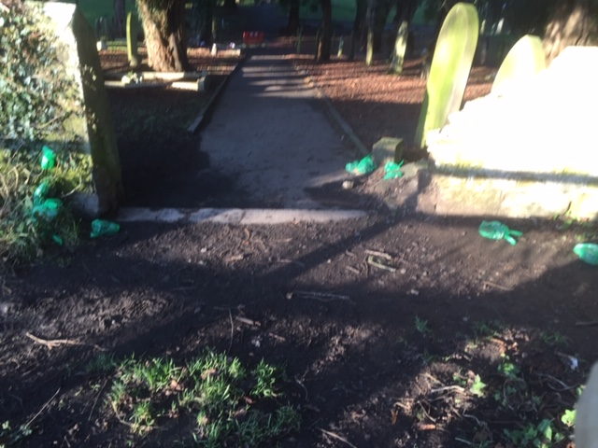
Full GREEN doggy bags littered around the entrance to the churchyard from the path – path behind photographer leads up to the golf course (another hot spot for bags deposited there)
- It is clear that the public will just throw the full bags into trees and onto the ground if bins are not in the correct place.
- In the interests of the amenity of the area (including the public footpath).
- The scale of full doggy bags left here does create a health and safety risk.
- On Sunday 10th January 2020 – a carrier bag was filled with full doggy bags.
Minutes from NCC/MTC meeting and current position:
MTC/NCC meeting response: “A bin can't be located here due to access for emptying. There is already a bin next to the gates.”
MLG response: ownership changed to MLG, working with our MLG Adopt a Street volunteers, investigations will start into other options available to resolve this.
Note: the bin in St Mary’s Church cemetery next to gates referred to by NCC, is on the opposite side of the cemetery, too far away for any dog walker to take their full bags too.

RB9-2020: [RB21-2019 and 2018]: Stanley Terrace Suggested Owner: MTC/NCC or LIDL store
The existing lamp post bin placed at the entrance to Lidl store should be replaced with a blue bin and placed near the path entrance to Lidl store. Alternatively, as per R12 above – could Lidl plc adopt a bin and manage the bin here reducing the no. of bins to be emptied by NCC NEAT team?
REASON:
- The scale of litter in this area is very high and gives an impression of a town that is blighted by litter with detritus being deposited in the bushes there.
Dec 2020 update:
Morpeth Town Council team have installed a small bin high on the lamppost by the car entrance to Lidl car park. This is being heavily used and is often seen full despite its height, moving this to a full blue bin in the Lidl pavement entrance will capture more detritus.
Minutes from NCC/MTC meeting and current position:
MTC/NCC meeting response: “The bin is not the property of either NCC or MTC, however MTC will look to purchase and site a new bin in the area.”
MLG response: Our thanks to Morpeth Town Council, a new bin will be placed near the entrance to Lidl pedestrian entrance, this should greatly help to reduce the scale of litter on Stanley Terrace.

RB10-2020: [RB26-2019, RB1-2018]: Castle Close Suggested Owner: NCC/MLG
Rear of Castle Close has been identified as an issue for the last 3 years, but not adopted at this time. The scale of litter here is alarming – support needed from NCC to look at options available to us. Area is around garages in Castle Close and the path down to the green area behind.
The summary of issues are:
- The debris that remains each year after the November bonfire, again large pieces of metal just sits in this area awaiting to be taken away.
- The tall nettles that are behind the garages and going down to burn are so deep that it is very difficult to clear the area of detritus. Could these bushes be cut lower so detritus can be picked out of the area.
- The area is a natural wind tunnel and detritus collects in this area. Can a small fence be put up along the bushes with a fine mesh to stop the detritus blowing into the woods behind and the burn?
REASONS: see para 1.4.
- An area where people are constantly dumping litter – the scale is large.
- A HOTSPOT (2) in the town that is having to be targeted by scouts and members of the MLG.
- General untidiness and all sorts of detritus left here.
- Its proximity to the burn does result in items flowing into the North Sea.
Minutes from NCC/MTC meeting and current position:
MTC/NCC meeting response: “Karbon Homes.”
MLG response: MLG have made contact with Karbon who have confirmed ownership is with NCC. MLG have made contact with NCC NEAT team asking them to clear the bushes, no response received at this time. Once done, the MLG team will clear the detritus in that area.

RB11-2020: [RB2-2019]: Whalton Road – westward Suggested Owner: NCC
In October 2019 –MLG reviewed the layby on the Whalton road – about 700 yards to west of the Piramal Healthcare factory. The amount of rubbish here was alarming – consideration should also be made to put a SULO bin here. In 2020 the scale of litter continues to grow, could we please put a SULO bin here for truck drivers to use? (it is a known overnight stop place for truck drivers waiting for the Piramal factory to open).
REASON:
- to improve the amenity of the area.
Minutes from NCC/MTC meeting and current position:
MTC/NCC meeting response: “This is a fine balance as installing a bin in such an area can encourage more waste and fly tipping.”
MLG response: MLG volunteer has tried to clear the layby, the scale of litter is terrible, it also appears to be a popular flytipping area, MLG volunteer has blitzed this layby filling 4 large black bags, he also found remains of a dead dog/cat in a carrier bag that had been dumped here. The type of items dumped here are like the remains of a building site, we need bushes cut back to gain access to the detritus plus bricks and concrete blacks taken away.
April 27th: MLG team have completed 2 Street Blitzes along the Whalton road, over 50 bags collected in 4 hours.

RB12-2020: [R34-2019]: Move of Bins Suggested Owner: MTC/NCC
Suggested MOVE of BINS to maximise usage:
The following existing bin locations are being identified by members of Morpeth Litter and the MLG KBT Ambassadors. In an attempt to improve the capture of litter the MLG volunteers would like MTC to consider movement of these bins:
- Bin at the front of St James Church, can we move this left-hand side of the alleyway entrance to St James’ car park.
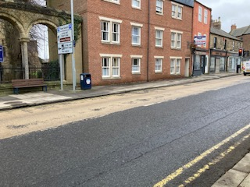
Bin at the front of St. James entrance – move 30m to the right?
- Carlisle Park swings area – move a litter bin that 7-8m up the slope to be located by the swings area.
- There has been a new bin placed on a location in front of Phoenix Court. Could this be moved to a location next to the signage for Whalebone Lane Car Park B?
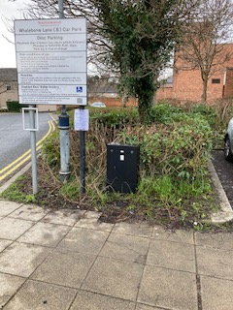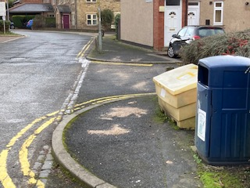
New location on rhs of sign? Whalebone Lane Car Park B sign?
- Bin located close to Galaxy Studios on Newgate Street is moved further down to entrance to T&G Allan arcade.
- The bin that was located in front of Jackson’s Barbers – Chantry Bridge has been taken away. Can the bin placed behind wall at the front of the Chantry be repositioned so it is more accessible to pedestrians on the other side of the wall. e.g., if the bin is placed on the slope on the other side of the wall, lower down to be just behind the bench would make it accessible to people sitting on the bench and pedestrians.
Could this give us an opportunity for a new bench on the left side where the bin is currently or
maybe a raised flowerbed?
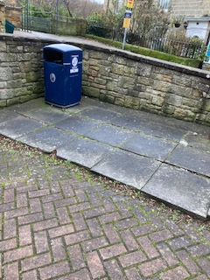
Bin to left of bench at Chantry – move to other side of wall?
- The old-style bin on Manchester St. could be better utilised by it being repositioned at the pathway entrance to St James’ car park, next to the library.
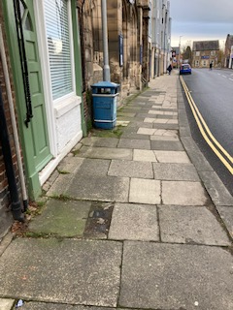
Could bin be moved to side entrance to St. James car park?
REASONS:
- A. St James’ Car Park has no bins at the Newgate St. entrance. Placement of the bin here could help to capture litter from people who about to enter the car park as well as the Newgate St. walkers.
- B. Request from MLG volunteers Graham and Val Langston who have observed a high amount of litter around the swings in Carlisle Park.
- C. Whalebone car parks are being hit badly by detritus – could we relocate the bin that is sitting in front of a semi-circle to a private set of houses to a more prominent place to encourage better use?
- D. This was rejected at last year’s end of year review. The volume of litter in this arcade remains high. Work has started on the extended shop opposite T&G Allan where it is expected the brick wall will be taken down and opened to a shop window. MLG requests that consideration again be made into placing a bin in the near vicinity of the new shop/subway. Covid-19 lockdowns has not improved the area – the new Harry’s Coffee bar has definitely increased the general detritus volume in the arcade.
- E. The sole bin along Chantry Bridge is very low behind a wall. By moving the bin to a different place, could we achieve ease of use for people sitting on the bench and walkers on the ramp towards Chantry Bridge? Existing bin is too low for any pedestrians walking up the ramp, often litter sits behind the bin where people have missed the bin.
- F. As A. above St James’ car park entrances are inundated with litter due to no bin located at the entrance into the car park. At no overall costs re NCC NEAT team resources, the existing bin could be relocated. There would be an additional benefit in that the new position is in a safer place to park a vehicle to empty the bin.
Minutes from NCC/MTC meeting and current position:
MTC/NCC meeting response:
a. This bin is well used.
b. Not justified, there are ample bins in the play area, we would not want to encourage staff to be carrying wasted down slopes for obvious health and safety reasons.
c. MTC need to do site visit to determine the need to move.
d. There is a bin down the street to the left when exiting the alley, also a one when exiting to the right. This alley is swept by NCC. This was discussed last year. the bins are equidistance on Newgate Street when leaving the tunnel.
e. The bin has been stolen and is yet to be found. MTC need to do a site visit to determine the need to move.
f. This is the only bin on Manchester Street so will not be moved.
MLG response: MLG would appreciate looking at this periodically, our experience in picking up litter has necessitated the raising of these requests. MLG volunteers endeavour to not increase the no. of bins to empty but could the move of a bin achieve more usage?
It is pleasing to see the lost bin outside Jacksons barbers replaced, being heavily used. The move of the bin on the opposite side of the Chantry bin has also helped to collect litter.

Any MLG volunteer who would like to pursue MOVE OF BINS, please raise individually with your town / county councillor with strong justification for moving a bin.

RB13-2020: Morrisons underground car park Suggested Owner: NCC
Morrisons underground car park is being polluted by large scale volume of litter. Members of MLG and Morpeth Rotary Club have an almost weekly clean-up of this area but since an area in the far-left corner is used by teenagers to meet and eat/drink – with no bins the items are discarded, thrown over the wall onto the banks of the burn or smashed on the floor.
REASONS:
- The scale of litter necessitates the placement of a bin in the far corner of the car park.
- Sweeper needed to clean-up the glass fragments that pollute the car park.
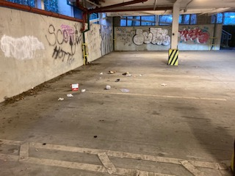
Area blighted – see far left bottom – wall aligning with river bank

Minutes from NCC/MTC meeting and current position:
MTC/NCC meeting response: “The car park is swept by NCC. NCC are unable to install a wheely bin due to height restrictions for emptying.”
MLG response: MLG Adopt a Street Volunteer will report back on status of the detritus here. Our thanks to NCC for starting hoovering of the underground car park.

RB14-2020: St Georges Hospital car park – paying machine Suggested Owner: MTC/NCC/MLG/NHS
New Hotspot identified in 2020 – need for a new Blue Bin located next to the paying machine at St George’s hospital.
REASONS:
- The scale of litter in this area is very high – see para 1.6 For scale of problem.
- Litter includes cans, plastic bottles, drink bottles, cigarette packages and butts
- Popular location for dog walkers – with the new estate here – more people walking around this area.
- On 27th January 2021 – visiting the site for latest photos – the scale of cigarette butts and empty packets was just astounding – 1000+ butts around the edges of the fences going round the corner. Empty cigarette packets thrown over the fence!
- Please as a minimum – a trial bin placed to see if it starts to address the littering that is taking place.
- There is no bin within ¼ mile - popular area for dog walkers – need for a bin is evident.
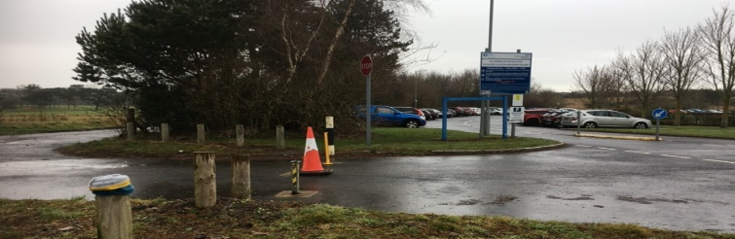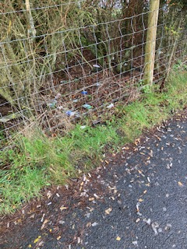
Recommended bin placed on this corner 27th Jan 2021 – 1000+ cigarette butts on the floor

Minutes from NCC/MTC meeting and current position:
MTC/NCC meeting response: “This would be for the hospital to address.”
MLG response: MLG have made contact with NHS team at Northgate hospital, they are looking at the matter to see what improvements they can make. 3rd June , we still await their response; further contact will be made in June 2021.

RB15-2020: Tommy’s Field / Morrisons bushes Suggested Owner: MTC/NCC/MLG/MORRISONS
It is suggested that a trial bin is placed near the hedges aligning Tommy’s Field in Morrisons car park. This will support the scale of the litter collecting along the burn and may reduce the scale of litter in the hedges.
Could we also ask Morrisons store to place around their car park bins to collect rubbish? The whole area is heavily hit by litter. Could the additional bins help?
REASONS: see R23 above.
- The scale of litter in this area – merits the placement of a bin.
- The car park away from the main building is not covered by any bin.
Could we place a bin just in the gravel area by the cone?
Minutes from NCC/MTC meeting and current position:
MTC/NCC meeting response: “This would be the responsibility of Morrisons to install their own bins.
MLG response: MLG are working with Morrisons to see if they can expand their Adopt a Bin to a new bin in this location.

RB16-2020:BT Telephone Exchange – Newgate St. Suggested Owner: MTC/NCC
It has been noted by a MLG volunteer that a blue bin needs to be placed by BT’s Telephone exchange.
REASON:
- The scale of litter in this area – merits the placement of a bin.
- This is a main route for children walking to Chantry and Newminster middle schools, often the children are carrying snacks just purchased from shops in the town.
Minutes from NCC/MTC meeting and current position:
MTC/NCC meeting response: : “This is too near the traffic lights, which would make it difficult to empty. There are bins in very proximity.’

A1.4 Reasons we should not give up!

A1.4.1 Why you should always wash your hands when back home!!

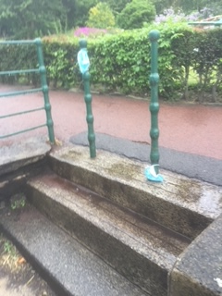
Someone thinks it is funny to dump their face masks here – a bin is just 10’ to the right of the posts!
Location: Steps from Castle Bank towards Carlisle Park clock.

A1.4.2 This is what an area is like before a MLG Volunteer has been there!

The following photo is an example of the mess our MLG volunteers come across and diligently sorted out – he cleared as much as he could carry then asked NCC NEAT team to take away the rest.
It's true you never know where a litter picker has been - just where they haven't been!
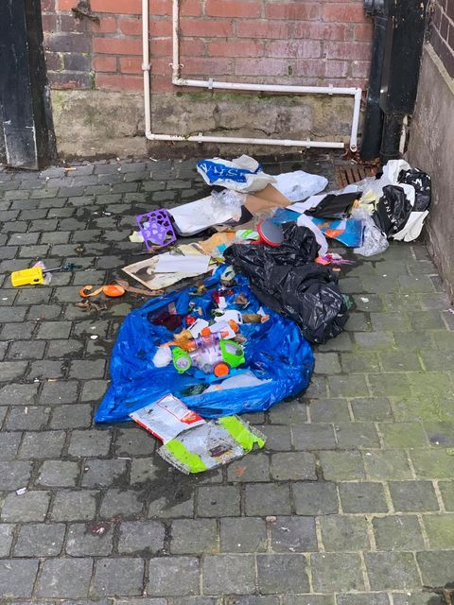
Location: Corporation Yard – where you will find 100’s of cigarette butts as well.

APPENDIX A2: 2021 MAJOR LITTER HOTSPOTS IDENTIFIED
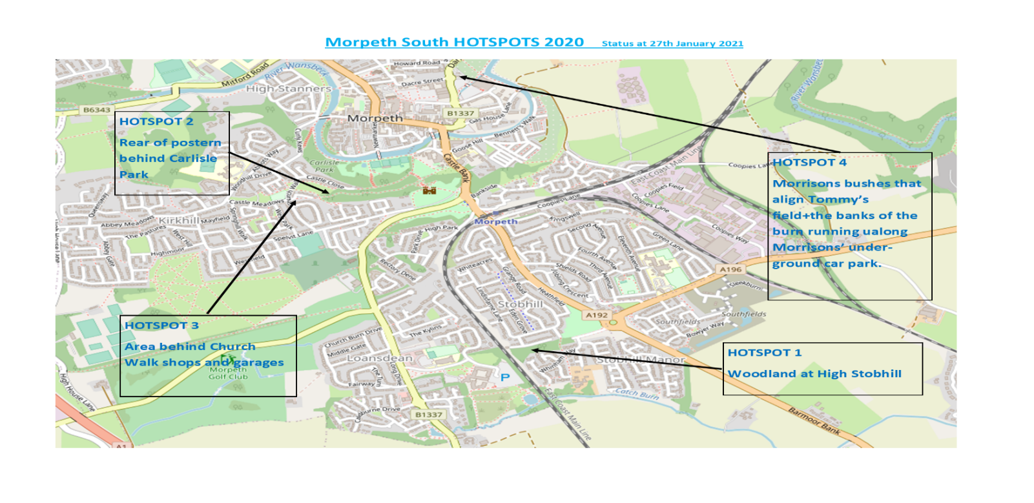
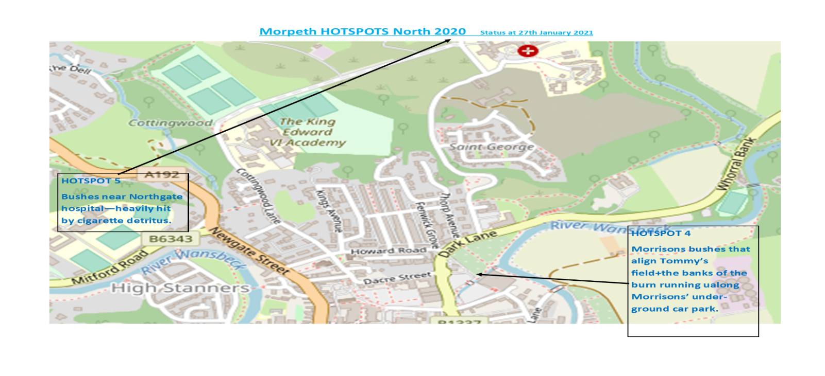
Successes in 2020– thanks to NCC team:
Craik Park: Sincere thanks to NCC for resolving this area – a major improvement has been made with no huge mounds of rubbish in front of the woods.
Mineral path in Coopies Lane: This lane is greatly improved with little general rubbish now present. Still hit by full doggy bags, if a doggy bin is placed here this are area can be closed as an issue.
Hotspots to be addressed in 2021:
HOTSPOT 2: The burn continues to be a hotspot – separate project being asked to see if we can make improvements here.
HOTSPOT 4: New area, Morpeth Town Council have stated the bushes will not be cut back, the danger to volunteers eyes and skins with sharp/jagged bushes stops any plans to extract litter from the bushes.
Separate action by Morpeth Litter group asking for Environment agency to help with fine mesh put up along top of wall of the underground car park.
HOTSPOT 5: New area, near Pay-in machine at Northgate Hospital – severe smokers area – 1000’s of cigarette butts and other detritus here. It is hoped a new bin provided by NHS will resolve this.

APPENDIX A3: 2021 NEW BIN RECOMMENDATIONS MAP
Morpeth North
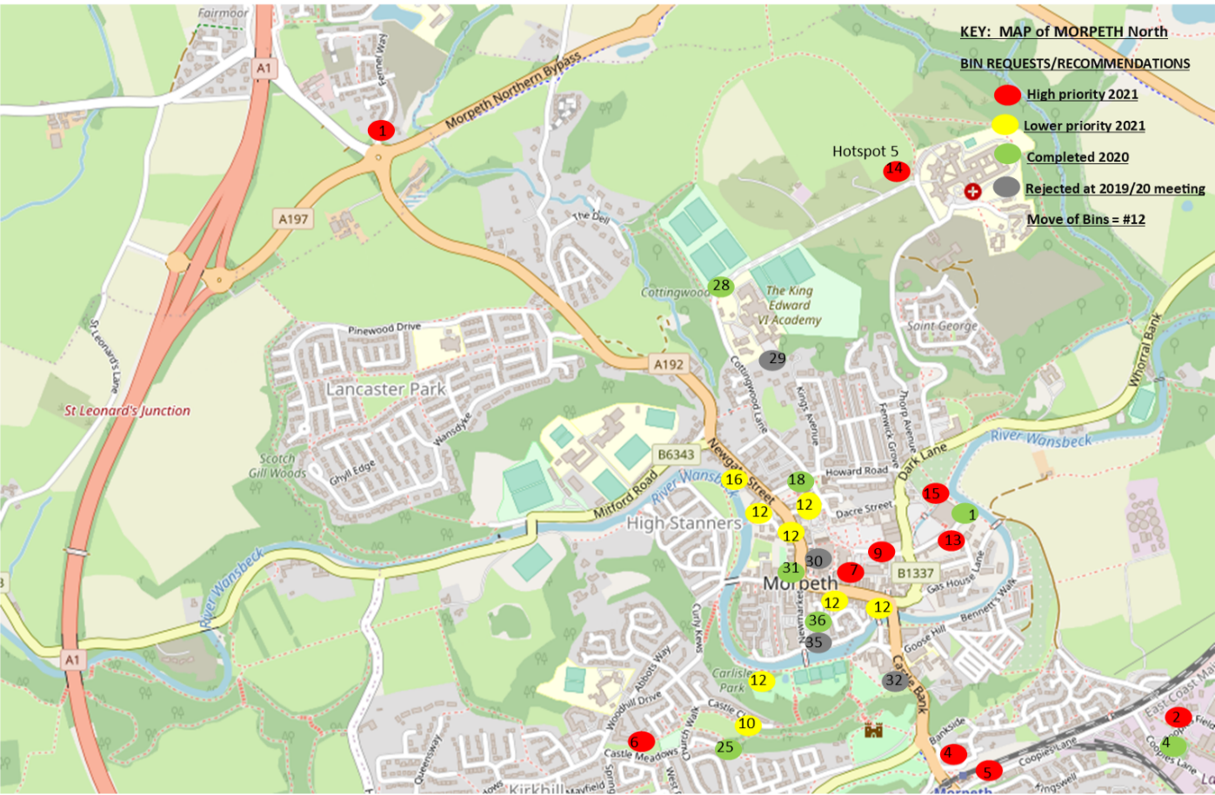
Morpeth South
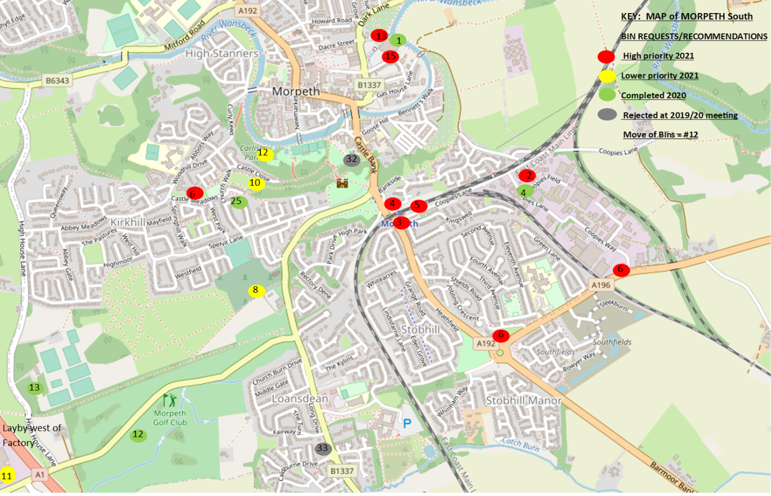

APPENDIX A4: 2021 MORPETH LITTER GROUP – ADOPT A STREET/STREET BLITZ
Morpeth North
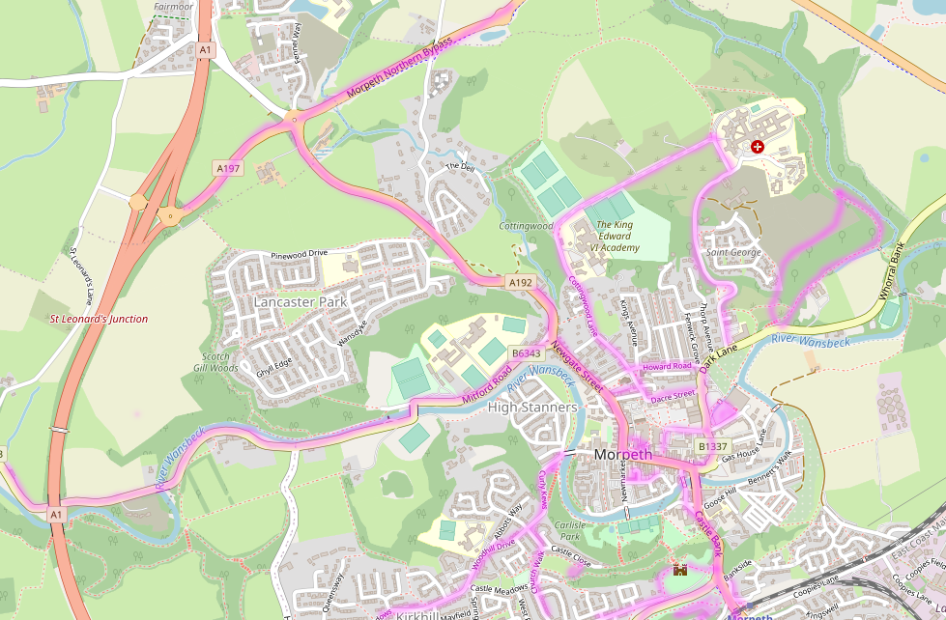
Morpeth South
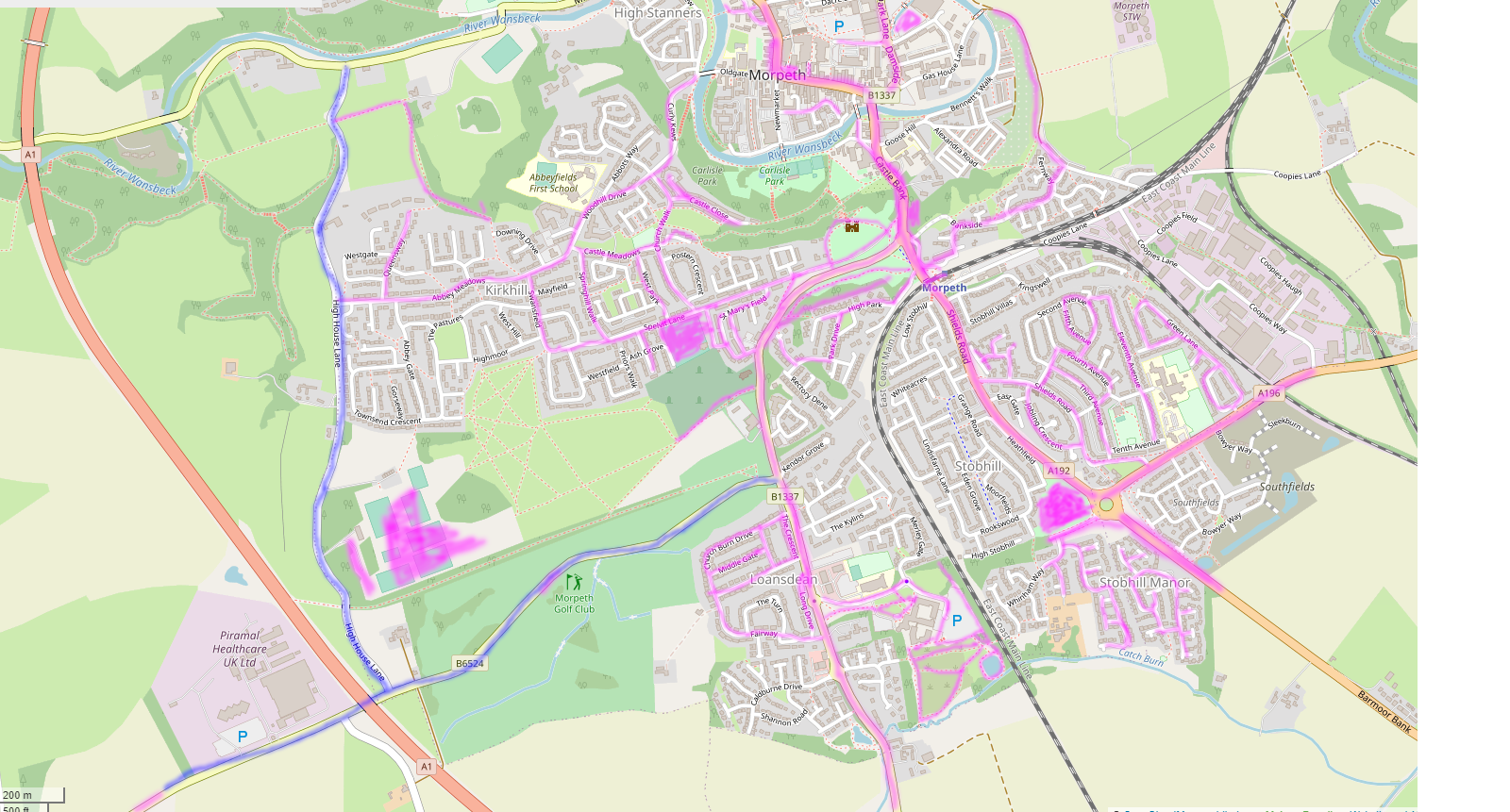
Purple Highlights denotes areas covered by Morpeth Litter Group Volunteers – maybe daily, weekly, monthly
Blue Highlights denotes streets/lanes/roads that have been STREET Blitzed by Morpeth Litter Group Volunteers – started April 2021
Our plans for 2021 will be to use all media, websites, Facebook, Twitter, Morpeth Herald and posters to encourage more people to adopt a street / location and try to keep Morpeth free of litter.

Maps reflect status at April 2021 – we currently have 72 people supporting the Adopt a Street initiative – a great thank you to all volunteers – you are making a big difference.

APPENDIX A5: HM Environment minister response – Rebecca Pow

 |  | Rebecca Pow MP Parliamentary Under Secretary of State
 | Seacole Building  2 Marsham Street  London  SW1P 4DF |  | T 03459 335577  defra.helpline@defra.gov.uk  www.gov.uk/defra
Your ref: IL25198
Our ref: MC2021/04098/SG

16 March 2021
Local councils are responsible for keeping public land clear of litter and refuse. This includes the majority of trunk roads and other, more minor roads. For any local litter issue, we recommend contacting the council to make sure it is aware of the problem. It is up to councils to decide how best to meet their statutory duty to keep their public land clear of litter and refuse.

We also want businesses to recognise what they can do to discourage the littering of their products and packaging, and the potential benefits to their brand of being associated with reducing, rather than causing, litter. The Litter Strategy sets out how we intend to work with the relevant industries to tackle certain types of particularly problematic litter, including fast-food packaging, smoking-related litter and chewing gum. We have published a voluntary code of practice for local partnerships on reducing litter caused by ‘foodonthego’”.

It gives businesses a framework to identify how, when and where their worst litter problems arise and to work out the best ways, in partnership with others, to solve these issues. Mr Richards may be pleased to know that the recommendations include carrying out daily litter picks on the frontage of the premises to the end of the pavement or for two metres in a pedestrianised area, where agreed with supporting agencies. The code has been successfully used but needs to be updated to take account of new research and changing patterns of food consumption. As set out in our Litter Strategy, we will work with members of the Litter Strategy Advisory Group and others to review and update this guidance.

I recently held a roundtable with large fast-food retailers to understand what action they are taking now to tackle the litter created by their products and explore how they can support the revision of Defra’s voluntary guidance on reducing litter caused by ‘foodonthego”. It was encouraging to hear about the initiatives they are working on and, more importantly, that they are committed to delivering lasting change by working together to tackle what is an industry wide issue.

Councils and others also have powers to tackle persistent, unreasonable behaviour that is having a negative effect on a community’s quality of life. Under the Anti-Social Behaviour, Crime and Policing Act 2014, councils, the police and designated social housing providers can issue Community Protection Orders and Public Space Protection Orders which can be used to require the owners of premises, such as fast food outlets, to take certain actions to tackle litter created by their activities.

In some places, street litter control notices may already be in place to prevent litter. These notices can require the owners of premises to take action to tackle litter, including taking remedial action up to 100 metres from the premises itself.

Thank you once again for taking the time to contact the Prime Minister about this important issue.

REBECCA POW MP

