Volunteer Enquiry Form
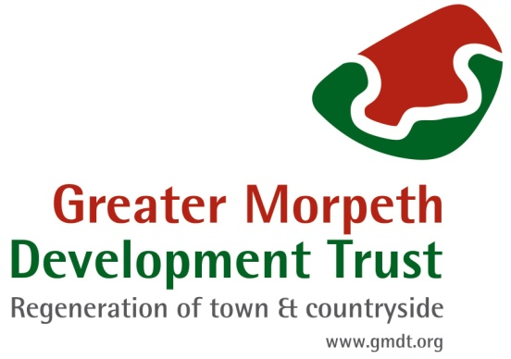

Title:
Full Name: |  |  | Known As:
Address:  Post code: |  |  | Home tel:
 |  |  | Mobile:
 |  |  | Email:
How would you like to help GMDT?
Please outline any skills, interests, hobbies, previous experience you would like to offer
Information on our database is strictly confidential and we do not pass on any personal data about
you to outside organisations and/or individuals without your express personal consent.
Do you agree that we may keep basic information from this form on computer? YES / NO
(Should you decide not to volunteer with us all personal information will be deleted.) (Delete)
How did you find out about volunteering with us? (Please tick as appropriate)
Press advert / article |  | From a member of GMDT |  |  | GMDT event
GMDT Website |  | Talk/Presentation |  |  | Referred by a friend
Other (please give details)

Please email your completed form to: info@gmdt.org and we will be in touch.
Thank you for your interest.

